专著13——AI时代的文旅行业的管理变革与组织转型之路 文献补充与数据分析报告

Executive Summary
已形成 35 条候选参考文献，满足每个专著子文件夹不少于 20 条的补充要求。
本证据包为《AI时代的文旅行业的管理变革与组织转型之路》补充了 35 条候选参考文献，其中 35 条发表于 2021 年及以后，说明该书题与近年数字技术、旅游管理和文化传播研究保持连接。主题上，当前文献主要集中在组织转型、服务创新、治理风险，可以支撑书稿从概念解释转向“技术—场景—主体—绩效”的论证链。方法上，样本文献呈现问卷/结构方程、实验/情景实验、文本挖掘/评论分析、案例/质性研究、预测/机器学习、综述/框架研究等路径，适合在书中分别转化为理论综述、案例框、方法训练和图表化教学材料。需要注意的是，Semantic Scholar 返回的题录不能替代全文精读；涉及地方数据、政策口径和企业案例成效的判断仍应回到原文、官方材料或授权数据核验。
证据边界：本报告基于 Semantic Scholar 题录、摘要和本地数字文旅文献语料生成；正式出版前需逐篇核验 DOI、页码、卷期和全文观点。

关键图表

年份分布
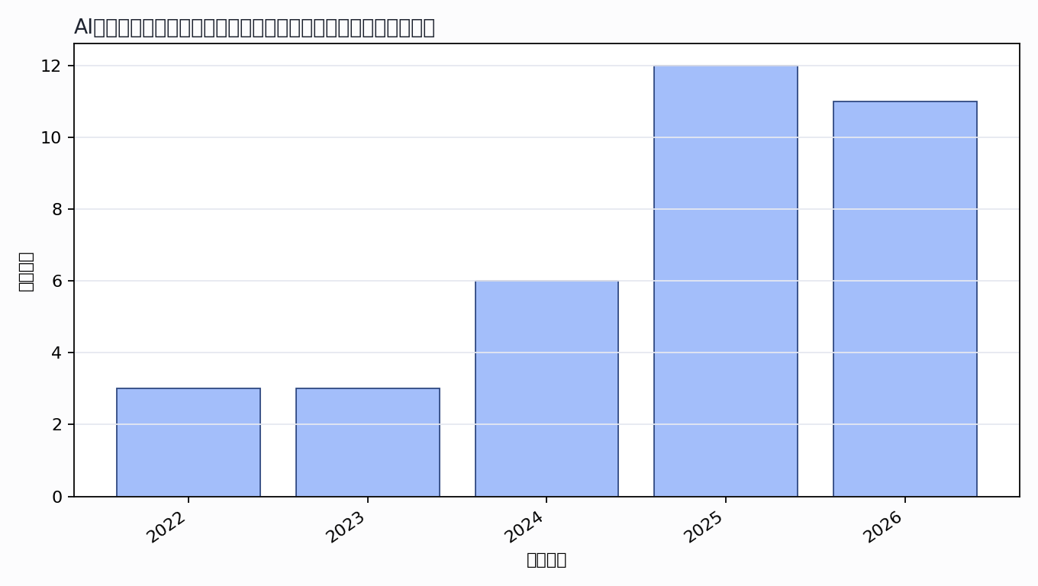

主题覆盖
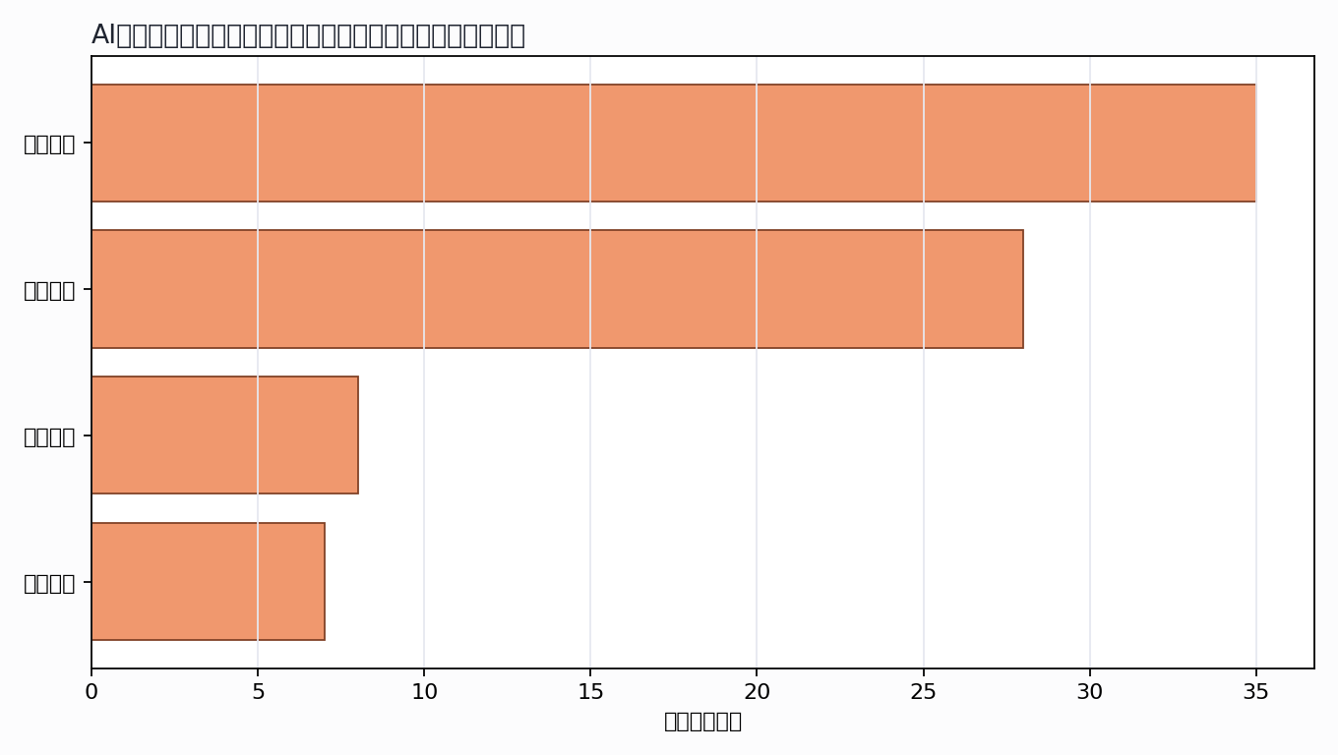

来源结构
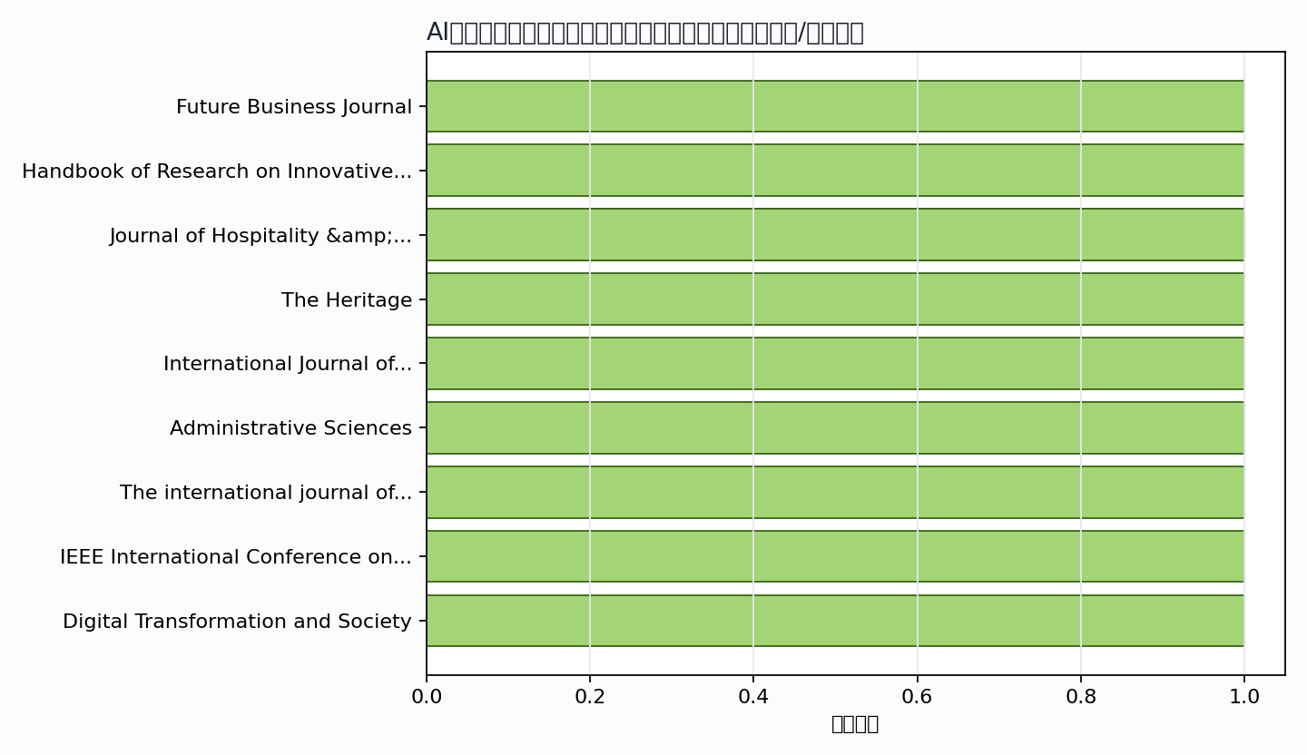

可进入书稿的论证链
- 概念层：使用高被引或综述型文献界定核心概念。
- 机制层：整理为技术能力、场景应用、主体协同、绩效反馈的论证链。
- 方法层：将实证方法转化为课堂练习、章节附录或研究设计示例。
- 边界层：对隐私、真实性、社区参与、算法偏见和数据授权设置专门讨论。

候选参考文献
- Hyunsu Kim; Kevin Kam Fung So; Seunghun Shin; Jing Li (2024). Artificial Intelligence in Hospitality and Tourism: Insights From Industry Practices, Research Literature, and Expert Opinions. Journal of Hospitality &amp; Tourism Research. DOI: 10.1177/10963480241229235.
主题映射：组织转型; 服务创新；引用数：114。
- T. Dang; M. Nguyen (2023). Systematic review and research agenda for the tourism and hospitality sector: co-creation of customer value in the digital age. Future Business Journal. DOI: 10.1186/s43093-023-00274-5.
主题映射：组织转型; 服务创新；引用数：45。
- Dana S. Nau (2022). Artificial Intelligence and Automation. Handbook of Research on Innovative Management Using AI in Industry 5.0. DOI: 10.4018/978-1-7998-8497-2.ch006.
主题映射：组织转型; 人机协同; 服务创新；引用数：26。
- Katarzyna Minor; Emmet McLoughlin; Sheena Carlisle (2024). The Digital Skills Gap – Is it Time to Rethink the Needs of Tourism and Hospitality Organizations in the UK?. Journal of Hospitality &amp; Tourism Education. DOI: 10.1080/10963758.2024.2316338.
主题映射：组织转型; 服务创新；引用数：25。
- J. Sánchez-Martín; Rebeca Guillén-Peñafiel; A. Hernández-Carretero (2025). Artificial Intelligence in Heritage Tourism: Innovation, Accessibility, and Sustainability in the Digital Age. The Heritage. DOI: 10.3390/heritage8100428.
主题映射：组织转型; 服务创新; 治理风险；引用数：17。
- R. Garcia; Linchi Kwok (2025). Generative artificial intelligence in human resource management: a critical reflection on impacts, resilience and roles. International Journal of Contemporary Hospitality Management. DOI: 10.1108/ijchm-01-2025-0159.
主题映射：组织转型; 服务创新; 治理风险；引用数：15。
- A. Seraj; A. Hasanein; B. Al‐Romeedy; Mohammed N. Elziny (2025). Redefining the Digital Frontier: Digital Leadership, AI, and Innovation Driving Next-Generation Tourism and Hospitality. Administrative Sciences. DOI: 10.3390/admsci15090369.
主题映射：组织转型; 服务创新；引用数：14。
- Zichan Qin; Guodong Wang; Min Jiang (2025). Working With a Digital Human Avatar: Employee–AI Symbiosis Shapes the Double‐Edged Sword Effects of Artificial Intelligence (AI) Awareness in the Hospitality Industry. The international journal of tourism research. DOI: 10.1002/jtr.70106.
主题映射：组织转型; 服务创新；引用数：10。
- R. Simões; Marcus Parreiras; Ana Clara Correa da Silva; C. E. Barbosa; Y. Lima; J. Souza (2022). Artificial Intelligence and Digital Transformation: Analyzing Future Trends. IEEE International Conference on Systems, Man and Cybernetics. DOI: 10.1109/SMC53654.2022.9945429.
主题映射：组织转型；引用数：10。
- K. Mavitha; Suraj Kushe Shekhar (2025). Mapping the landscape of digital transformation and digital technologies in the hotel industry: a comprehensive bibliometric analysis. Digital Transformation and Society. DOI: 10.1108/dts-09-2024-0178.
主题映射：组织转型; 服务创新; 治理风险；引用数：7。
- Dr. Sivarethinamohan (2023). Exploring the Transformation of Digital Tourism: Trends, Impacts, and Future Prospects. 2023 International Conference on Digital Applications, Transformation & Economy (ICDATE). DOI: 10.1109/ICDATE58146.2023.10248691.
主题映射：组织转型; 服务创新；引用数：7。
- Priyant Banerjee; Arshad Bhat (2025). Transforming Smart Hospitality: Leveraging AI and IoT for Sustainable Tourism, Enhanced Guest Experience, and Cybersecurity Resilience. Eco-Tourism and Sustainable Development. DOI: 10.63385/etsd.v1i1.87.
主题映射：组织转型; 人机协同; 服务创新；引用数：6。
- Ana Marija Gričnik; Simona Šarotar Žižek; Branka Zolak Poljašević; Kristina Črnjar (2024). TALENT MANAGEMENT IN THE AGE OF DIGITAL TRANSFORMATION AND CHANGES IN THE WORKFORCE CHARACTERISTICS. Tourism and hospitality industry. DOI: 10.20867/thi.27.25.
主题映射：组织转型；引用数：6。
- Ayman Harb; Wejdan Alakaleek; Suzy Hatough-Bouran; Ahmed Freewan; A. Al-Harahsheh; Hadeel Al-Maaitah (2025). Empowering Women Homepreneurs in Tourism and Hospitality: Entrepreneurial Competencies and Learning Approach. Journal of Tourism and Services. DOI: 10.29036/0ymceq94.
主题映射：组织转型; 服务创新；引用数：5。
- M. Khalifa; M. Albaz; Walaa Mohamed Nagea (2023). Impact of the Application of Artificial Intelligence on Human Resource Management in the Tourism Companies Sector.. World Research of Business Administration Journal. DOI: 10.56830/wrba11202305.
主题映射：组织转型; 服务创新；引用数：5。
- Min-Sun Lee; Billy Bai; Annamarie D. Sisson; R. Costa (2026). Economic impact of artificial intelligence (AI): Conceptualization of business value of AI and future agenda for tourism and hospitality research. Tourism Economics. DOI: 10.1177/13548166261418787.
主题映射：组织转型; 人机协同; 服务创新；引用数：3。
- Ilker Cingillioglu; N. Wellalage (2025). The digital tightrope: balancing value and ethics in hotel transformation. Journal of Hospitality and Tourism Technology. DOI: 10.1108/jhtt-04-2025-0297.
主题映射：组织转型; 服务创新; 治理风险；引用数：3。
- Ahmed Mustafa Ali (2024). Governance of Cultural Heritage Management in Iraq in the Age of Artificial Intelligence. Iraqi Literary and Cultural Review (ILCR). DOI: 10.69513/ilcr.v2.i2.a4.
主题映射：组织转型; 治理风险；引用数：3。
- D. T. Gómez Rodríguez (2025). The convergence between artificial intelligence and tourism: perspectives for sustainable development and operational efficiency. Investigación, Tecnología e Innovación. DOI: 10.53591/iti.v17i23.2239.
主题映射：组织转型; 人机协同; 服务创新; 治理风险；引用数：2。
- Marijana Seočanac (2025). Smart HRM 4.0: The digital transformation of human resource management in tourism. European Journal of Applied Economics. DOI: 10.5937/ejae22-56542.
主题映射：组织转型；引用数：2。
- Güzide Zeynep Egeli; Hülya Kurgun; E. Aktaş; Avşar Kurgun (2024). Expectations for the Use of Generative Artificial Intelligence in Higher Education: A Research on the Perceptions of Tourism Faculty Students. Uluslararası Sosyal ve Ekonomik Çalışmalar Dergisi. DOI: 10.62001/gsijses.1480930.
主题映射：组织转型; 服务创新; 治理风险；引用数：2。
- S. R. Muminova (2022). ARTIFICIAL INTELLIGENCE AS A TOOL FOR PUBLIC MANAGEMENT IN TOURISM. Central Russian Journal of Social Sciences. DOI: 10.22394/2071-2367-2022-17-5-172-182.
主题映射：组织转型；引用数：2。
- Dr. Mahendra Pal Singh Dr. Mahendra Pal Singh (2026). Smart Hospitality Operations: A Systematic Review of Digital Transformation. International Scientific Journal of Engineering and Management. DOI: 10.55041/isjem08048.
主题映射：组织转型; 人机协同; 服务创新；引用数：1。
- Jumhur Hakim; Ida Ayu Ketut Sumawidari (2026). Digital transformation enhances tourism competitiveness, sustainability, and visitor experience in the digital era. Journal of Commerce, Management, and Tourism Studies. DOI: 10.58881/jcmts.v5i1.242.
主题映射：组织转型; 服务创新；引用数：1。
- B. Al‐Romeedy (2026). AI-driven knowledge and intelligence: a strategic framework for competitive advantage in tourism and hospitality industry. Business Process Management Journal. DOI: 10.1108/bpmj-06-2025-1024.
主题映射：组织转型; 服务创新；引用数：1。
- M. Meladze; Nino Khakhubia (2025). The Impact of Digital Transformation on Tourism and Hospitality in Georgia. European Scientific Journal. DOI: 10.19044/esj.2025.v21n39p217.
主题映射：组织转型; 服务创新；引用数：1。
- Yuchu Shi (2025). Employee Relationship Management in Resorts under Artificial Intelligence: A Systematic Literature Review and Research Agenda. Asia Pacific Economic and Management Review. DOI: 10.62177/apemr.v2i6.868.
主题映射：组织转型; 服务创新；引用数：1。
- Mohammed Majeed (2024). Artificial Intelligence in Business Management. Unknown venue. DOI: 10.2174/97898152382111240101.
主题映射：组织转型；引用数：1。
- Dr. Habib Al Souleiman (2026). The Role of Artificial Intelligence in Modern Food Service Management: Insights from the Hospitality Industry. Unveiling seven continents yearbook journal. DOI: 10.65326/u7y566767.
主题映射：组织转型; 人机协同; 服务创新; 治理风险；引用数：0。
- Muhsin Mahdi Rebat Al-kanany (2026). The Role of Artificial Intelligence Applications in Supporting Sustainable Tourism Development: An Analytical Study in the Hotel Sector (Case Study: Babylon Hotel). Academia Open. DOI: 10.21070/acopen.11.2026.13916.
主题映射：组织转型; 服务创新；引用数：0。
- Dr. Umakant Indolia; Dr. Dilip Sarah (2026). Technology and Innovation in Hospitality and Tourism: A Management Perspective. International Journal of Latest Technology in Engineering Management &amp; Applied Science. DOI: 10.51583/ijltemas.2026.150500004.
主题映射：组织转型; 服务创新；引用数：0。
- Dr. Vinesh Ottuparammal; D. V.H; Dr. Muhammed Noufal K (2026). TRANSFORMING INDIA'S TOURISM AND HOSPITALITY INDUSTRY: EMERGING TRENDS, ECONOMIC CONTRIBUTIONS, AND FUTURE OPPORTUNITIES. EPRA International Journal of Economic and Business Review. DOI: 10.36713/epra27828.
主题映射：组织转型; 服务创新；引用数：0。
- Lynda Dede Graham; B. K. Sasraku-Neequaye (2026). Smart Hospitality Operations: A Systematic Review of Digital Transformation, Intelligent Systems and Operational Excellence in Contemporary Hospitality. International journal of research and scientific innovation. DOI: 10.51244/ijrsi.2026.1303000097.
主题映射：组织转型; 人机协同; 服务创新；引用数：0。
- Natalia Dobrіanska; S. Shekera (2026). Scientific Research of Business Processes in Tourism and Animation Services: Integration of Artificial Intelligence to Improve the Quality of Travel. Economic journal Odessa polytechnic university. DOI: 10.15276/ej.01.2026.15.
主题映射：组织转型；引用数：0。
- Jirayut Pitanon; Siriporn Khetjenkarn; Kannapat Kankaew; P. Nakpathom; Kwanporn Boonnag; Kanjanasit Chinnapha; A. Jaboob; Ali Baawain (2026). SUSTAINABLE TOURISM DESTINATIONS THROUGH DIGITAL INNOVATION: SMART RESOURCE MANAGEMENT IN THE THAI HOSPITALITY SECTOR. Geo Journal of Tourism and Geosites. DOI: 10.30892/gtg.662spl14-1775.
主题映射：组织转型; 服务创新；引用数：0。
Markdown 源文件：20260705_专著13——AI时代的文旅行业的管理变革与组织转型之路_文献补充与数据分析报告.md

