专著12——AI时代的文旅产品营销 文献补充与数据分析报告

Executive Summary
已形成 35 条候选参考文献，满足每个专著子文件夹不少于 20 条的补充要求。
本证据包为《AI时代的文旅产品营销》补充了 35 条候选参考文献，其中 35 条发表于 2021 年及以后，说明该书题与近年数字技术、旅游管理和文化传播研究保持连接。主题上，当前文献主要集中在AI营销、内容生产、推荐系统，可以支撑书稿从概念解释转向“技术—场景—主体—绩效”的论证链。方法上，样本文献呈现问卷/结构方程、实验/情景实验、文本挖掘/评论分析、案例/质性研究、预测/机器学习、综述/框架研究等路径，适合在书中分别转化为理论综述、案例框、方法训练和图表化教学材料。需要注意的是，Semantic Scholar 返回的题录不能替代全文精读；涉及地方数据、政策口径和企业案例成效的判断仍应回到原文、官方材料或授权数据核验。
证据边界：本报告基于 Semantic Scholar 题录、摘要和本地数字文旅文献语料生成；正式出版前需逐篇核验 DOI、页码、卷期和全文观点。

关键图表

年份分布
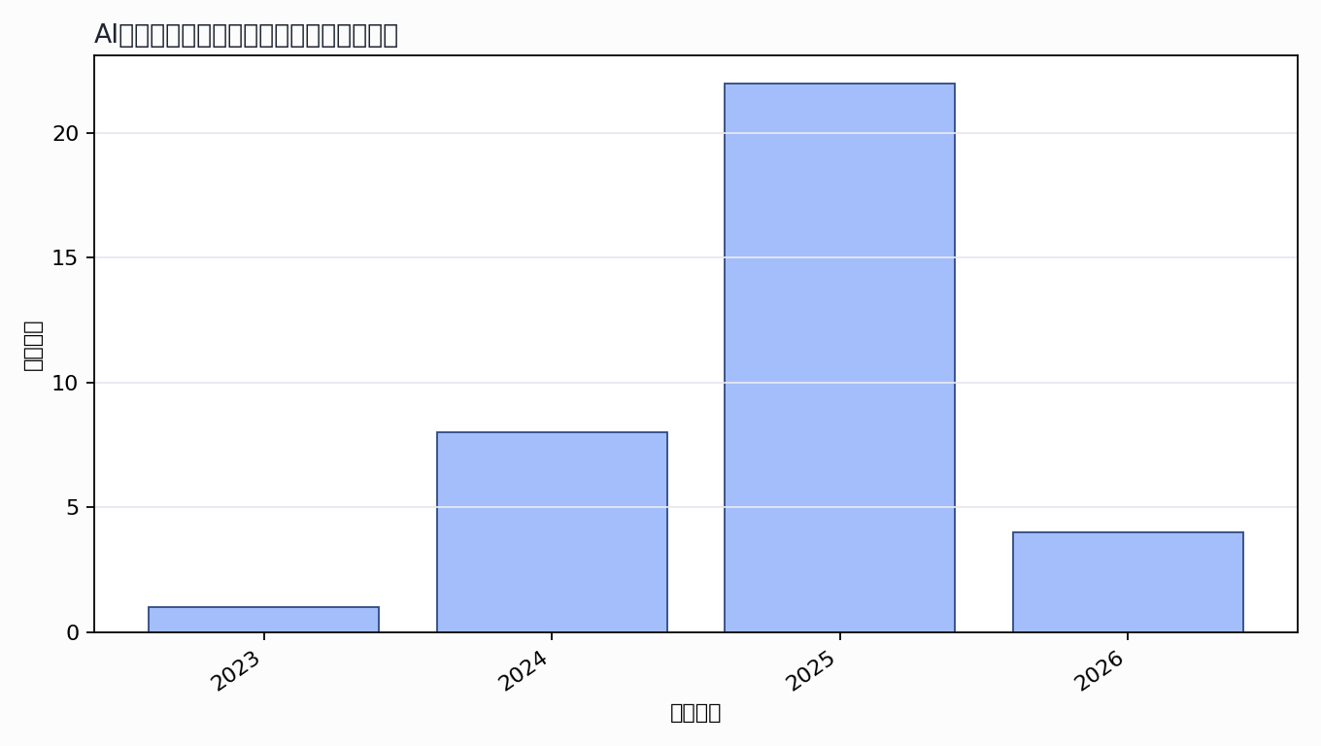

主题覆盖
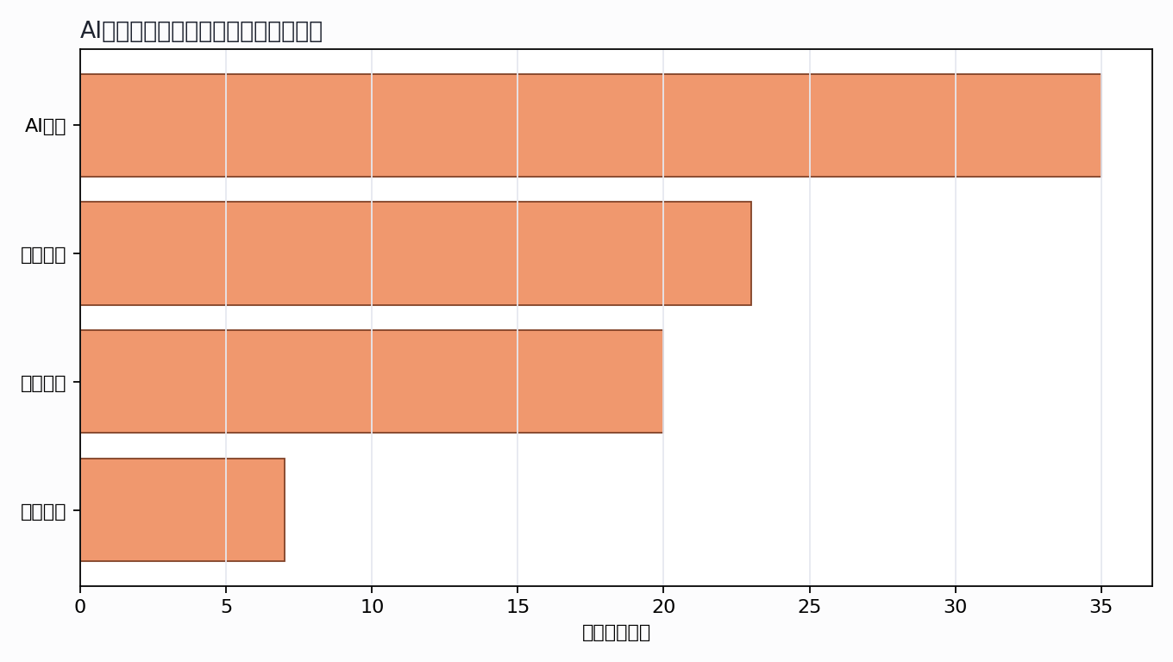

来源结构
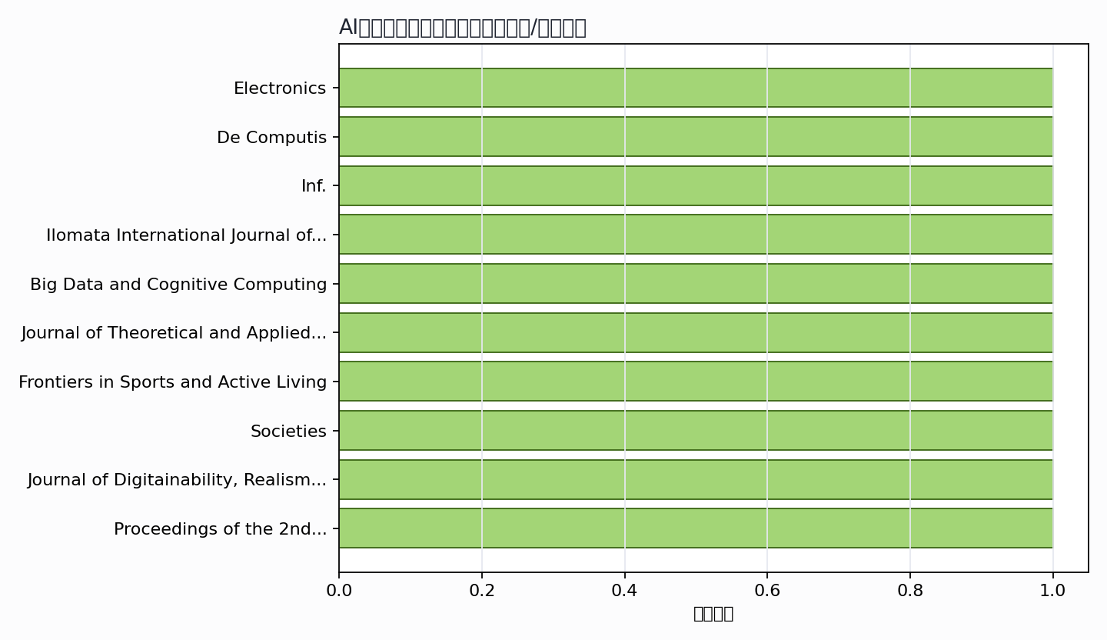

可进入书稿的论证链
- 概念层：使用高被引或综述型文献界定核心概念。
- 机制层：整理为技术能力、场景应用、主体协同、绩效反馈的论证链。
- 方法层：将实证方法转化为课堂练习、章节附录或研究设计示例。
- 边界层：对隐私、真实性、社区参与、算法偏见和数据授权设置专门讨论。

候选参考文献
- Lázaro Florido‐Benítez; Benjamín del Alcázar Martínez (2024). How Artificial Intelligence (AI) Is Powering New Tourism Marketing and the Future Agenda for Smart Tourist Destinations. Electronics. DOI: 10.3390/electronics13214151.
主题映射：AI营销；引用数：67。
- Tasin Islam; A. Miron; M. Nandy; J. Choudrie; Xiaohui Liu; Yongmin Li (2024). Transforming Digital Marketing with Generative AI. De Computis. DOI: 10.3390/computers13070168.
主题映射：AI营销; 内容生产；引用数：54。
- Galina Ilieva; Tania Yankova; Stanislava Klisarova-Belcheva (2024). Effects of Generative AI in Tourism Industry. Inf.. DOI: 10.3390/info15110671.
主题映射：AI营销; 推荐系统；引用数：37。
- Muhammad Umam Mubarok; Maheni Ika Sari; Y. Wibowo; Raisun Mathew (2024). Comparative Study of Artificial Intelligence (AI) Utilization in Digital Marketing Strategies Between Developed and Developing Countries: A Systematic Literature Review. Ilomata International Journal of Management. DOI: 10.61194/ijjm.v6i1.1534.
主题映射：AI营销; 推荐系统; 内容生产；引用数：28。
- Catherine Reed; M. Wynn; R. Bown (2025). Artificial Intelligence in Digital Marketing: Towards an Analytical Framework for Revealing and Mitigating Bias. Big Data and Cognitive Computing. DOI: 10.3390/bdcc9020040.
主题映射：AI营销; 内容生产；引用数：15。
- Katarzyna Żyminkowska; Edyta Zachurzok-Srebrny (2025). The Role of Artificial Intelligence in Customer Engagement and Social Media Marketing - Implications from a Systematic Review for the Tourism and Hospitality Sectors. Journal of Theoretical and Applied Electronic Commerce Research. DOI: 10.3390/jtaer20030184.
主题映射：AI营销; 内容生产；引用数：13。
- Hans Westerbeek (2025). Algorithmic fandom: how generative AI is reshaping sports marketing, fan engagement, and the integrity of sport. Frontiers in Sports and Active Living. DOI: 10.3389/fspor.2025.1597444.
主题映射：AI营销; 推荐系统; 内容生产；引用数：13。
- Babu George; Anupama Peter Mattathil (2025). Empowering African American Tourism Entrepreneurs with Generative AI: Bridging Innovation and Cultural Heritage. Societies. DOI: 10.3390/soc15020034.
主题映射：AI营销; 内容生产；引用数：8。
- Luh Komang Candra Dewi; Ida Bagus Udayana Putra; Suwigyo Widodo; Yudithia Yudithia; Augusto Soares (2025). An Empirical Study on the Artificial Intelligence Practices on the Digital Marketing Effectiveness within Tourism Village in Bali, Indonesia. Journal of Digitainability, Realism &amp; Mastery (DREAM). DOI: 10.56982/dream.v4i01.290.
主题映射：AI营销; 推荐系统; 内容生产; 绩效评价；引用数：7。
- Xiaoying Lin; Weijuan Ruan (2023). Research on the Marketing Transformation of Insurance Industry Under Generative Artificial Intelligence Technology. Proceedings of the 2nd International Conference on Public Management, Digital Economy and Internet Technology, ICPDI 2023, September 1–3, 2023, Chongqing, China. DOI: 10.4108/eai.1-9-2023.2338781.
主题映射：AI营销; 推荐系统; 内容生产；引用数：7。
- R. Reznikov (2024). PRACTICAL RECOMMENDATION OF USING GENERATIVE AI IN BUSINESS. Social Science Research Network. DOI: 10.2139/ssrn.4851637.
主题映射：AI营销; 推荐系统; 内容生产；引用数：6。
- Andrew Smith; James Hutson (2024). From concept to creation: The role of generative artificial intelligence in the new age of digital marketing. Design. DOI: 10.36922/dp.4776.
主题映射：AI营销; 内容生产; 绩效评价；引用数：5。
- Raghib Abid; Palash Saha; Md. Mominul Islam (2025). The Impact of Artificial Intelligence (AI) for Transforming Tourism Marketing on the USA Industry Practices. Journal of Information Systems and Informatics. DOI: 10.51519/journalisi.v7i1.1016.
主题映射：AI营销; 推荐系统；引用数：4。
- Giuseppe Lanfranchi; Alessandra Cioli; Andrea Amanti; L. Marinelli (2025). Reconfiguring competitive advantage: a resource dynamic framework for generative AI adoption in digital content marketing. European Journal of Innovation Management. DOI: 10.1108/ejim-03-2024-0317.
主题映射：AI营销; 推荐系统; 内容生产；引用数：4。
- Y. Dwivedi (2024). Revolutionizing Digital Marketing: The Impact of Generative AI Automation in Transforming Digital Marketing Strategies. INTERANTIONAL JOURNAL OF SCIENTIFIC RESEARCH IN ENGINEERING AND MANAGEMENT. DOI: 10.55041/ijsrem37870.
主题映射：AI营销; 推荐系统; 内容生产；引用数：4。
- Orcun Sarioguz; Evin Miser (2024). Assessing the role of artificial intelligence in enhancing customer personalization: A study of ethical and privacy implications in digital marketing. International Journal of Science and Research Archive. DOI: 10.30574/ijsra.2024.13.2.2207.
主题映射：AI营销; 推荐系统; 内容生产；引用数：4。
- Dr. M. Hema Sundari; Parhana R; Dr. K. Santhanalakshmi; Haridharan K N (2025). Artificial Intelligence in Digital Marketing: A Systematic Review and Strategic Framework for AI-Augmented Marketing. International Research Journal on Advanced Engineering and Management (IRJAEM). DOI: 10.47392/irjaem.2025.0410.
主题映射：AI营销; 推荐系统; 内容生产；引用数：3。
- Z. Bujdosó; Noémi Vida; Balázs Máté; Kornel Nagy; Bernadett Bringye (2025). THE ARTIFICIAL INTELLIGENCE USAGE AND BENEFITS IN TOURISM MARKETING. Geo Journal of Tourism and Geosites. DOI: 10.30892/gtg.602spl12-1488.
主题映射：AI营销; 内容生产; 绩效评价；引用数：2。
- Wiwin Riski Windarsari; Achmad Ridha; Andi Rahmatullah Mangga; Hasisa Haruna (2025). SYSTEMATIC LITERATURE MAPPING AND BIBLIOMETRIC SYNTHESIS: STUDY OF THE IMPACT OF ARTIFICIAL INTELLIGENCE ON MARKETING PERFORMANCE. JURNAL MANEKSI. DOI: 10.31959/jm.v14i2.3000.
主题映射：AI营销; 推荐系统; 绩效评价；引用数：2。
- V. Nianko; Zinaida Andrushkevych (2025). Innovative approaches to digital marketing: using artificial intelligence to achieve sustainable development of enterprises. Economic sustainability and business practices. DOI: 10.21272/esbp.2025.1-05.
主题映射：AI营销; 推荐系统; 内容生产；引用数：2。
- S. Raza; M. Anwar; Jeetesh Kumar; Emenyeonu, C. Ogadimma; Umer Zaman; Amjad Ali Shah (2025). Can Smart Mobile Applications Attract Travellers? Exploring Catenation Between Digital Tourism Entrepreneurs’ Use of Artificial Intelligence Generative Chatbots for Interactive Marketing Communication and Virtual Reality. Journal of creative communications. DOI: 10.1177/09732586251345220.
主题映射：AI营销; 绩效评价；引用数：2。
- Harith Yas; Maha Mustafa; O. Abdalaziz; Wided Dafri; Qusay AL-Falahi; B. Kashmoola; Adel A. S. Salem; Yas (2025). Artificial Intelligence and Digital Marketing: Ethical Challenges of Digital Influence on Public Perception and Consumer Behavior in the Law of the UAE. Research Journal in Advanced Humanities. DOI: 10.58256/5hjmrw16.
主题映射：AI营销; 内容生产；引用数：2。
- Roberto Cervelló-Royo; Carlos Devece; J. Galdón-Salvador; J. Lull (2026). Tourism in the age of generative AI: a systematic bibliometric review of opportunities, challenges and uncertainties. ESIC Market. DOI: 10.7200/esicm.57.427.
主题映射：AI营销；引用数：1。
- Mihaela-Carmen Muntean; A. Căpățînă; Adrian Micu; Angela-Eliza Micu; I. Șorcaru; O. Lupoae (2025). UNLOCKING THE DIGITAL GATEWAY: ARTIFICIAL INTELLIGENCE IMPACT IN TRANSFORMING TOURISM MARKETING. PROCEEDINGS OF THE INTERNATIONAL MANAGEMENT CONFERENCE. DOI: 10.24818/imc/2024/05.02.
主题映射：AI营销；引用数：1。
- Gautam Srivastava; Surajit Bag; P. J. Ramudu; S. Shrivastav; J. Pueschel; Abla Chaouni Benabdellah (2025). Theoretical Perspectives on the Impact of Generative AI on the Tourism Sector. Journal of Global Information Management. DOI: 10.4018/jgim.388177.
主题映射：AI营销；引用数：1。
- Rendro Laksmono; Agung Zulfikri; Yana Priyana (2025). The Use of Artificial Intelligence to Improve Digital Marketing Strategies for MSMEs in Indonesia. RIGGS: Journal of Artificial Intelligence and Digital Business. DOI: 10.31004/riggs.v4i4.3256.
主题映射：AI营销; 推荐系统；引用数：1。
- Ghaling Achmad Abdul Ghonisyah; Ai Kusmiati Asyiah (2025). The Amplification of Generative Artificial Intelligence (AI) in Content Marketing For Women Micro-Entrepreneurs: Qualitative Case Study Approach. Indonesian Journal of Business and Entrepreneurship. DOI: 10.17358/ijbe.11.3.724.
主题映射：AI营销; 内容生产; 绩效评价；引用数：1。
- Nikhil V P (2025). Study On The Impact Of Artificial Intelligence Apps For Branding And Marketing In Digital Marketing. International Journal For Multidisciplinary Research. DOI: 10.36948/ijfmr.2025.v07i03.45286.
主题映射：AI营销; 推荐系统；引用数：1。
- Sahil Khan (2025). Role of Generative AI in Digital Campaigns. INTERNATIONAL JOURNAL OF SCIENTIFIC RESEARCH IN ENGINEERING AND MANAGEMENT. DOI: 10.55041/ijsrem50580.
主题映射：AI营销; 推荐系统; 内容生产；引用数：1。
- Faizan Ali; Usman Khan; Kashif Ali Khan (2025). Generative Artificial Intelligence in Hospitality and Tourism Marketing: Exploring Perceptions, Risks, Benefits from Managerial Standpoint. ICHRIE Research Reports. DOI: 10.61701/873322.272.
主题映射：AI营销; 推荐系统；引用数：1。
- Yuyun Yuniarsih; Nunung Sanusi; Abyan Faliq Athallah; Rafly Ramadhany (2025). ANALYTICAL STUDY OF INSTAGRAM AS AN AI-BASED DIGITAL MARKETING MEDIA COMMUNICATION TOOL IN THE TAJUR KATINEUNG NATURAL TOURISM SECTOR, PURWAKARTA, WEST JAVA. Multidisciplinary Indonesian Center Journal (MICJO). DOI: 10.62567/micjo.v2i3.1173.
主题映射：AI营销; 内容生产；引用数：1。
- Latha Rani Buddha; Dr.T.Venkateswarlu (2025). A STUDY ON MAPPING THREE DECADES OF LITERATURE ON DIGITAL MARKETING USING GENERATIVE AI. Lex Localis-journal of Local Self-government. DOI: 10.52152/4bx54x15.
主题映射：AI营销; 推荐系统; 内容生产；引用数：1。
- Raed Wishah; A. Al-Sukkar; Z. Dannoun; Jumana Al Gaafreh; Shifaa Qaimary; Leila Rawashdeh (2026). impact of generative AI on marketing innovation and business growth challenges and opportunities in the digital economy. Heritage and Sustainable Development. DOI: 10.37868/hsd.v8i1.1714.
主题映射：AI营销; 推荐系统; 内容生产；引用数：0。
- Nadhrathul Ain Ibrahim; Noor Azlina Mohamed Yunus; Khamisah Abd Manaf; Nik Rozila Nik Mohd Masdek; Purnomo M. Antara; Heny Hendrayati; Mohd Zamri Anuar (2026). USING GENERATIVE ARTIFICIAL INTELLIGENCE (GEN AI) FOR TIKTOK CONTENT MARKETING AMONG ONLINE SELLERS: A TECHNOLOGY ACCEPTANCE MODEL PERSPECTIVE. Advanced International Journal of Business Entrepreneurship and SMEs. DOI: 10.35631/aijbes.827004.
主题映射：AI营销; 内容生产；引用数：0。
- Mehmet Yorulmaz (2026). The strategic impact of artificial intelligence on medical tourism marketing. TURKISH JOURNAL OF MARKETING. DOI: 10.30685/tujom.v10i3.220.
主题映射：AI营销; 推荐系统; 绩效评价；引用数：0。
Markdown 源文件：20260705_专著12——AI时代的文旅产品营销_文献补充与数据分析报告.md

