专著10——屯堡文化数字化传承与旅游活化 文献补充与数据分析报告

Executive Summary
已形成 35 条候选参考文献，满足每个专著子文件夹不少于 20 条的补充要求。
本证据包为《屯堡文化数字化传承与旅游活化》补充了 35 条候选参考文献，其中 34 条发表于 2021 年及以后，说明该书题与近年数字技术、旅游管理和文化传播研究保持连接。主题上，当前文献主要集中在文化传承、旅游活化、社区主体，可以支撑书稿从概念解释转向“技术—场景—主体—绩效”的论证链。方法上，样本文献呈现问卷/结构方程、实验/情景实验、文本挖掘/评论分析、案例/质性研究、预测/机器学习、综述/框架研究等路径，适合在书中分别转化为理论综述、案例框、方法训练和图表化教学材料。需要注意的是，Semantic Scholar 返回的题录不能替代全文精读；涉及地方数据、政策口径和企业案例成效的判断仍应回到原文、官方材料或授权数据核验。
证据边界：本报告基于 Semantic Scholar 题录、摘要和本地数字文旅文献语料生成；正式出版前需逐篇核验 DOI、页码、卷期和全文观点。

关键图表

年份分布
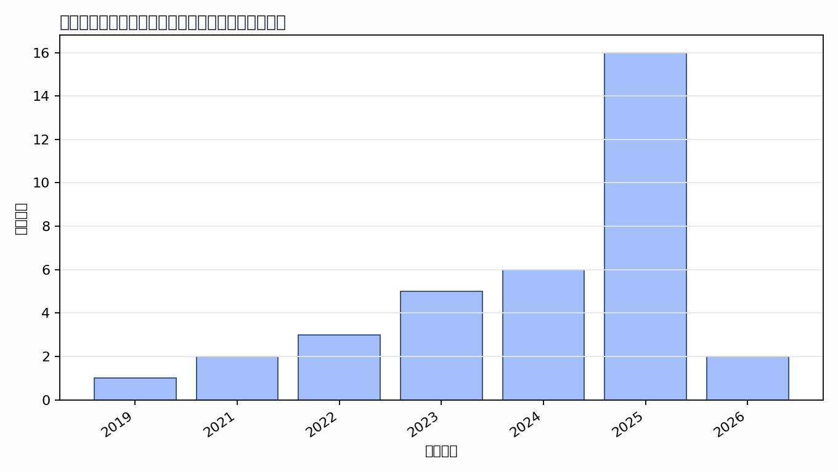

主题覆盖
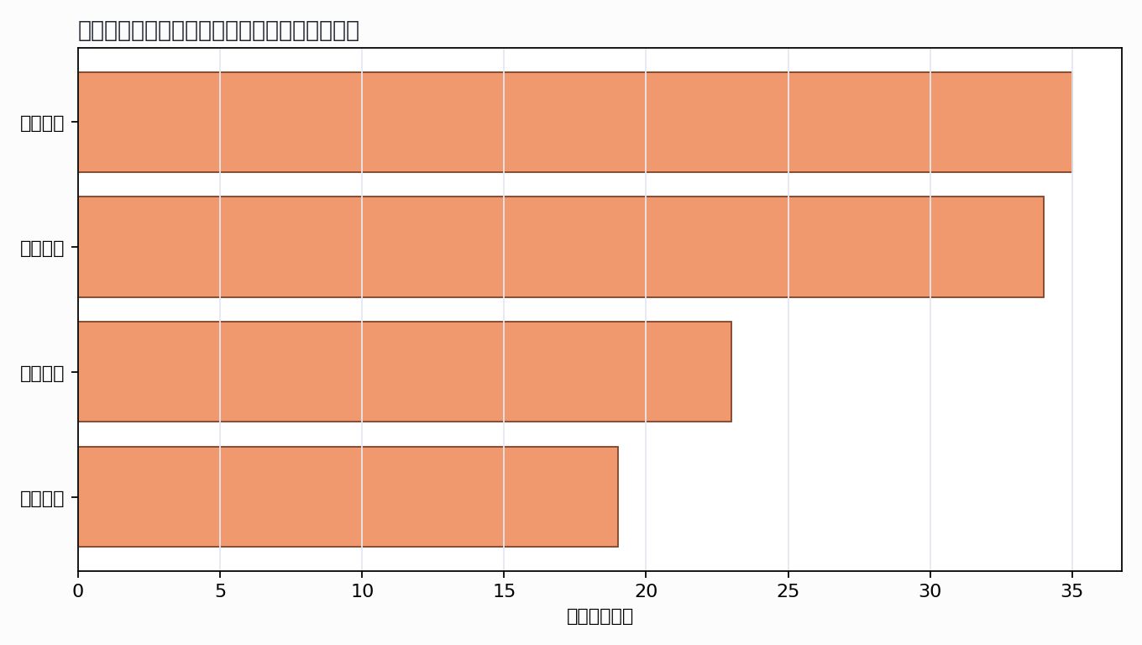

来源结构
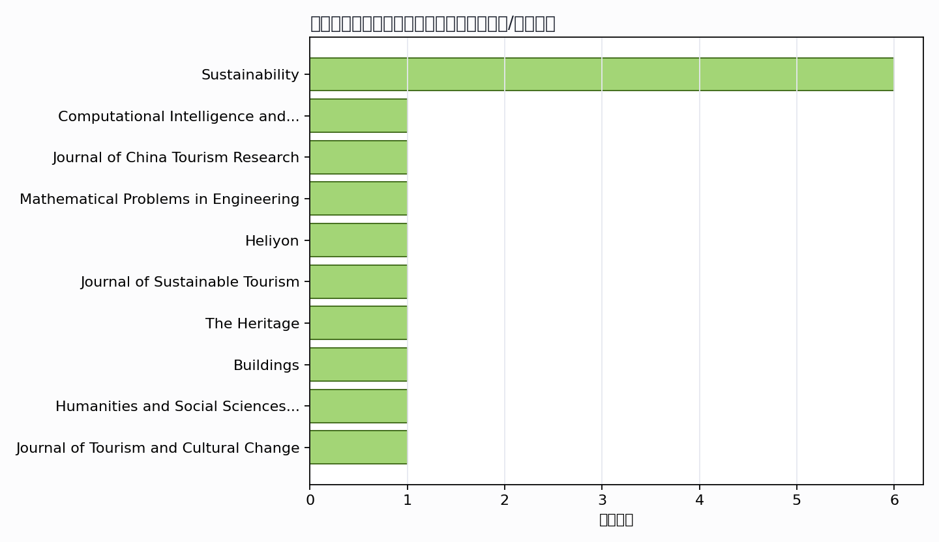

可进入书稿的论证链
- 概念层：使用高被引或综述型文献界定核心概念。
- 机制层：整理为技术能力、场景应用、主体协同、绩效反馈的论证链。
- 方法层：将实证方法转化为课堂练习、章节附录或研究设计示例。
- 边界层：对隐私、真实性、社区参与、算法偏见和数据授权设置专门讨论。

候选参考文献
- Qihang Qiu; Tianxiang Zheng; Zheng Xiang; Mu Zhang (2019). Visiting Intangible Cultural Heritage Tourism Sites: From Value Cognition to Attitude and Intention. Sustainability. DOI: 10.3390/su12010132.
主题映射：文化传承; 旅游活化; 社区主体; 数字传播；引用数：96。
- Yuqian Wei; Hengyu Liu; Keun-Soo Park (2021). Examining the Structural Relationships among Heritage Proximity, Perceived Impacts, Attitude and Residents’ Support in Intangible Cultural Heritage Tourism. Sustainability. DOI: 10.3390/su13158358.
主题映射：文化传承; 旅游活化; 社区主体；引用数：46。
- Z. Cai; Keke Cai; Tao Huang; Ge Zhang; Ruixi Chen (2024). Spatial Distribution Characteristics and Sustainable Inheritance Strategies of National Traditional Fine Arts Intangible Cultural Heritage in China. Sustainability. DOI: 10.3390/su16114488.
主题映射：文化传承; 旅游活化; 数字传播；引用数：29。
- Lingling Xiao (2022). Intangible Cultural Heritage Reproduction and Revitalization: Value Feedback, Practice, and Exploration Based on the IPA Model. Computational Intelligence and Neuroscience. DOI: 10.1155/2022/8411999.
主题映射：文化传承; 旅游活化; 数字传播；引用数：29。
- Wenbin Luo; Yulian Lu; D. Timothy; Xiaolin Zang (2022). Tourism and conserving intangible cultural heritage: Residents’ perspectives on protecting the nüshu female script. Journal of China Tourism Research. DOI: 10.1080/19388160.2022.2036663.
主题映射：文化传承; 旅游活化; 社区主体；引用数：25。
- Huan-Qing Zhao; Xi Zhao; E. Elahi; Fushuai Wang (2022). Policy Evaluation of Drama-Related Intangible Cultural Heritage Tourism for Boosting Green Industry: An Empirical Analysis Based on Quasi-Natural Experiment. Sustainability. DOI: 10.3390/su14095380.
主题映射：文化传承; 旅游活化；引用数：24。
- Xi Deng; Il-tae Kim; Chong Shen (2021). Research on Convolutional Neural Network-Based Virtual Reality Platform Framework for the Intangible Cultural Heritage Conservation of China Hainan Li Nationality: Boat-Shaped House as an Example. Mathematical Problems in Engineering. DOI: 10.1155/2021/5538434.
主题映射：文化传承; 旅游活化; 数字传播；引用数：24。
- Xi Zhao; Ehsan Elahi; Fushuai Wang; Huibin Xing; Zainab Khalid (2024). Sustainable tourism development for traditional Chinese drama's intangible cultural heritage. Heliyon. DOI: 10.1016/j.heliyon.2024.e25483.
主题映射：文化传承; 旅游活化；引用数：22。
- Yang Zhang; Qingyan Zheng; Li Huang; Timothy J. Lee; S. Hyun (2023). Alienation and authenticity in intangible cultural heritage tourism. Journal of Sustainable Tourism. DOI: 10.1080/09669582.2023.2284642.
主题映射：文化传承; 旅游活化; 社区主体；引用数：20。
- J. Sánchez-Martín; Rebeca Guillén-Peñafiel; A. Hernández-Carretero (2025). Artificial Intelligence in Heritage Tourism: Innovation, Accessibility, and Sustainability in the Digital Age. The Heritage. DOI: 10.3390/heritage8100428.
主题映射：文化传承; 旅游活化; 社区主体; 数字传播；引用数：17。
- Zhiwei Zhou; Zhen Liu; Genqiao Wang (2024). Driving Sustainable Cultural Heritage Tourism in China through Heritage Building Information Modeling. Buildings. DOI: 10.3390/buildings14103120.
主题映射：文化传承; 旅游活化; 社区主体; 数字传播；引用数：15。
- Kexin Ren; J. F. I. Lam (2026). Knowledge graph-driven digital preservation of intangible cultural heritage: a cross-cultural comparative study of Chinese and Western implementation paradigms. Humanities and Social Sciences Communications. DOI: 10.1057/s41599-025-06186-9.
主题映射：文化传承; 旅游活化; 社区主体; 数字传播；引用数：10。
- Fatema Shubbar; Djamel Boussaa; Muhammed Madandola (2025). Cultural heritage tourism as a catalyst of urban regeneration: the case of the historic city of Manama, Bahrain. Journal of Tourism and Cultural Change. DOI: 10.1080/14766825.2025.2565594.
主题映射：文化传承; 旅游活化; 社区主体；引用数：7。
- Zhang Lei; Jialin Wan (2024). The Impact of Cultural and Creative Products Arising from Intangible Cultural Heritage on Economic Development: A Case Study of Ebian County, China. Journal of Resources and Ecology. DOI: 10.5814/j.issn.1674-764x.2024.04.028.
主题映射：文化传承; 旅游活化；引用数：7。
- Huilan Wei; Rui Zhu; Jinyi Wu (2025). Promoting the Sustainable Development of Industrial Heritage Tourism Through Digital Intelligence: User Acceptance and Interface Design Research. Sustainability. DOI: 10.3390/su17188432.
主题映射：文化传承; 旅游活化; 数字传播；引用数：4。
- Z. Chen; Shimin Fu (2023). Research on the Evaluation of the Effect of Tourism Revitalization of Intangible Cultural Heritage in China in the Context of New Media. Applied Mathematics and Nonlinear Sciences. DOI: 10.2478/amns.2023.2.00518.
主题映射：文化传承; 旅游活化; 数字传播；引用数：4。
- Hua Long; Zhifeng Wang; Long Meng; Xiaoxia Ma; Huiping Pei (2025). Revitalization Mechanisms of the Ancient Tea Forest Cultural Landscape of Jingmai Mountain: Perspectives on Intangible Cultural Heritage Protection and Sustainable Development. Journal of Lifestyle and SDGs Review. DOI: 10.47172/2965-730x.sdgsreview.v5.n05.pe05721.
主题映射：文化传承; 旅游活化; 社区主体; 数字传播；引用数：3。
- Zhan Xu; Feng Liu; Guobin Xia; Shuo Wang; Yiting Duan; Luwen Yu; Shichao Zhao; Muzi Li (2025). Immersive HCI for Intangible Cultural Heritage in Tourism Contexts: A Narrative Review of Design and Evaluation. Sustainability. DOI: 10.3390/su18010153.
主题映射：文化传承; 旅游活化; 社区主体; 数字传播；引用数：3。
- D. M. Soeswoyo; M. H. Dewantara; Dyah Purwanti; D. Pramesti; Maidar Simanihuruk; Nila Rifai (2025). CIMANDE'S CULTURAL LEGACY: EXPERT INSIGHTS ON ENHANCING SUSTAINABLE TOURISM THROUGH INTANGIBLE HERITAGE. Geo Journal of Tourism and Geosites. DOI: 10.30892/gtg.58134-1419.
主题映射：文化传承; 旅游活化; 社区主体；引用数：3。
- Ousanee Sawagvudcharee (2024). Engaing Brand Awareness for Sustainable Innovations in Cultural Tourism Towards Intangible Cultural Heritage (ICH): The Case Studies of China, Myanmar, Thailand, and Australia. Revista de Gestão Social e Ambiental. DOI: 10.24857/rgsa.v18n12-199.
主题映射：文化传承; 旅游活化; 社区主体；引用数：3。
- Mengshan Li (2023). The Value Review and Implementation Path of the Intangible Cultural Heritage Ningbo Opera Empowering Rural Revitalization. Journal of Sociology and Ethnology. DOI: 10.23977/jsoce.2023.050914.
主题映射：文化传承; 旅游活化；引用数：3。
- Yue Li; Tiantian Li; Yue Bai; N. Ismail; Jinjin Chen; Taoyu Wei; Hashem Salarzadeh Jenatabadi (2025). Interpreting visitor experiences with digital cultural heritage exhibitions in Yimeng China through thematic analysis. Scientific Reports. DOI: 10.1038/s41598-025-29323-5.
主题映射：文化传承; 旅游活化; 社区主体; 数字传播；引用数：2。
- Ramadhan19; Muhammad Zikri Muhammad Zikri (2025). Creative Tourism as the Key to Community Empowerment: Revitalizing Local Narratives through Cultural Performances at Prambanan Temple. Journal of Tourism and Creativity. DOI: 10.19184/jtc.v9i1.53692.
主题映射：文化传承; 旅游活化; 社区主体；引用数：2。
- Seunghoon Lee; B. King (2025). A Virtual Lens on Tradition: Safeguarding Intangible Cultural Heritage Through AR and VR. Unknown venue. DOI: 10.1177/27652157251344834.
主题映射：文化传承；引用数：2。
- Xueyun Wu; Haksoon Yim (2024). Research on the protection of intangible cultural heritage and sustainable development of city brands—Taking Jingdezhen as an example. Journal of Infrastructure Policy and Development. DOI: 10.24294/jipd.v8i12.9295.
主题映射：文化传承; 旅游活化; 社区主体；引用数：2。
- Xiaoxiao Fu (2023). Intangible cultural heritage and tourism in China: a critical approach. Journal of Heritage Tourism. DOI: 10.1080/1743873X.2023.2278943.
主题映射：文化传承; 旅游活化; 社区主体；引用数：2。
- Su Keqin; Sun Yu (2026). Research On China’s Intangible Cultural Heritage: Current Status, Hot Topics, Challenges and Future Prospects. International Journal of Arts, Humanities &amp; Social Science. DOI: 10.56734/ijahss.v7n4a6.
主题映射：文化传承; 旅游活化; 数字传播；引用数：1。
- L. Law; Huiwei Chen; Shuwen Liu; Ming Cheung (2025). Top-down rural heritage revitalization and economic development: A case study of Tangwei village, Dongguan, Guangdong, China. Journal of Chinese Architecture and Urbanism. DOI: 10.36922/jcau.5029.
主题映射：文化传承; 旅游活化; 社区主体；引用数：1。
- Jiao He; D. B. Mohamad (2025). The impact of residents empowerment on the protection of intangible cultural heritage based on social exchange theory. Environment and Social Psychology. DOI: 10.59429/esp.v10i1.3343.
主题映射：文化传承; 旅游活化; 社区主体; 数字传播；引用数：1。
- Sonesay Haekham (2025). The Sustainable Conservation of the E-Pok Puppet: An Intangible Cultural Heritage of Luang Prabang. Souphanouvong University Journal Multidisciplinary Research and Development. DOI: 10.69692/sujmrd110389.
主题映射：文化传承; 旅游活化; 社区主体; 数字传播；引用数：1。
- Huang Li (2025). The Intangible Cultural Heritage Revitalization and Rural Revitalization Practice of Market Folk Art – A Field Study Based on the Huji Book Fair. Critical Humanistic Social Theory. DOI: 10.62177/chst.v2i2.338.
主题映射：文化传承; 旅游活化; 社区主体；引用数：1。
- Siti Gomo; Sarmadan; Gres Grasia Azmin; Ardia Septi Wijayanti; B. P. Adhi; Saiful. (2025). DIGITAL REVITALIZATION OF SILAT MANDAR: A COMMUNITY-ORIENTED EDUCATIONAL APPROACH FOR SAFEGUARDING INTANGIBLE HERITAGE IN TIDUNG ISLAND. Lex Localis-journal of Local Self-government. DOI: 10.52152/801600.
主题映射：文化传承; 旅游活化; 社区主体; 数字传播；引用数：1。
- Yuhua Yuan; Mohd Johari Mohd Yusof; Azmiah Abd Ghafar; Chan Fatt Cheah (2025). Challenges in Safeguarding Cultural Heritage: A Case Study of Chinese Traditional Villages in Huangpu District, Guangzhou, China. International Journal of Academic Research in Business and Social Sciences. DOI: 10.6007/ijarbss/v15-i2/24806.
主题映射：文化传承; 旅游活化; 社区主体; 数字传播；引用数：1。
- Yanzheng Tuo; Zhibin Lin; Jingke Zhao; Ye Chen (2025). Bringing Fairy Tales to Life: The Enchanting Power of Virtual Influencers in Cultural Heritage Promotion. 2025 International Conference on Culture-Oriented Science & Technology (CoST). DOI: 10.1109/CoST68045.2025.00076.
主题映射：文化传承; 旅游活化; 社区主体; 数字传播；引用数：1。
- Mingyan Xiao; Yue Chen; Hua Huang (2023). The Impact of Interactive AR Technology on the Communication of Intangible Cultural Heritage - Case Study of Chaozhou Opera in China. Human Factors in Virtual Environments and Game Design. DOI: 10.54941/ahfe1003876.
主题映射：文化传承; 旅游活化; 数字传播；引用数：1。
Markdown 源文件：20260705_专著10——屯堡文化数字化传承与旅游活化_文献补充与数据分析报告.md

