专著9——安顺美食旅游与品牌数字化传播 文献补充与数据分析报告

Executive Summary
已形成 29 条候选参考文献，满足每个专著子文件夹不少于 20 条的补充要求。
本证据包为《安顺美食旅游与品牌数字化传播》补充了 29 条候选参考文献，其中 19 条发表于 2021 年及以后，说明该书题与近年数字技术、旅游管理和文化传播研究保持连接。主题上，当前文献主要集中在社交媒体、目的地形象、游客行为，可以支撑书稿从概念解释转向“技术—场景—主体—绩效”的论证链。方法上，样本文献呈现问卷/结构方程、实验/情景实验、文本挖掘/评论分析、案例/质性研究、预测/机器学习、综述/框架研究等路径，适合在书中分别转化为理论综述、案例框、方法训练和图表化教学材料。需要注意的是，Semantic Scholar 返回的题录不能替代全文精读；涉及地方数据、政策口径和企业案例成效的判断仍应回到原文、官方材料或授权数据核验。
证据边界：本报告基于 Semantic Scholar 题录、摘要和本地数字文旅文献语料生成；正式出版前需逐篇核验 DOI、页码、卷期和全文观点。

关键图表

年份分布
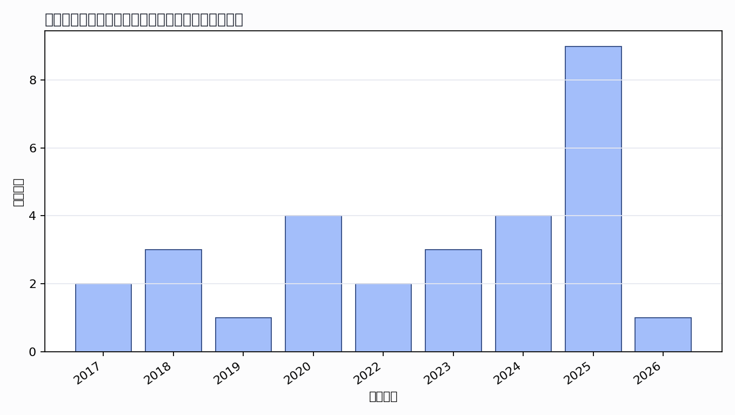

主题覆盖
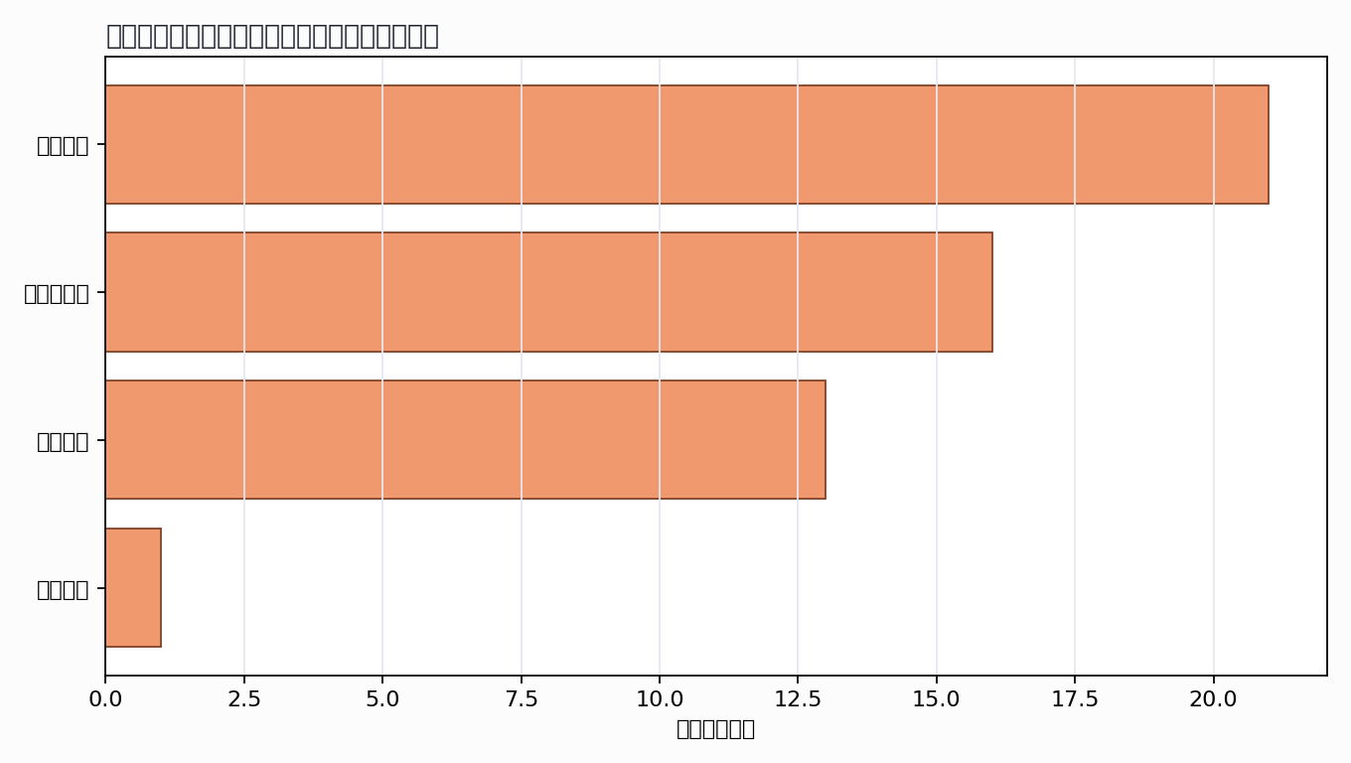

来源结构
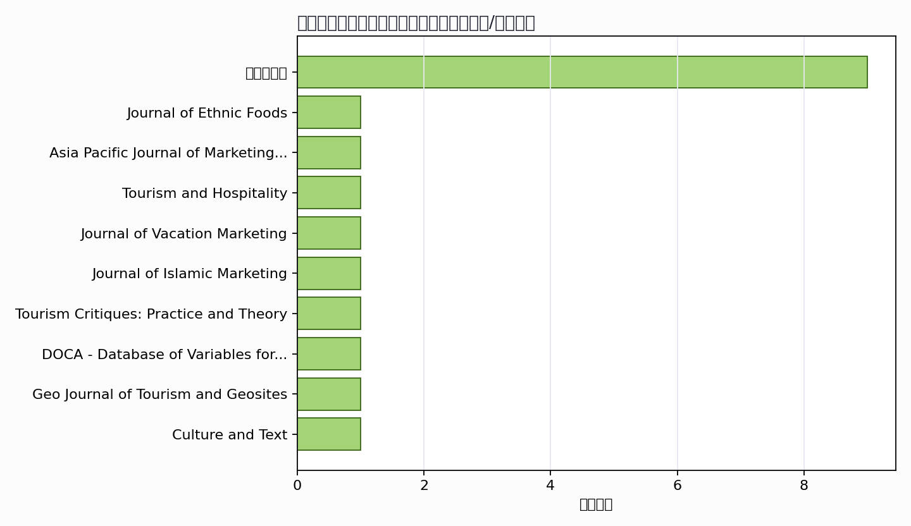

可进入书稿的论证链
- 概念层：使用高被引或综述型文献界定核心概念。
- 机制层：整理为技术能力、场景应用、主体协同、绩效反馈的论证链。
- 方法层：将实证方法转化为课堂练习、章节附录或研究设计示例。
- 边界层：对隐私、真实性、社区参与、算法偏见和数据授权设置专门讨论。

候选参考文献
- Fajar Kusnadi Kusumah Putra; Mandradhitya Kusuma Putra; Selvi Novianti (2023). Taste of asean: traditional food images from Southeast Asian countries. Journal of Ethnic Foods. DOI: 10.1186/s42779-023-00189-0.
主题映射：社交媒体；引用数：45。
- Alberto Amore; Hiran Roy (2020). Blending foodscapes and urban touristscapes: international tourism and city marketing in Indian cities. Unknown venue. DOI: 10.1108/ijtc-09-2019-0162.
主题映射：社交媒体; 目的地形象; 游客行为；引用数：26。
- D. Vrontis; G. Basile; M. Tani; A. Thrassou (2020). Culinary attributes and technological utilization as drivers of place authenticity and branding: the case of Vascitour, Naples. Unknown venue. DOI: 10.1108/JPMD-03-2020-0024.
主题映射：社交媒体; 目的地形象; 游客行为；引用数：19。
- Yung-Chuan Huang (2023). The roles of social media and mutual relationships between travel attitudes and brand equity. Asia Pacific Journal of Marketing and Logistics. DOI: 10.1108/apjml-02-2023-0108.
主题映射：社交媒体; 目的地形象; 游客行为；引用数：15。
- Ramon Hurdawaty; Wirawan Dony Dahana; Yuary Farradia (2025). Understanding Revisit Intention in Local Culinary Tourism: The Mediating Role of Memorable Culinary Tourism Experience and Destination Image. Tourism and Hospitality. DOI: 10.3390/tourhosp6040184.
主题映射：社交媒体; 目的地形象; 游客行为；引用数：13。
- Yasmin Babalou; Amirhossein Maleki; H. Gibson (2025). Social media influencers as catalysts for transforming risk perception, crafting destination image, and elevating culinary tourism in Iran. Journal of Vacation Marketing. DOI: 10.1177/13567667241306428.
主题映射：社交媒体; 目的地形象；引用数：10。
- Mohammad Muhlis Anwar (2025). Connecting halal culinary content and tourist intentions: a framework of image, trust and behavioral drivers. Journal of Islamic Marketing. DOI: 10.1108/jima-01-2025-0071.
主题映射：社交媒体; 游客行为；引用数：6。
- Kun SangKun; Pei Ying Woon; Poh Ling Tan (2024). Destination image branding for world heritage sites: a methodology combining GIS with sentiment analysis. Tourism Critiques: Practice and Theory. DOI: 10.1108/trc-04-2024-0012.
主题映射：社交媒体; 目的地形象；引用数：5。
- S. Kim; S. Pan (2018). Preface to Journal of Travel and Tourism Marketing Special Issue on visual media and tourism. Unknown venue. DOI: 10.1080/10548408.2018.1422423.
主题映射：待人工判读；引用数：5。
- P. Arifianto; Nofrizaldi Nofrizaldi (2020). Komunikasi Visual Kuliner Banyumas sebagai Media Pendukung City Branding “Better Banyumas”. Unknown venue. DOI: 10.33633/andharupa.v6i1.2733.
主题映射：社交媒体; 目的地形象；引用数：3。
- Jérôme Chariatte; Diana Ingenhoff (2025). Country reputation. DOCA - Database of Variables for Content Analysis. DOI: 10.34778/4k.
主题映射：目的地形象；引用数：2。
- Shiva Hashemi; Mengyi Miao; M. Ahmed; M. Zahari; Sima Ahmadpour (2025). SELECTIVE EATING AND ITS IMPACT ON CULINARY DESTINATION IMAGE: THE MALAYSIAN EXPERIENCE. Geo Journal of Tourism and Geosites. DOI: 10.30892/gtg.62418-1584.
主题映射：社交媒体; 目的地形象; 游客行为；引用数：1。
- Lanlan Kuang (2024). Creating a Sustainable Narrative: The Interplay of Ecological Agriculture, Cultural Heritage, and Community Efficacy in Contemporary China. Culture and Text. DOI: 10.1515/cat-2024-0002.
主题映射：饮食遗产; 社交媒体；引用数：1。
- Unknown author (2020). Edinburgh Research Explorer Food consumption experiences. Unknown venue. URL: https://www.semanticscholar.org/paper/e9846e12edd1d2140a1023ef43757b2d6ce08aab.
主题映射：游客行为；引用数：1。
- Komang Ratih Tunjungsari; Dika Pranadipa Koeswiryono (2018). Local Cuisine and Tourists Experience in Bali Through Social Media Practices. Journal of Business on Hospitality and Tourism. DOI: 10.22334/JBHOST.V4I1.104.
主题映射：社交媒体; 目的地形象; 游客行为；引用数：1。
- Bambang Noorsetya; Umi Chayatin; Budi Siswanto; Saudah; S. Widayati (2017). Colorful Urban Village as the New Tourism Destination in Malang: The Positive Outcome of Slum Revitalization. Unknown venue. URL: https://www.semanticscholar.org/paper/8657ae463fcf93f8221b56757bdaf46de162f328.
主题映射：待人工判读；引用数：1。
- Ziyong He (2026). Niche tourism experiences: Exploring county-level tourism consumption in China. Journal of Tourism Management Research. DOI: 10.18488/31.v13i1.4798.
主题映射：社交媒体; 目的地形象; 游客行为；引用数：0。
- Muhammad Manshoor Hussain Abbasi; Syed Shams ul Hassan; Saniya Moazzam (2025). Pakistani Content Projection on Chinese Media: Its Role in Promoting Tourism. Journal of Political Stability Archive. DOI: 10.63468/jpsa.3.3.31.
主题映射：社交媒体；引用数：0。
- Safina Annajah N Samsudin (2025). PROMOTING CULINARY TOURISM : A STUDY IN PANTAI LOSARI. Proceedings International Conference on Marine Tourism and Hospitality Studies. DOI: 10.33649/iconmths.v2i1.841.
主题映射：社交媒体; 游客行为；引用数：0。
- Rahmat Kusnedi; M. Wildan; M. Irfan; Dikki Z Choesrani (2025). Integrasi Platform Digital dalam Pengembangan Kuliner Lokal untuk Mendukung Gastronomy Tourism Berkelanjutan. Garina. DOI: 10.69697/garina.v17i2.377.
主题映射：社交媒体; 游客行为；引用数：0。
- U. Ehsan; Muhammad Shehzad Hanif (2025). Assessing Perceived Value of Patients: A Qualitative Study of Orthopaedic Patients. Inverge Journal of Social Sciences. DOI: 10.63544/ijss.v4i4.187.
主题映射：社交媒体; 目的地形象; 游客行为；引用数：0。
- Wen Wang; Rongrong Gao; Shiting Tang (2024). The Evolution of the Perceived Destination Image Based on Network Text Analysis. Proceedings of the 2024 International Conference on Smart City and Information System. DOI: 10.1145/3685088.3685188.
主题映射：社交媒体; 目的地形象；引用数：0。
- Songyu Jiang; Jiangyun Chen; Han Wang; Nutteera Phakdeephirot (2024). Bibliometrics approach to portray the research agenda of film and television tourism. Smart Tourism. DOI: 10.54517/st2776.
主题映射：社交媒体; 目的地形象；引用数：0。
- M. T. Imran Yasin; Muhamad Muhamad (2023). Durian Culinary Products Based on Local Food as a Culinary Tourism Attraction in Medan City. Jurnal Toursci. DOI: 10.62885/toursci.v1i2.74.
主题映射：社交媒体；引用数：0。
- Putri Anindhita Faradila; Fitriya Fitriya; Abdul Basyith (2022). Revitalisasi Kuliner Bingen Palembang Sebagai Sarana Pelestarian Kuliner Tradisional Palembang Dan Peningkatan Kualitas Ekonomi Masyarakat Seberang Ulu II Kota Palembang. Jurnal Nasional Pengabdian Masyarakat. DOI: 10.47747/jnpm.v3i1.934.
主题映射：待人工判读；引用数：0。
- Farida Hariyati; Abdul Khohar; M. Azidan (2022). Pemanfaatan Media Sosial pada Pengembangan UMKM Desa Wisata Kepuh, Kabupaten Cirebon. Jurnal Media Pengabdian Komunikasi. DOI: 10.52434/medikom.v2i2.33.
主题映射：社交媒体; 目的地形象；引用数：0。
- R. Bhardwaj (2019). Dham: The traditional feast of Himachali cuisine to promote sustainable tourism. Unknown venue. URL: https://www.semanticscholar.org/paper/93cefa4d612d1f8bbfd403af5639f9c3e4e3e052.
主题映射：待人工判读；引用数：0。
- Lapo Tandazo; José Abel (2018). “DISEÑO DE LA GUÍA GASTRONÓMICA ANCESTRAL, MEDIANTE LA APLICACIÓN DE LA METODOLOGÍA DEL INVENTARIO REALIZADA POR EL MINISTERIO DE CULTURA, PARA RESCATAR TRADICIONES GASTRONÓMICAS EN LA COMUNIDAD COFAN DURENO DEL CANTÓN LAGO AGRIO, PROVINCIA DE SUCUMBÍOS. Unknown venue. URL: https://www.semanticscholar.org/paper/4d095b6eea8abb5c3dca825377b5c97f82e85426.
主题映射：待人工判读；引用数：0。
- Tuan Mastiniwati Tuan Mansor; Shafura Shariff; A. Putra (2017). Destination Image on Theory of Reason Action on Intention to Visit World Monument Funded Site (Kampung Cina River Front, Kuala Terengganu). Unknown venue. URL: https://www.semanticscholar.org/paper/733678793bb1720ca97b5ef07b426f49c765dde1.
主题映射：目的地形象; 游客行为；引用数：0。
Markdown 源文件：20260705_专著9——安顺美食旅游与品牌数字化传播_文献补充与数据分析报告.md

