专著8——安顺美食旅游与品牌数字化传播 文献补充与数据分析报告

Executive Summary
已形成 34 条候选参考文献，满足每个专著子文件夹不少于 20 条的补充要求。
本证据包为《安顺美食旅游与品牌数字化传播》补充了 34 条候选参考文献，其中 27 条发表于 2021 年及以后，说明该书题与近年数字技术、旅游管理和文化传播研究保持连接。主题上，当前文献主要集中在美食旅游、地方认同、目的地品牌，可以支撑书稿从概念解释转向“技术—场景—主体—绩效”的论证链。方法上，样本文献呈现问卷/结构方程、实验/情景实验、案例/质性研究、预测/机器学习、综述/框架研究等路径，适合在书中分别转化为理论综述、案例框、方法训练和图表化教学材料。需要注意的是，Semantic Scholar 返回的题录不能替代全文精读；涉及地方数据、政策口径和企业案例成效的判断仍应回到原文、官方材料或授权数据核验。
证据边界：本报告基于 Semantic Scholar 题录、摘要和本地数字文旅文献语料生成；正式出版前需逐篇核验 DOI、页码、卷期和全文观点。

关键图表

年份分布
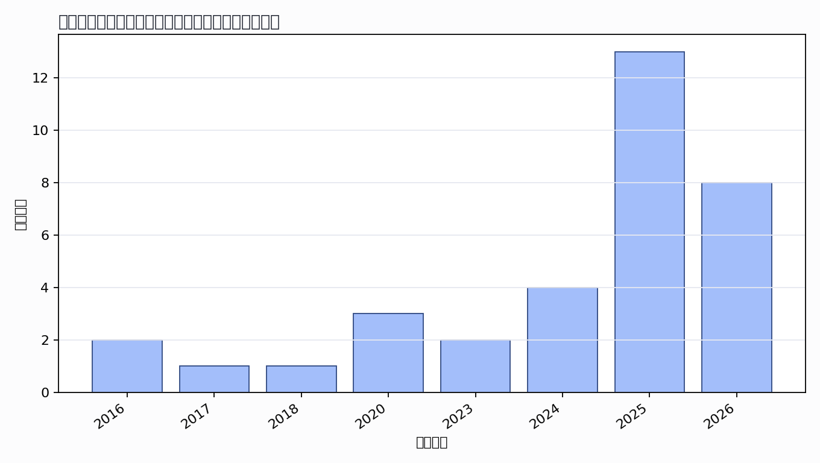

主题覆盖
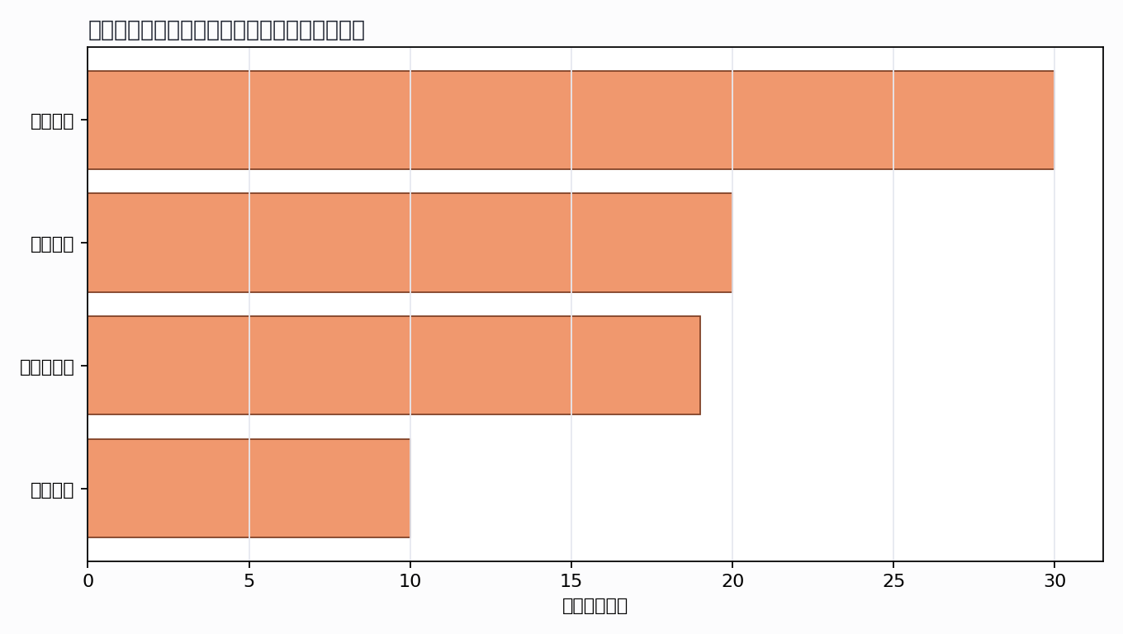

来源结构
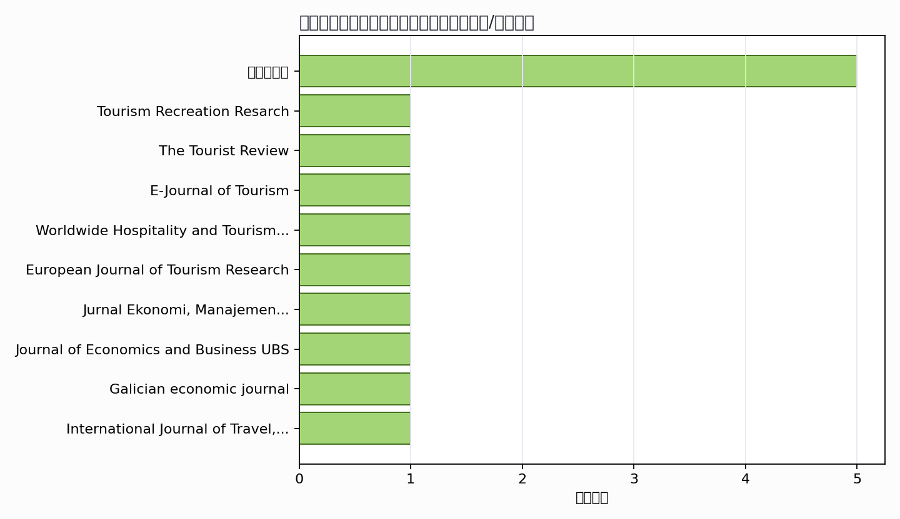

可进入书稿的论证链
- 概念层：使用高被引或综述型文献界定核心概念。
- 机制层：整理为技术能力、场景应用、主体协同、绩效反馈的论证链。
- 方法层：将实证方法转化为课堂练习、章节附录或研究设计示例。
- 边界层：对隐私、真实性、社区参与、算法偏见和数据授权设置专门讨论。

候选参考文献
- Peter Björk; Hannele Kauppinen-Räisänen (2016). Exploring the multi-dimensionality of travellers' culinary-gastronomic experiences. Unknown venue. DOI: 10.1080/13683500.2013.868412.
主题映射：美食旅游；引用数：213。
- Xilei Chen; Zhaoyu Chen (2023). Impact of video content on gastronomic image construction and tourists’ intention to (re-) visit Macao. Tourism Recreation Resarch. DOI: 10.1080/02508281.2023.2296812.
主题映射：目的地品牌; 数字营销; 地方认同；引用数：16。
- G. Kumar R (2023). Food tourism research in India – current trends and future scope. The Tourist Review. DOI: 10.1108/tr-07-2022-0366.
主题映射：美食旅游; 目的地品牌；引用数：11。
- Xue Fa Tong; David Yoon Kin Tong; Waikeung Tam (2016). Food Tourism: The Melaka Gastronomic Experience. Unknown venue. URL: https://www.semanticscholar.org/paper/dae2cfecf7cc127d1c473f23be5160e3fd00a10e.
主题映射：美食旅游；引用数：11。
- A. Kontis; A. Gkoumas (2017). “Greek Breakfast”: A New Tourism Brand Name for an Age-Long Gastronomy Tradition. Unknown venue. DOI: 10.1007/978-3-319-56288-9_32.
主题映射：美食旅游；引用数：9。
- Marceilla Suryana; Eko Susanto; Dinarsiah Chendraningrum (2025). Beyond Consumption: Exploring Sensory, Symbolic, and Digital Influences in Gastronomic Tourist Behaviour (Evidence from Indonesia). E-Journal of Tourism. DOI: 10.24922/eot.v12i2.2176.
主题映射：美食旅游; 目的地品牌; 数字营销；引用数：6。
- S. Kim; S. Pan (2018). Preface to Journal of Travel and Tourism Marketing Special Issue on visual media and tourism. Unknown venue. DOI: 10.1080/10548408.2018.1422423.
主题映射：待人工判读；引用数：5。
- Önder Yayla; Merve Özgür Göde; Sema Ekincek (2024). Global palates: unraveling digital nomads’ culinary journeys and gastro-tourist profiles. Worldwide Hospitality and Tourism Themes. DOI: 10.1108/whatt-03-2024-0045.
主题映射：美食旅游; 地方认同；引用数：4。
- N. Ramón (2020). Relational dynamics of high-level gastronomy in tourism. European Journal of Tourism Research. DOI: 10.54055/ejtr.v24i.415.
主题映射：美食旅游; 目的地品牌；引用数：4。
- Kartika Theresia Simangunsong; Hanif Hasan; Pelliyezer Karo Karo; Muhammad Halfi Indra Syahputra; Mustika Permatasari; Samuel Hamonangan; Fatma Az Zahra (2025). The Influence of Social Media, Tourist Experience, and Brand Awareness on Culinary Tourism in Lahat Hospitality Industry. Jurnal Ekonomi, Manajemen Pariwisata dan Perhotelan. DOI: 10.55606/jempper.v3i3.5276.
主题映射：美食旅游; 目的地品牌; 数字营销; 地方认同；引用数：3。
- Paulina Aruan; Nanang Suryadi (2025). Gastronomy Tourism dalam Perspektif Pemasaran Destinasi: Systematic Literature Review and Bibliometric Mapping Using VOSviewer. Journal of Economics and Business UBS. DOI: 10.52644/zgmgj151.
主题映射：美食旅游; 目的地品牌; 数字营销; 地方认同；引用数：3。
- N. Letunovska; Dariia Lytvynenko (2025). Gastronomic tourism as a tool for promoting healthy nutrition: managing and market trends. Galician economic journal. DOI: 10.33108/galicianvisnyk_tntu2025.02.113.
主题映射：美食旅游; 地方认同；引用数：2。
- Abi Saptadinata; Mita Purnamasari (2025). The Preservation Ecosystem of Toge Goreng: An Analysis of Tourist, Youth Generation, and Culinary Business Perspectives in Achieving the Sustainability of Bogor's Traditional Cuisine. International Journal of Travel, Hospitality and Events. DOI: 10.56743/ijothe.v4i2.533.
主题映射：美食旅游; 目的地品牌; 数字营销; 地方认同；引用数：1。
- Drago Cvijanović; A. Vujko; D. Sekulić (2025). Gastronomy as a catalyst for destination branding and sustainable tourism: Insights from rural Serbia and Italy. Marketing. DOI: 10.5937/mkng2503195c.
主题映射：美食旅游; 目的地品牌; 地方认同；引用数：1。
- Afrilia Elizabet Sagala (2025). Development of Community-Based Tourism of Culinary: A Case Study of Lembah Desa Pulutan, Pulutan Village, Wonosari District, Gunungkidul Regency. The Journal Gastronomy Tourism. DOI: 10.17509/gastur.v12i2.80892.
主题映射：美食旅游; 目的地品牌; 数字营销; 地方认同；引用数：1。
- Dyaloka Puspita Ningrum Dyaloka; Syakdiah Syakdiah (2024). Peran Komunikasi Pemasaran Modern pada Produk Kuliner Tradisional di Teras Jahe Yogyakarta. Jurnal PIKMA : Publikasi Ilmu Komunikasi Media Dan Cinema. DOI: 10.24076/pikma.v7i1.1735.
主题映射：美食旅游; 数字营销；引用数：1。
- З. В. Бойко; Наталія Горожанкіна; М. В. Корнєєв; Г. В. Щолокова; С. О. Уманська (2024). PECULIARITIES OF THE DEVELOPMENT OF GASTRONOMIC TOURISM IN GEORGIA. Systems and Technologies. DOI: 10.32782/2521-6643-2024-2-68.17.
主题映射：美食旅游; 地方认同；引用数：1。
- Joshua Imanuel; Talitha Ferina Aileen; Olivia; Kelly Virginia Putri; Budi Setiawan (2026). Pelestarian Bacang Vegan Sebagai Kuliner Khas Kampung Wisata Tematik Ranca Indah, Serpong, Kota Tangerang Selatan. Jurnal Pariwisata dan Perhotelan. DOI: 10.47134/pjpp.v3i2.5838.
主题映射：美食旅游; 地方认同；引用数：0。
- Mykhailo Lepkiy (2026). IMAGE MANAGEMENT OF UKRAINE'S GASTRONOMIC TOURIST PRODUCT: ECONOMIC ANALYSIS AND MARKET POTENTIAL. Business Navigator. DOI: 10.32782/business-navigator.84-56.
主题映射：地方认同；引用数：0。
- S. Ganguly; Sherry Abraham (2026). From Awadhi Traditions to Global Recognition: Analyzing the Multi-Dimensional Impact of UNESCO Gastronomy Status on Lucknow’s Tourism Ecosystem. Shanlax International Journal of Management. DOI: 10.34293/management.v13is1-i2-feb.10398.
主题映射：美食旅游; 目的地品牌; 地方认同；引用数：0。
- Shinta Teviningrum; Heddy Shri Ahimsa-Putra; Eni Harmayani; Tri Kuntoro Priyambodo (2026). Exploring Opportunities and Challenges in the Development of Culinary Tourism Packages in Jakarta. International Journal of Tourism &amp; Hospitality Reviews. DOI: 10.18510/ijthr.2026.1311.
主题映射：美食旅游; 数字营销；引用数：0。
- V. Casales-Garcia; Aldan Jay; L. Museros; I. Sanz; L. Gonzalez-Abril (2026). Explainable Gastronomic Region Classification Using Dish Image Colors. International Journal of Computational Intelligence Systems. DOI: 10.1007/s44196-026-01289-w.
主题映射：美食旅游; 目的地品牌；引用数：0。
- Thi Diem Kieu Nguyen; T. Bui; Minh Pham (2026). Evaluating the role of street food experience, destination image, and satisfaction in shaping tourist behavior. Tourism and hospitality management. DOI: 10.20867/thm.32.2.11.
主题映射：美食旅游; 目的地品牌；引用数：0。
- Iroda Mukhammadieva (2026). Digital Gastrodiplomacy: A Multimodal Semiotic Analysis of How YouTube Food Travel Vlogs Construct Destination Image in Uzbekistan. Tourism and Hospitality. DOI: 10.3390/tourhosp7050129.
主题映射：美食旅游; 目的地品牌；引用数：0。
- E. Kaverina; A. Burov; A. Logvinenko; Anqi Wang (2026). Creative Industries in the Gastronomy Sector: Evolving Communication Trends. Litera. DOI: 10.25136/2409-8698.2026.2.77757.
主题映射：美食旅游; 地方认同；引用数：0。
- Pendampingan Politeknik; Pariwisata Bali; Wawan Irawan Saputra¹; Hendro Soejadi²; M. Thariq; Yafi Soejadi³; Art Dito Pangestu⁴; Suci Sandi (2025). Pelatihan Pengemasan dengan Teknologi Retort dan Pemasaran Digital Kuliner Lokal di Desa Wisata Mulyaharja, Bogo. Jurnal Pengabdian Kepada Masyarakat Makardhi. DOI: 10.52352/makardhi.v5i2.2158.
主题映射：美食旅游; 目的地品牌; 数字营销; 地方认同；引用数：0。
- Zoriana Gerasymiv; B. Luhovyi; I. Solovei (2025). PROSPECTS FOR THE DEVELOPMENT OF GASTRONOMIC TOURISM IN THE TERNOPIL REGION. Development of Management and Entrepreneurship Methods on Transport (ONMU). DOI: 10.31375/2226-1915-2025-2-190-203.
主题映射：美食旅游; 目的地品牌; 地方认同；引用数：0。
- Yashwant Singh; Sanjeeb Pal; Sushil Kumar; Jai Sonker; Uday Pratap Singh (2025). Modeling the Dynamics of Culinary Tourism: Mathematical Insights into Trends and Socio-Economic Impacts. Journal of Information Systems Engineering & Management. DOI: 10.52783/jisem.v10i12s.1700.
主题映射：美食旅游; 目的地品牌；引用数：0。
- Rahmat Kusnedi; M. Wildan; M. Irfan; Dikki Z Choesrani (2025). Integrasi Platform Digital dalam Pengembangan Kuliner Lokal untuk Mendukung Gastronomy Tourism Berkelanjutan. Garina. DOI: 10.69697/garina.v17i2.377.
主题映射：美食旅游; 数字营销; 地方认同；引用数：0。
- Eliud Orindo Nandi; Wilson Muna (2025). Bodaboda Identification and Urban Crime Control in Nairobi Central Business District, Kenya. International journal of research and innovation in social science. DOI: 10.47772/ijriss.2025.914mg0049.
主题映射：美食旅游; 地方认同；引用数：0。
- Parinya Ruangthip; Wichien Rueboon (2025). Beyond Tradition: Digitizing Local Food Heritage for Ecosystem Efficiency in Thailand’s Eastern Economic Corridor. Journal of Cultural Analysis and Social Change. DOI: 10.64753/jcasc.v11i1.3034.
主题映射：美食旅游; 目的地品牌; 地方认同；引用数：0。
- Melistyari Dewi; G. Ayu; Putri Yunita; Ni Luh Dewi; Gede; Research Objectives (2024). SUSTAINABLE GASTRONOMIC DESTINATIONS : A CULINARY AND MARKETING INNOVATION FOR SERANGAN ISLAND. International Proceeding Global Sustainable Tourism Conference. DOI: 10.30813/glost.v0i0.5915.
主题映射：美食旅游; 目的地品牌; 地方认同；引用数：0。
- Anica Radulović (2020). Karakteristike japanske kuhinje i njen utjecaj na turizam u Japanu. Unknown venue. URL: https://www.semanticscholar.org/paper/45d0883ae48de58b6f175348a1af7a2f0e1369ed.
主题映射：待人工判读；引用数：0。
- I. Nesterchuk (2020). GASTRONOMY BRAND OF THE TERRITORY (ON THE EXAMPLE OF THE CULTURAL AND HISTORICAL HERITAGE OF THE RIGHT-BANK POLISSIA). GEOGRAPHY AND TOURISM. DOI: 10.17721/2308-135X.2020.60.43-56.
主题映射：美食旅游; 目的地品牌; 地方认同；引用数：0。
Markdown 源文件：20260705_专著8——安顺美食旅游与品牌数字化传播_文献补充与数据分析报告.md

