专著6——文化遗产数字化保护与利用 文献补充与数据分析报告

Executive Summary
已形成 35 条候选参考文献，满足每个专著子文件夹不少于 20 条的补充要求。
本证据包为《文化遗产数字化保护与利用》补充了 35 条候选参考文献，其中 31 条发表于 2021 年及以后，说明该书题与近年数字技术、旅游管理和文化传播研究保持连接。主题上，当前文献主要集中在保护监测、展示利用、数字采集，可以支撑书稿从概念解释转向“技术—场景—主体—绩效”的论证链。方法上，样本文献呈现问卷/结构方程、实验/情景实验、案例/质性研究、预测/机器学习、综述/框架研究等路径，适合在书中分别转化为理论综述、案例框、方法训练和图表化教学材料。需要注意的是，Semantic Scholar 返回的题录不能替代全文精读；涉及地方数据、政策口径和企业案例成效的判断仍应回到原文、官方材料或授权数据核验。
证据边界：本报告基于 Semantic Scholar 题录、摘要和本地数字文旅文献语料生成；正式出版前需逐篇核验 DOI、页码、卷期和全文观点。

关键图表

年份分布
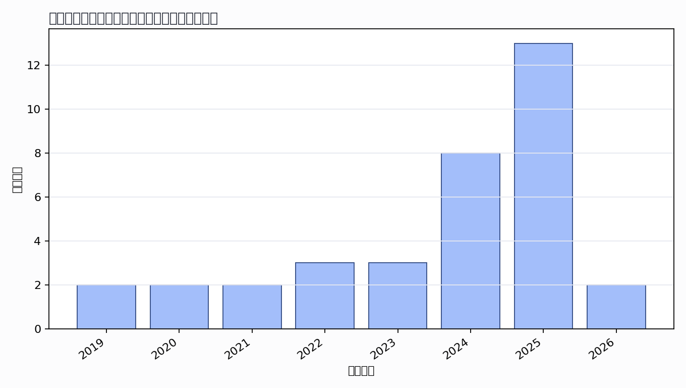

主题覆盖
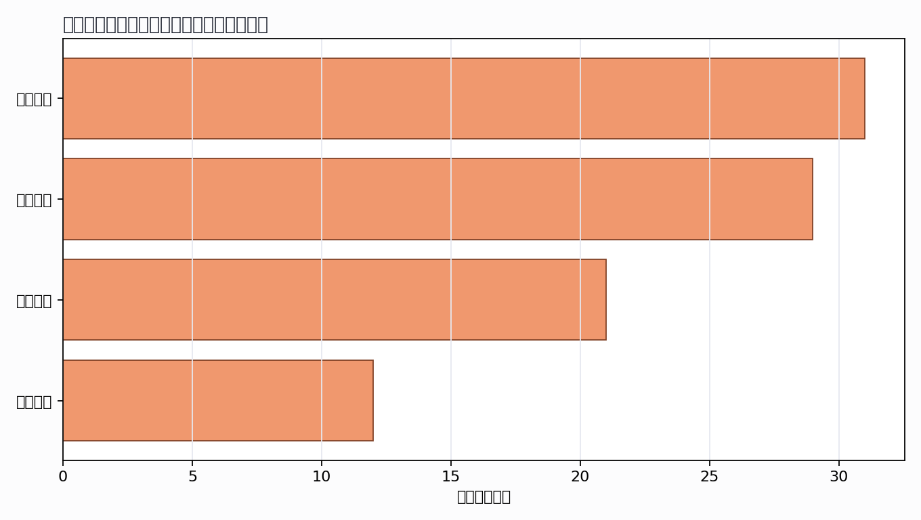

来源结构
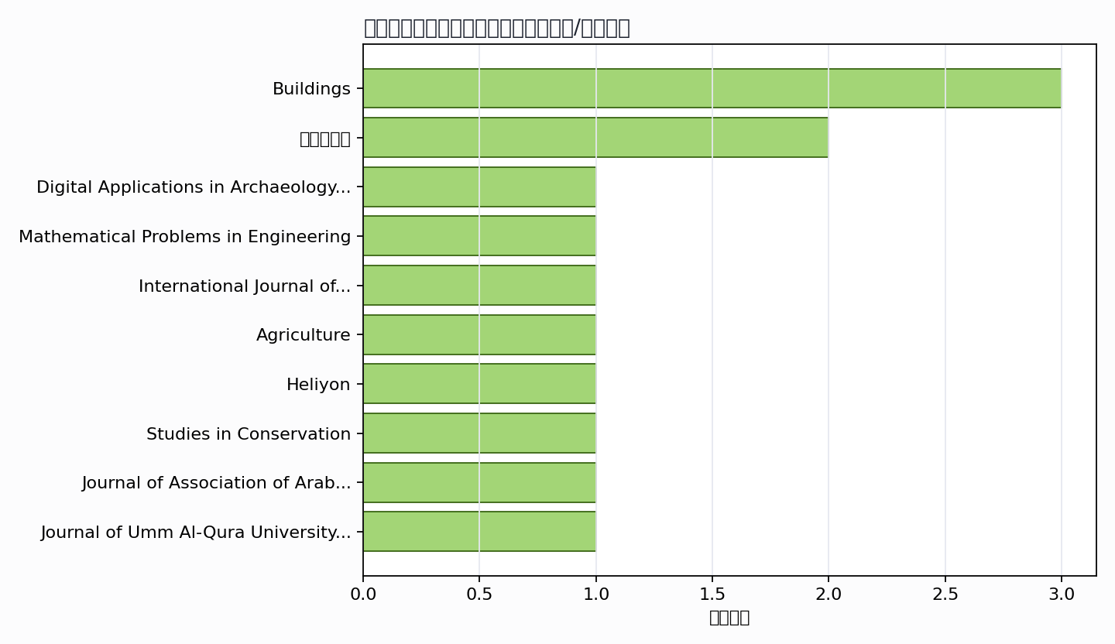

可进入书稿的论证链
- 概念层：使用高被引或综述型文献界定核心概念。
- 机制层：整理为技术能力、场景应用、主体协同、绩效反馈的论证链。
- 方法层：将实证方法转化为课堂练习、章节附录或研究设计示例。
- 边界层：对隐私、真实性、社区参与、算法偏见和数据授权设置专门讨论。

候选参考文献
- Ikrom Nishanbaev (2020). A web repository for geo-located 3D digital cultural heritage models. Digital Applications in Archaeology and Cultural Heritage. DOI: 10.1016/j.daach.2020.e00139.
主题映射：数字采集; 保护监测; 展示利用；引用数：46。
- Xi Deng; Il-tae Kim; Chong Shen (2021). Research on Convolutional Neural Network-Based Virtual Reality Platform Framework for the Intangible Cultural Heritage Conservation of China Hainan Li Nationality: Boat-Shaped House as an Example. Mathematical Problems in Engineering. DOI: 10.1155/2021/5538434.
主题映射：数字采集; 保护监测; 展示利用；引用数：24。
- T. Nguyen; S. T. Do; Long Le-Hoai; V. Nguyen; Truong-An Pham (2022). Practical workflow for cultural heritage digitalization and management: a case study in Vietnam. International Journal of Construction Management. DOI: 10.1080/15623599.2022.2054268.
主题映射：数字采集; 保护监测; 展示利用；引用数：21。
- Abdi Shukri Yasin; Z. Bacsi (2025). Agritourism and Rural Development: A Global Bibliometric Analysis of the State of Research, Limitations, and Future Directions. Agriculture. DOI: 10.3390/agriculture15080866.
主题映射：保护监测; 展示利用；引用数：17。
- S. Chernbumroong; Perasuk Worragin; Natchaya Wongwan; K. Intawong; Pipitton Homla; Kitti Puritat (2024). Digitization of myth: The HimmapanVR Project's role in cultural preservation. Heliyon. DOI: 10.1016/j.heliyon.2024.e30052.
主题映射：数字采集; 保护监测; 展示利用; 伦理治理；引用数：11。
- Ling Zhu; Jingshu Gao; Lei Fu; Yuqi Yan; Jiufang Lv (2023). Application of Digital Technology to Chinese Traditional Furniture: A Review. Studies in Conservation. DOI: 10.1080/00393630.2023.2260629.
主题映射：数字采集; 保护监测; 展示利用；引用数：11。
- A. Abdo (2019). Digital Heritage Applications and its Impact on Cultural Tourism. Journal of Association of Arab Universities for Tourism and Hospitality. DOI: 10.21608/jaauth.2019.76472.
主题映射：数字采集; 保护监测; 展示利用；引用数：10。
- Abdulmajeed Almasoudi; A. Q. Bhatti; Ayed Eid Alluqmani; Abdulaziz Alotaibi (2025). Investigation of enhancing heritage preservation utilizing heritage building information modeling (HBIM). Journal of Umm Al-Qura University for Engineering and Architecture. DOI: 10.1007/s43995-025-00116-1.
主题映射：数字采集; 保护监测; 展示利用; 伦理治理；引用数：9。
- Biyas Ghosh; Rajdeo Singh; Madhuri Sawant (2024). Digital Technology: A Step to Protect Cave Art of Indian Subcontinent as National Heritage – A Review. Preservation, Digital Technology &amp; Culture. DOI: 10.1515/pdtc-2023-0047.
主题映射：数字采集; 保护监测；引用数：7。
- Sukardi Sukardi; Moh. Fadli; D. Puspitawati; Diah Pawestri Maharani; M. Luthfi (2022). Legal optic on digitalization of cultural heritage through e-tourism and e-government to back up ecotourism in greater Malang Indonesia. Legality : Jurnal Ilmiah Hukum. DOI: 10.22219/ljih.v30i2.21420.
主题映射：保护监测; 展示利用；引用数：7。
- Khayrinisa Yunuskhodjaeva; Umida Almatova; Nodir Karimov; Surayyo Khaydarova; S. Jalolova; Akramov Bahodir; Ibragimjan Toshmatov (2025). THE ROLE OF DIGITAL TECHNOLOGY IN ARCHIVING ETHNO-TOURISTIC LANDMARKS. Archives for Technical Sciences. DOI: 10.70102/afts.2025.1732.015.
主题映射：数字采集; 保护监测; 展示利用; 伦理治理；引用数：6。
- Yao Wu; Yonglan Wu; Mingrui Miao; Muxian Wang; Xiaobin Li; António Candeias (2025). Research on Construction of Suzhou’s Historical Architectural Heritage Corridors and Cultural Relics-Themed Trails Based on Current Effective Conductance (CEC) Model. Buildings. DOI: 10.3390/buildings15152605.
主题映射：保护监测; 展示利用; 伦理治理；引用数：6。
- T. Trencheva; Evelina Zdravkova (2019). INTELLECTUAL PROPERTY MANAGEMENT IN DIGITIZATION AND DIGITAL PRESERVATION OF CULTURAL HERITAGE. EDULEARN19 Proceedings. DOI: 10.21125/EDULEARN.2019.1468.
主题映射：数字采集; 保护监测; 展示利用；引用数：6。
- Zhe Lai; Yingying Xiao; Zitong Chen; Huiwen Li; Lukui Huang (2024). Preserving Woodcraft in the Digital Age: A Meta-Model-Based Robotic Approach for Sustainable Timber Construction. Buildings. DOI: 10.3390/buildings14092900.
主题映射：保护监测；引用数：5。
- M. Bashir; Salman Asghar; Muhammad Ashfaq; Syed Shahzeb Raza; S. Zahoor (2024). Digitalizing Tourism and Interactive Navigation: A Case Study of Pakistan. Journal of Asian development studies. DOI: 10.62345/jads.2024.13.1.46.
主题映射：数字采集; 展示利用；引用数：5。
- Polina Stoyanova (2024). Digital Cultural Heritage as a Strategic Resource for Innovations. Strategies for Policy in Science and Education-Strategii na Obrazovatelnata i Nauchnata Politika. DOI: 10.53656/str2024-1s-8-dig.
主题映射：数字采集; 展示利用；引用数：5。
- Prashamsa Ghimire (2023). Digitizing Cultural Heritage of Nepal: Tools for Conservation and Restoration. Unity Journal. DOI: 10.3126/unityj.v4i01.52245.
主题映射：数字采集; 保护监测; 伦理治理；引用数：5。
- Y. Sui; Jian Zhang (2021). Study on protection strategy of traditional village cultural heritage in Internet Era. Unknown venue. DOI: 10.1088/1755-1315/768/1/012157.
主题映射：保护监测; 展示利用；引用数：5。
- Yi Hu; Siki Sun; Ye Chen; Zhike Yang (2025). Role and challenges of rural tourism in promoting sustainable rural development. International Theory and Practice in Humanities and Social Sciences. DOI: 10.70693/itphss.v2i3.145.
主题映射：数字采集; 保护监测; 展示利用; 伦理治理；引用数：4。
- Wenjun Ge; M. A. A. Manan (2025). A Review of and Prospect of Village Architecture Research from the Perspective of Rural Tourism. World. DOI: 10.3390/world6010021.
主题映射：保护监测; 展示利用; 伦理治理；引用数：4。
- Juan Wu (2024). Han Dynasty Portrait Image Feature Extraction and Cloud Computing-supported Symbolic Interpretation: A New Approach to Cultural Heritage Digitalization. Scalable Computing : Practice and Experience. DOI: 10.12694/scpe.v25i6.3299.
主题映射：数字采集; 保护监测; 展示利用；引用数：4。
- Jian-fei Chen; Jie Zhong; Qingqian Ning; Zhengjia Xu; Hiroatsu Fukuda (2026). Heritage Conservation and Management of Traditional Anhui Dwellings Using 3D Digitization: A Case Study of the Architectural Heritage Clusters in Huangshan City. Buildings. DOI: 10.3390/buildings16010211.
主题映射：数字采集; 保护监测; 伦理治理；引用数：3。
- Esra S. Abdoh (2025). Utilizing Modern Technology for the Preservation of Ancient Manuscripts and Rare Books: The Digitization Project at King Abdulaziz Complex for Endowment Libraries as a Model. Restaurator. International journal for the preservation of library and archival material. DOI: 10.1515/res-2024-0016.
主题映射：数字采集; 保护监测；引用数：3。
- Ning Gao; Buchao Wang; Xinheng Pan; Lan Yang; Shijie Tan; Xuguang Zhu (2025). Serious Game Promotes the Cultural Transmission of Agricultural Heritage Mulberry-Dyke and Fishpond System. SAGE Open. DOI: 10.1177/21582440251348019.
主题映射：保护监测; 展示利用；引用数：3。
- Hua Long; Zhifeng Wang; Long Meng; Xiaoxia Ma; Huiping Pei (2025). Revitalization Mechanisms of the Ancient Tea Forest Cultural Landscape of Jingmai Mountain: Perspectives on Intangible Cultural Heritage Protection and Sustainable Development. Journal of Lifestyle and SDGs Review. DOI: 10.47172/2965-730x.sdgsreview.v5.n05.pe05721.
主题映射：保护监测; 展示利用; 伦理治理；引用数：3。
- Wisman Hadi; Lili Tansliova; Trisnawati Hutagalung; Kana Saputra S (2025). Augmented Reality as an Innovative Tool for Digitizing North Sumatran Folklore: Enhancing Educational Tourism Media Literacy for Children With Special Needs in Indonesia. Theory and Practice in Language Studies. DOI: 10.17507/tpls.1506.29.
主题映射：展示利用；引用数：3。
- Chunyi Lin; Chen Li (2024). Digitization of intangible cultural heritage as a key factor in the transformation of cultural tourism integration: An analytical perspective of the digitalization framework. Trends in Social Sciences and Humanities Research. DOI: 10.61784/tsshrv2n190.
主题映射：数字采集; 展示利用；引用数：3。
- Shiqi Liu (2020). Cultural Tourism Policies and Digital Transition of Ancient Village Heritage Conservation in China. Unknown venue. DOI: 10.1007/978-3-030-36342-0_3.
主题映射：保护监测; 展示利用；引用数：3。
- Leiling Zhang (2026). Preserving Cultural Heritage in the Age of Tourism: Stakeholder Collaboration and Digital Solutions for Sustainable Development. Sustainable Development. DOI: 10.1002/sd.70186.
主题映射：保护监测; 展示利用; 伦理治理；引用数：2。
- D. Hasan (2025). Revolutionizing Cultural Heritage Preservation in Bangladesh: Virtual Reality Integration at Chhoto Sona Mosque. International journal of research and innovation in applied science. DOI: 10.51584/ijrias.2025.1001039.
主题映射：数字采集; 保护监测; 展示利用；引用数：2。
- L. Judijanto; A. Malik (2025). A Systematic Bibliometric Review of Cultural Heritage Conservation Research. The Eastasouth Journal of Social Science and Humanities. DOI: 10.58812/esssh.v3i01.771.
主题映射：保护监测; 展示利用；引用数：2。
- T. Nguyen; N. Le; Dai Huu Nguyen; Son Hong Nguyen (2022). Preserving cultural heritage and tourism promoting city values: Applying digitalization trends to cultural heritage. Engineering & Technology. DOI: 10.32508/stdjet.v5i2.975.
主题映射：数字采集; 保护监测; 展示利用; 伦理治理；引用数：2。
- Badruzzaman; Radiwan; Priyono; Trida Chairu; Muh. Hamdani; Andy Suryandi; M. Athar; Ismail Muzakir (2025). Cultural Advancement Strategy: Realities, Paradigms, and Policy Orientations in Managing UNESCO Cultural Heritage. The Journal of Academic Science. DOI: 10.59613/kb1f5n05.
主题映射：保护监测; 展示利用; 伦理治理；引用数：1。
- Min Xu (2024). Digital technology-enabled non-heritage spatial landscape design in the context of rural revitalization. Applied Mathematics and Nonlinear Sciences. DOI: 10.2478/amns-2024-0811.
主题映射：保护监测; 展示利用；引用数：1。
- Andi Abidah (2023). TRANSFORMASI DIGITAL PERAN AI DALAM KONSERVASI DAN RESTORASI BANGUNAN HERITAGE. SEMINAR NASIONAL DIES NATALIS 62. DOI: 10.59562/semnasdies.v1i1.809.
主题映射：数字采集; 保护监测；引用数：1。
Markdown 源文件：20260705_专著6——文化遗产数字化保护与利用_文献补充与数据分析报告.md

