专著5——文旅元宇宙与沉浸式体验设计 文献补充与数据分析报告

Executive Summary
已形成 35 条候选参考文献，满足每个专著子文件夹不少于 20 条的补充要求。
本证据包为《文旅元宇宙与沉浸式体验设计》补充了 35 条候选参考文献，其中 31 条发表于 2021 年及以后，说明该书题与近年数字技术、旅游管理和文化传播研究保持连接。主题上，当前文献主要集中在VR/AR、遗产展示、沉浸体验，可以支撑书稿从概念解释转向“技术—场景—主体—绩效”的论证链。方法上，样本文献呈现问卷/结构方程、实验/情景实验、文本挖掘/评论分析、案例/质性研究、预测/机器学习、综述/框架研究等路径，适合在书中分别转化为理论综述、案例框、方法训练和图表化教学材料。需要注意的是，Semantic Scholar 返回的题录不能替代全文精读；涉及地方数据、政策口径和企业案例成效的判断仍应回到原文、官方材料或授权数据核验。
证据边界：本报告基于 Semantic Scholar 题录、摘要和本地数字文旅文献语料生成；正式出版前需逐篇核验 DOI、页码、卷期和全文观点。

关键图表

年份分布
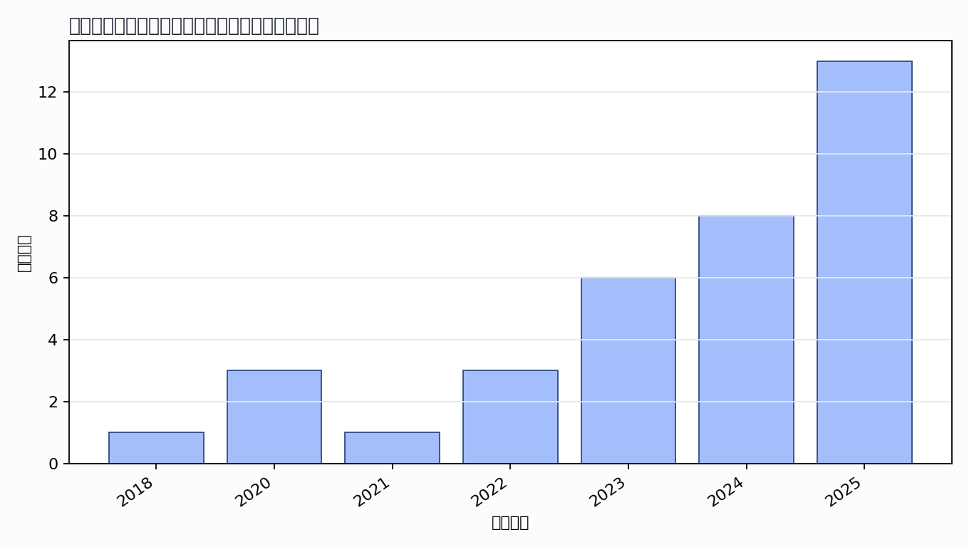

主题覆盖
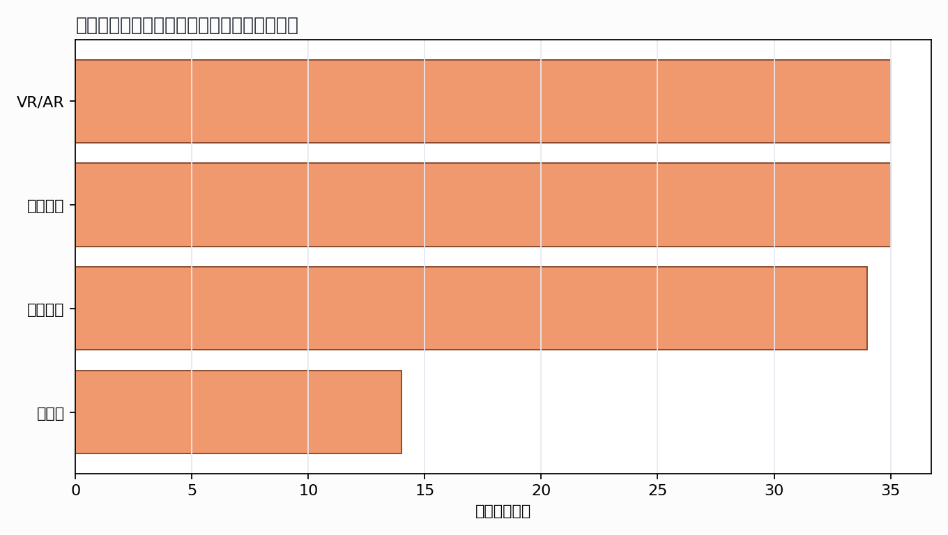

来源结构
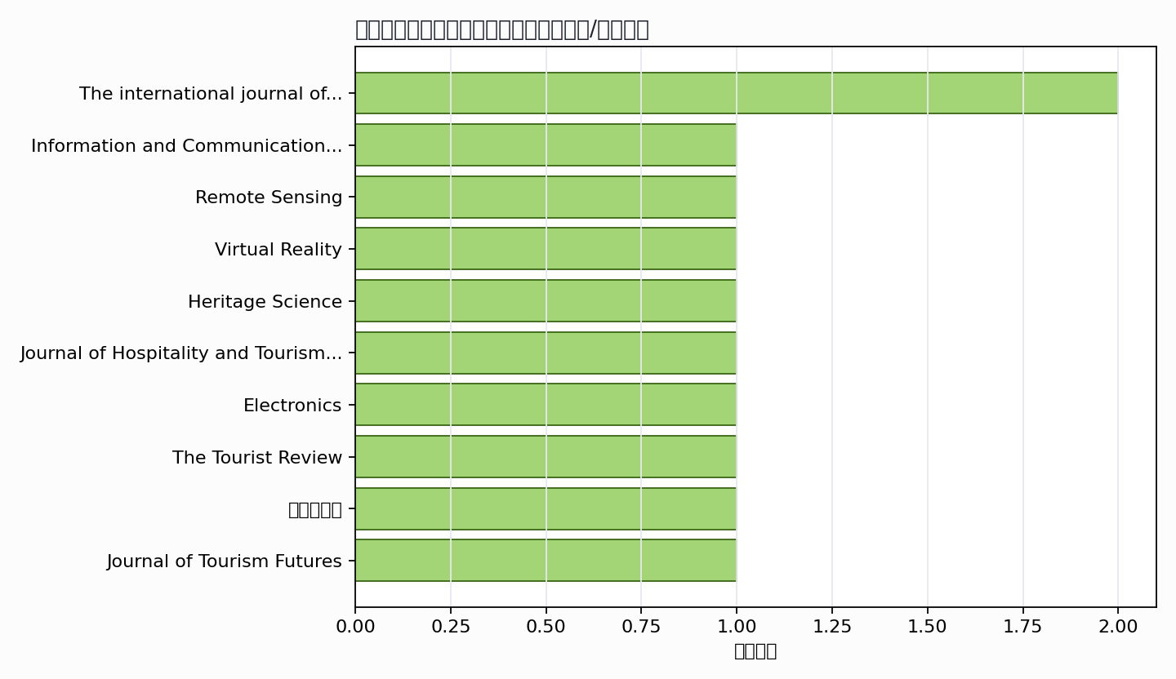

可进入书稿的论证链
- 概念层：使用高被引或综述型文献界定核心概念。
- 机制层：整理为技术能力、场景应用、主体协同、绩效反馈的论证链。
- 方法层：将实证方法转化为课堂练习、章节附录或研究设计示例。
- 边界层：对隐私、真实性、社区参与、算法偏见和数据授权设置专门讨论。

候选参考文献
- Dimitrios Buhalis; Nurshat Karatay (2022). Mixed Reality (MR) for Generation Z in Cultural Heritage Tourism Towards Metaverse. Information and Communication Technologies in Tourism. DOI: 10.1007/978-3-030-94751-4_2.
主题映射：元宇宙; VR/AR; 沉浸体验; 遗产展示；引用数：198。
- Florent Poux; Quentin Valembois; C. Mattes; L. Kobbelt; R. Billen (2020). Initial User-Centered Design of a Virtual Reality Heritage System: Applications for Digital Tourism. Remote Sensing. DOI: 10.3390/rs12162583.
主题映射：VR/AR; 沉浸体验; 遗产展示；引用数：99。
- M. S. Anwar; Jie Yang; Jaroslav Frnda; Ahyoung Choi; Nilufar Baghaei; Miram Ali (2025). Metaverse and XR for cultural heritage education: applications, standards, architecture, and technological insights for enhanced immersive experience. Virtual Reality. DOI: 10.1007/s10055-025-01126-z.
主题映射：元宇宙; VR/AR; 沉浸体验; 遗产展示；引用数：91。
- C. Zhu; D. Wu; C. Hall; L. Fong; S. Koupaei; Feifei Lin (2023). Exploring non‐immersive virtual reality experiences in tourism: Empirical evidence from a world heritage site. The international journal of tourism research. DOI: 10.1002/jtr.2574.
主题映射：元宇宙; VR/AR; 沉浸体验; 遗产展示；引用数：68。
- Zhanling Fan; Chongcheng Chen; Hongyu Huang (2022). Immersive cultural heritage digital documentation and information service for historical figure metaverse: a case of Zhu Xi, Song Dynasty, China. Heritage Science. DOI: 10.1186/s40494-022-00749-8.
主题映射：元宇宙; VR/AR; 沉浸体验; 遗产展示；引用数：57。
- Wajdy Omran; Ricardo F. Ramos; Beatriz Casais (2023). Virtual reality and augmented reality applications and their effect on tourist engagement: a hybrid review. Journal of Hospitality and Tourism Technology. DOI: 10.1108/jhtt-11-2022-0299.
主题映射：VR/AR; 沉浸体验; 遗产展示；引用数：52。
- Bashar Dayoub; Peifeng Yang; Sarah Omran; Qiuyi Zhang; Alaa Dayoub (2024). Digital Silk Roads: Leveraging the Metaverse for Cultural Tourism within the Belt and Road Initiative Framework. Electronics. DOI: 10.3390/electronics13122306.
主题映射：元宇宙; VR/AR; 沉浸体验; 遗产展示；引用数：28。
- J. F. Prados-Castillo; J. A. Torrecilla-García; Francisco Liébana-Cabanillas (2024). Metaverse as a booster of tourism transformation towards virtual management strategies. The Tourist Review. DOI: 10.1108/tr-10-2023-0750.
主题映射：元宇宙; VR/AR; 沉浸体验; 遗产展示；引用数：26。
- A. Marasco (2020). Beyond virtual cultural tourism: history-living experiences with cinematic virtual reality. Unknown venue. DOI: 10.1344/THJ.2020.2.1.
主题映射：VR/AR; 沉浸体验; 遗产展示；引用数：20。
- Nazim Hanis Zainal Abidin; Muhammad Ashraf Fauzi; Walton Wider; Wan Muhammad Noor Sarbani Mat Daud; Rusnifaezah Musa (2025). Metaverse in tourism and hospitality industry: science mapping of the current and future trends. Journal of Tourism Futures. DOI: 10.1108/jtf-05-2024-0089.
主题映射：元宇宙; VR/AR; 沉浸体验; 遗产展示；引用数：19。
- Pancham Singh; Neeti Pahuja; Mrignainy Kansal; Siddhant Gurung; Utkarsh Shukla; Sandeep K. S. Gupta (2024). Enhancing Tourism Experiences and Preserving Cultural Heritage with AR and VR. International Conference on Database Theory. DOI: 10.1109/ICDT61202.2024.10489490.
主题映射：VR/AR; 沉浸体验; 遗产展示；引用数：15。
- Chunyu Jiang; S. Phoong; Sedigheh Moghavvemi (2025). Cultural odyssey in the metaverse: investigating the impact of virtual technologies on tourist reuse behavior and social sustainability. Humanities and Social Sciences Communications. DOI: 10.1057/s41599-025-05132-z.
主题映射：元宇宙; VR/AR; 沉浸体验; 遗产展示；引用数：14。
- Hyerim Park; Jungi Kim; Sunyoung Bang; Woontack Woo (2018). The Effect of Applying Film-induced Tourism to Virtual Reality Tours of Cultural Heritage Sites. 2018 3rd Digital Heritage International Congress (DigitalHERITAGE) held jointly with 2018 24th International Conference on Virtual Systems & Multimedia (VSMM 2018). DOI: 10.1109/DigitalHeritage.2018.8810089.
主题映射：VR/AR; 沉浸体验; 遗产展示；引用数：12。
- Yage Lu; Gaofeng Mi; Honglei Lu; Yuan Wang (2025). Immersive Technologies in Built Heritage Spaces: Understanding Tourists’ Continuance Intention Toward Sustainable AR and VR Applications at the Terracotta Warriors Museum. Buildings. DOI: 10.3390/buildings15193481.
主题映射：VR/AR; 沉浸体验; 遗产展示；引用数：9。
- FA Cao Shuran; Anor Salim; Xu Ying (2024). Enhancing Cultural Heritage Tourism through Market Innovation and Technology Integration. Evolutionary Studies in Imaginative Culture. DOI: 10.70082/esiculture.vi.1030.
主题映射：VR/AR; 沉浸体验; 遗产展示；引用数：9。
- Alisia Iacovino; L. D. Paolis; V. Ndou (2020). Technologies to Support Tourism Innovation and Cultural Heritage: Development of an Immersive Virtual Reality Application. International Conference on Augmented and Virtual Reality. DOI: 10.1007/978-3-030-58468-9_1.
主题映射：VR/AR; 沉浸体验; 遗产展示；引用数：9。
- Soteris Constantinou; Andreas Pamboris; R. Alexandrou; Christoforos Kronis; D. Zeinalipour-Yazti; H. Papadopoulos; Andreas Konstantinidis (2022). EnterCY: A Virtual and Augmented Reality Tourism Platform for Cyprus. International Conference on Mobile Data Management. DOI: 10.1109/MDM55031.2022.00069.
主题映射：VR/AR; 沉浸体验; 遗产展示；引用数：7。
- Neena Sinha; Garima Kapoor; Nikita Kataria (2025). Customer Engagement in Virtual Tourism: Embracing Immersive Experience of Culture and Heritage. The international journal of tourism research. DOI: 10.1002/jtr.70094.
主题映射：VR/AR; 沉浸体验; 遗产展示；引用数：6。
- Yun Li; Cuixia Li; Jianfeng Cui; Yuan Gao (2024). Application and Reflection of Virtual Reality in Digital Tourism Development. Applied Mathematics and Nonlinear Sciences. DOI: 10.2478/amns-2024-0841.
主题映射：VR/AR; 沉浸体验; 遗产展示；引用数：6。
- Wen Wen; Xiangmeng Wang; Ziwen Ye (2025). Protection and immersive experience of cultural heritage in the digital age: Technological empowerment, spatial reproduction, and future risks. Arts &amp; Communication. DOI: 10.36922/ac025040005.
主题映射：VR/AR; 沉浸体验; 遗产展示；引用数：5。
- Muthana Faaeq Almasooudi (2024). The possibility of applying metaverse in cultural heritage tourism: A case study on the ancient city of Babylon. Tourism and Hospitality Research. DOI: 10.1177/14673584241308167.
主题映射：元宇宙; VR/AR; 遗产展示；引用数：5。
- K. A. Samah; M. N. H. H. Jono; A. C. M. Zulkepli; N. A. Deraman; Shahadan Saad; A. G. Buja; L. Riza (2021). Immersive Virtual Reality in Preserving Historical Tourism. International Conference on System Engineering and Technology. DOI: 10.1109/ICSET53708.2021.9612577.
主题映射：VR/AR; 沉浸体验; 遗产展示；引用数：5。
- Teqiao Shen; Jialei Rong (2025). Research on Smart Cultural Tourism Based on Virtual Reality Technology. Frontiers in Computing and Intelligent Systems. DOI: 10.54097/71g3qa08.
主题映射：VR/AR; 沉浸体验; 遗产展示；引用数：4。
- F. A. Widodo; Addin Aditya; Rahmat Kurniawan (2024). Enhancing Tangible Cultural Heritage Preservation through Virtual Reality: A Case Study of Watu Gong Sites in Indonesia. 2024 11th International Conference on Electrical Engineering, Computer Science and Informatics (EECSI). DOI: 10.1109/EECSI63442.2024.10776179.
主题映射：VR/AR; 沉浸体验; 遗产展示；引用数：4。
- Dimitra Skandali (2025). Metaverse Tourism: Opportunities, AI-Driven Marketing, and Ethical Challenges in Virtual Travel. Encyclopedia. DOI: 10.3390/encyclopedia5030135.
主题映射：元宇宙; VR/AR; 沉浸体验; 遗产展示；引用数：3。
- Zhan Xu; Feng Liu; Guobin Xia; Shuo Wang; Yiting Duan; Luwen Yu; Shichao Zhao; Muzi Li (2025). Immersive HCI for Intangible Cultural Heritage in Tourism Contexts: A Narrative Review of Design and Evaluation. Sustainability. DOI: 10.3390/su18010153.
主题映射：VR/AR; 沉浸体验; 遗产展示；引用数：3。
- Addin Aditya; Rahmat Kurniawan; F. Maulana; Muhammad Alif Nur Darwanza (2025). DESIGN AND IMPLEMENTATION OF A METAVERSE-BASED PLATFORM FOR THEMATIC TOURISM VILLAGES. Jurnal Teknik Informatika (Jutif). DOI: 10.52436/1.jutif.2025.6.1.4209.
主题映射：元宇宙; VR/AR; 沉浸体验; 遗产展示；引用数：3。
- Yongkang Xing; Conor Fahy; Guokai Feng; Yi Liang; Haiqi Huang; J. Shell (2024). Digital Storytelling in Virtual Reality: Bridging the Virtual and Reality in Cultural Tourism at the Great Bay Area. 2024 IEEE International Conference on Artificial Intelligence and eXtended and Virtual Reality (AIxVR). DOI: 10.1109/aixvr59861.2024.00061.
主题映射：VR/AR; 沉浸体验; 遗产展示；引用数：3。
- Mengyuan Zhou; Yixuan Yan (2023). The Research on the Application of Metaverse in the Cultural and Tourism Industry. Advances in Economics, Management and Political Sciences. DOI: 10.54254/2754-1169/47/20230379.
主题映射：元宇宙; VR/AR; 沉浸体验; 遗产展示；引用数：3。
- HongYi Shih (2023). Heritage Museum Evolution: Virtual Realitizing Heritage Museums in Taiwan with An Exploratory Virtual Reality Museum Project. 2023 Pacific Neighborhood Consortium Annual Conference and Joint Meetings (PNC). DOI: 10.23919/PNC58718.2023.10314973.
主题映射：VR/AR; 沉浸体验; 遗产展示；引用数：3。
- P. Correia (2025). Metaverse in tourism: A pathway to sustainability and regeneration. International Journal of Technology Management &amp; Sustainable Development. DOI: 10.1386/tmsd_00104_1.
主题映射：元宇宙; VR/AR; 沉浸体验; 遗产展示；引用数：2。
- P. Correia (2025). From Virtual to Reality: Enhancing Cultural Tourism Through AI, VR, and the Metaverse. International Conference on Tourism Research. DOI: 10.34190/ictr.8.1.3460.
主题映射：元宇宙; VR/AR; 沉浸体验; 遗产展示；引用数：2。
- Nurul Farah Atikah Mohamad Zahar; Siti Norlizaiha Harun; Edzrie Shah Shaharudin; Irin Caisarina; A.R. Abdul Ghani (2025). Beneficial Impact of COVID-19 Pandemic: The Potential of Virtual Heritage Tours for Tourism in Malaysia. Built environment journal. DOI: 10.24191/bej.v21isi.1562.
主题映射：VR/AR; 沉浸体验; 遗产展示；引用数：2。
- A. Vlachos; S. Krinidis; K. Papadimitriou; A. Manglis; A. Fourkiotou; D. Tzovaras (2023). iBLUECULTURE: A NOVEL SYSTEM OF REAL-TIME UNDERWATER IMAGE TRANSMISSION IN A VIRTUAL REALITY ENVIRONMENT, AS A NEW MANAGERIAL APPROACH FOR UNDERWATER CULTURAL HERITAGE. The International Archives of the Photogrammetry, Remote Sensing and Spatial Information Sciences. DOI: 10.5194/isprs-archives-xlviii-1-w2-2023-269-2023.
主题映射：VR/AR; 沉浸体验; 遗产展示；引用数：2。
- Yin Guojun; Fan Jinyu; Liu Yang; Li Xin (2023). Chinese Traditional Wheelbarrow Restoration and Game Design Based on Virtual Reality Technology. International Conference on Virtual Reality. DOI: 10.1109/ICVR57957.2023.10169813.
主题映射：VR/AR; 沉浸体验; 遗产展示；引用数：2。
Markdown 源文件：20260705_专著5——文旅元宇宙与沉浸式体验设计_文献补充与数据分析报告.md

