专著4——旅游大数据分析与决策 文献补充与数据分析报告

Executive Summary
已形成 35 条候选参考文献，满足每个专著子文件夹不少于 20 条的补充要求。
本证据包为《旅游大数据分析与决策》补充了 35 条候选参考文献，其中 32 条发表于 2021 年及以后，说明该书题与近年数字技术、旅游管理和文化传播研究保持连接。主题上，当前文献主要集中在决策支持、客流预测、文本挖掘，可以支撑书稿从概念解释转向“技术—场景—主体—绩效”的论证链。方法上，样本文献呈现问卷/结构方程、实验/情景实验、文本挖掘/评论分析、案例/质性研究、预测/机器学习、综述/框架研究等路径，适合在书中分别转化为理论综述、案例框、方法训练和图表化教学材料。需要注意的是，Semantic Scholar 返回的题录不能替代全文精读；涉及地方数据、政策口径和企业案例成效的判断仍应回到原文、官方材料或授权数据核验。
证据边界：本报告基于 Semantic Scholar 题录、摘要和本地数字文旅文献语料生成；正式出版前需逐篇核验 DOI、页码、卷期和全文观点。

关键图表

年份分布
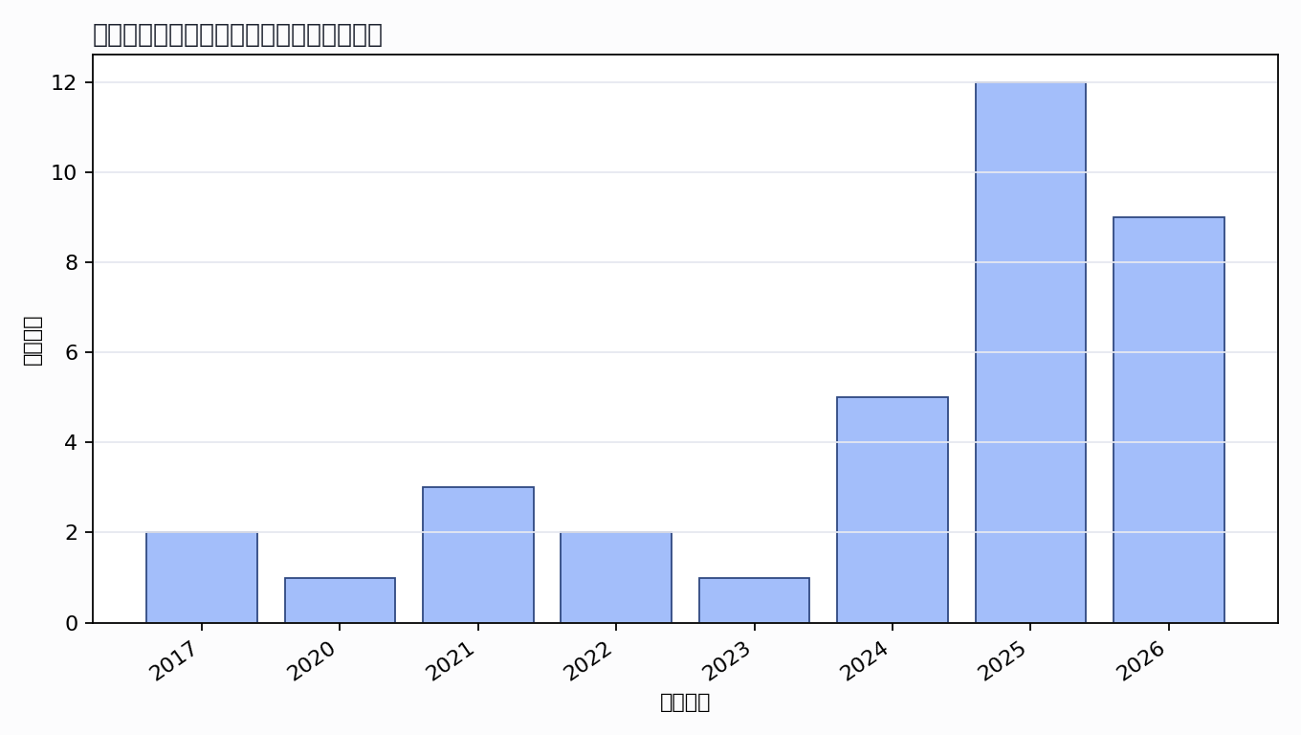

主题覆盖
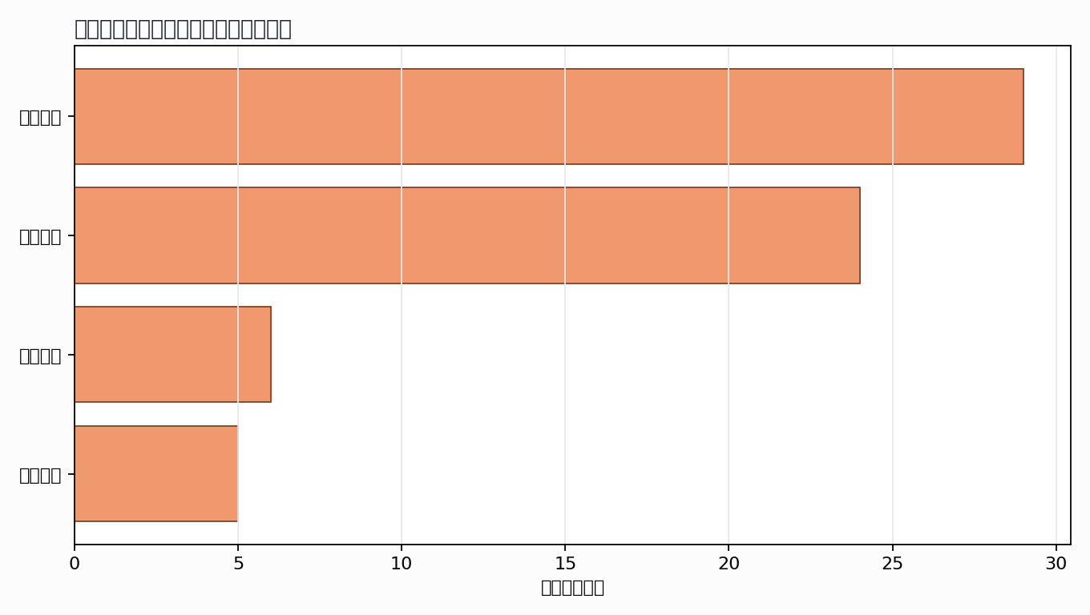

来源结构
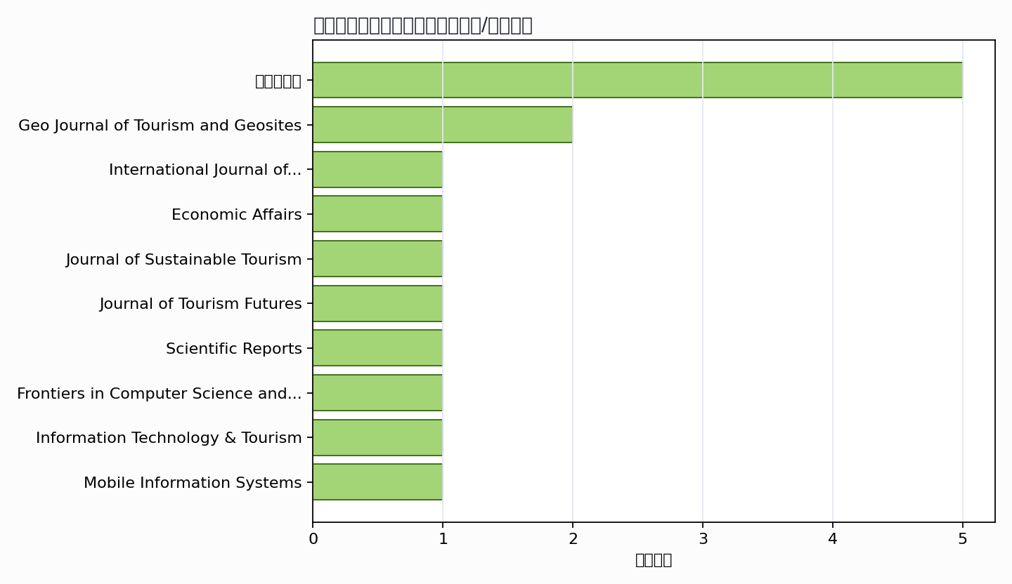

可进入书稿的论证链
- 概念层：使用高被引或综述型文献界定核心概念。
- 机制层：整理为技术能力、场景应用、主体协同、绩效反馈的论证链。
- 方法层：将实证方法转化为课堂练习、章节附录或研究设计示例。
- 边界层：对隐私、真实性、社区参与、算法偏见和数据授权设置专门讨论。

候选参考文献
- V. Ramos; W. Yamaka; B. Alorda; S. Sriboonchitta (2021). High-frequency forecasting from mobile devices’ bigdata: an application to tourism destinations’ crowdedness. International Journal of Contemporary Hospitality Management. DOI: 10.1108/IJCHM-10-2020-1170.
主题映射：客流预测; 空间分析; 决策支持；引用数：33。
- S. Das (2024). Application of AI Technology for the Development of Destination Tourism towards an Intelligent Information System. Economic Affairs. DOI: 10.46852/0424-2513.3.2024.31.
主题映射：客流预测; 决策支持；引用数：30。
- O. Alawneh; Mahmoud Allahham; Ahmed Falah Hasan Habeeb; W. Almajali; I. A. Al-Nsour; Omar Jawabreh (2025). EVALUATING HOW BIG DATA ANALYSIS MEDIATES THE IMPACT OF DIGITAL MARKETING STRATEGIES ON TOURISM DEVELOPMENT IN JORDAN. Geo Journal of Tourism and Geosites. DOI: 10.30892/gtg.62405-1571.
主题映射：客流预测; 决策支持；引用数：9。
- I. Confente; Valentina Mazzoli; Nicola Camatti; Dario Bertocchi (2024). Integrating tourists’ walk and talk: a methodological approach for tracking and analysing tourists’ real behaviours for more sustainable destinations. Journal of Sustainable Tourism. DOI: 10.1080/09669582.2024.2322120.
主题映射：客流预测；引用数：8。
- Giovanni De Luca; M. Rosciano (2024). Google Trends data and transfer function models to predict tourism demand in Italy. Journal of Tourism Futures. DOI: 10.1108/jtf-01-2023-0018.
主题映射：客流预测; 决策支持；引用数：6。
- Unknown author (2021). Big Data empowered Agility for dynamic, volatile, and time-sensitive service industries: The case of Tourism sector. International Journal of Contemporary Hospitality. Unknown venue. URL: https://www.semanticscholar.org/paper/31164b5037657816e606fb61d1c3de18d67df7e2.
主题映射：待人工判读；引用数：6。
- Xin Cui (2025). Urban tourism management based on artificial neural networks analysis and data mining. Scientific Reports. DOI: 10.1038/s41598-025-01237-2.
主题映射：客流预测; 决策支持；引用数：5。
- Sanjida Rahman; Afm Tanvir Anjum; Jannat Ara; Malay Sarkar (2026). Artificial Intelligence for Revenue Forecasting, Risk Management, and Financial & Business Planning in International Sports Tourism: The FIFA World Cup USA 2026 Case. Frontiers in Computer Science and Artificial Intelligence. DOI: 10.32996/jcsts.2026.5.2.4.
主题映射：客流预测; 决策支持；引用数：4。
- Konstantinos Vogklis (2025). Leveraging spatiotemporal big data for sustainable destination development: an interdisciplinary approach. Information Technology & Tourism. DOI: 10.1007/s40558-025-00338-y.
主题映射：待人工判读；引用数：4。
- Fangyuan Xu; Feng Han (2022). Tourist Attraction Recommendation Method and Data Management Based on Big Data Analysis. Mobile Information Systems. DOI: 10.1155/2022/7161522.
主题映射：决策支持；引用数：3。
- BS Krishnamma; K. Babu; Aleena Maria Zacharia (2025). Tourism 2.0: Exploring the evolution of smart destinations. Journal of Management Research and Analysis. DOI: 10.18231/j.jmra.2025.002.
主题映射：决策支持；引用数：2。
- Lu Huang (2025). Research on the path of sustainable tourism development based on optical augmented reality and artificial intelligence decision support. International Conference on Intelligent Transportation and Smart Cities. DOI: 10.1117/12.3074005.
主题映射：客流预测; 决策支持；引用数：2。
- V. Savitska (2025). DIGITALISATION OF THE PUBLIC ADMINISTRATION SYSTEM IN THE CONTEXT OF ECONOMIC AND LEGAL AREAS OF EUROPEAN INTEGRATION. Baltic Journal of Economic Studies. DOI: 10.30525/2256-0742/2025-11-1-270-280.
主题映射：客流预测; 空间分析；引用数：2。
- R. Raman; D. Buddhi; Girish Lakhera; Zatin Gupta; Anand Joshi; Dimple Saini (2023). An investigation on the role of artificial intelligence in scalable visual data analytics. Artificial Intelligence and Symbolic Computation. DOI: 10.1109/AISC56616.2023.10085495.
主题映射：文本挖掘; 空间分析; 决策支持；引用数：2。
- S. Varelas; Evangelia Kopanaki; N. Georgopoulos (2020). A strategic tourism knowledge base for socio-economic and environmental data analytics: The role of Big Data analysis. Unknown venue. DOI: 10.25944/ZNMWSE.2020.01.6976.
主题映射：决策支持；引用数：2。
- Dimitris Kavroudakis; Zinovia-Maria Penteridou (2017). Geographical Analysis of Emergency Evacuations in the Aegean Sea: Towards the Utilization of Big Data Analytics. Unknown venue. DOI: 10.1007/978-3-319-54558-5_15.
主题映射：空间分析; 决策支持；引用数：2。
- Sohrab Khan Magsi; M. Ahmad; Muhammad Amoon Khalid; Muhammad Irfan Syed; Jafar M. H. Ali; M. Fazal (2026). Enterprise Intelligence 5.0: Human AI Co-Creation Models for Strategic Leadership, Innovation, and Competitive Advantage. Inverge Journal of Social Sciences. DOI: 10.63544/ijss.v5i1.220.
主题映射：客流预测; 文本挖掘; 决策支持；引用数：1。
- Marcell Kupi (2025). THE IMPACT OF AN ARTIFICIAL INTELLIGENCE-BASED FORECASTING MODEL ON THE DEVELOPMENT OF SUSTAINABLE TOURISM. Geo Journal of Tourism and Geosites. DOI: 10.30892/gtg.61334-1544.
主题映射：客流预测; 决策支持；引用数：1。
- Erato Koustoumpardi (2025). Evaluating Forecasting Methods in Tourism: A Systematic Review of Data Sources and Big Data Analytics. International Journal of Tourism &amp; Hospitality Reviews. DOI: 10.18510/ijthr.2025.1221.
主题映射：客流预测; 文本挖掘; 决策支持；引用数：1。
- M. Keertana; C. Vijay; Vishnu Kumar (2025). Digital Twin Applications in Tourism Destination Management: Predictive Modelling for Tourist Flow and Resource Optimization. Asian Review of Social Sciences. DOI: 10.70112/arss-2025.14.2.4333.
主题映射：客流预测; 决策支持；引用数：1。
- Hanan Hussein Mustafa; Montader M. Hasan; Isroilov Sardorbek Solijon ugli; Q. Omonov; Sutar Manisha Balkrishna (2025). Big Data and Artificial Intelligence In Tourism: Enhancing Customer Experience And Market Insights. 2025 International Conference on Computational Innovations and Engineering Sustainability (ICCIES). DOI: 10.1109/ICCIES63851.2025.11032434.
主题映射：客流预测; 决策支持；引用数：1。
- O. Pobihun; H. Shchuka; A. Makarenko (2025). ANALYSIS OF THE USE OF INNOVATIONS TO INCREASE THE ATTRACTIVENESS OF TOURIST DESTINATIONS. THE SCIENTIFIC ISSUES OF TERNOPIL VOLODYMYR HNATIUK NATIONAL PEDAGOGICAL UNIVERSITY. SERIES: GEOGRAPHY. DOI: 10.25128/2519-4577.25.3.10.
主题映射：客流预测; 决策支持；引用数：1。
- Ali Nikseresht (2025). A Hybrid Game-Theory and Deep Learning Framework for Predicting Tourist Arrivals via Big Data Analytics and Opinion Leader Detection. arXiv.org. DOI: 10.48550/arXiv.2507.03411.
主题映射：客流预测; 决策支持；引用数：1。
- Kai Xu (2024). The High-Quality Development of the Esports Industry in the Yangtze River Delta Region. International Journal of Management Studies and Social Science Research. DOI: 10.56293/ijmsssr.2024.4921.
主题映射：客流预测; 决策支持；引用数：1。
- Lata Pande; Santoshi Sengupta (2024). Data Analytics in Smart Tourism Design: A review paper. E3S Web of Conferences. DOI: 10.1051/e3sconf/202455601038.
主题映射：客流预测; 文本挖掘; 决策支持；引用数：1。
- Maria Gorete Ferreira Dinis; Maria Celeste Eusébio; Z. Breda; Ana Madaleno (2022). MODELLING TOURISM DEMAND USING GOOGLE ANALYTICS: A CASE STUDY OF PORTUGAL’S ALENTEJO REGION. Enlightening Tourism: A Pathmaking Journal. DOI: 10.33776/et.v12i1.5652.
主题映射：客流预测; 决策支持；引用数：1。
- Jinyan Chen (2021). Tracking Social Media to Understand Visitors' Travel Patterns: a Big Data Approach. Unknown venue. DOI: 10.25904/1912/4238.
主题映射：待人工判读；引用数：1。
- A. Rayner (2017). Smart Decision-Making and Productivity in the Digital World: The Case of PATAmPOWER. Unknown venue. DOI: 10.1057/978-1-137-37879-8_8.
主题映射：待人工判读；引用数：1。
- Олег Слободянюк; Вероніка Буторіна; О. С. Олійник (2026). ЗАСТОСУВАННЯ ІНФОРМАЦІЙНИХ ТЕХНОЛОГІЙ BIG DATA ТА МАРКЕТИНГОВОЇ АНАЛІТИКИ ДЛЯ ФОРМУВАННЯ КОНКУРЕНТНИХ ПЕРЕВАГ ПІДПРИЄМСТВ ТУРИЗМУ ТА ГОСТИННОСТІ. Market Infrastructure. DOI: 10.32782/infrastruct88-28.
主题映射：客流预测; 文本挖掘; 决策支持；引用数：0。
- Aoyu Li; Shiyu Liu (2026). Tourist Flow Computational Modeling and ABM Simulation Framework for Smart Tourism Big Data Analysis. International Conference on the Software Process. DOI: 10.1109/ICSP69961.2026.11540983.
主题映射：空间分析; 决策支持；引用数：0。
- Yu Kan (2026). Tourism Resource Management and Optimization Based on Internet of Things Edge Computing. Engineering Reports. DOI: 10.1002/eng2.70677.
主题映射：客流预测; 决策支持；引用数：0。
- R. Srivastava; Varinder Singh Rana; Mohammad Abu Faiz (2026). Smart tourism in sports: leveraging predictive analytics for strategic decision-making. Sport, Business and Management: An International Journal. DOI: 10.1108/sbm-05-2025-0131.
主题映射：客流预测; 决策支持；引用数：0。
- Shihao Fu; Jingtao Hang; Leilei Li (2026). LSTM-Seq2Seq Hybrid Model Integrating Multi-Dimensional Location Features for Long-Term Scenic Spot Traffic Flow Prediction. 2026 5th International Conference on Electronics Technology and Artificial Intelligence (ETAI). DOI: 10.1109/ETAI68332.2026.11485091.
主题映射：决策支持；引用数：0。
- Lixuan Zhao; Dejin Li; Shuo Wen; Kangyuan He; Xuping Zhou; Qifeng Li (2026). Forecasting tourist travel demand of single tourist attraction using Wasserstein generative adversarial network with gradient penalty. International Conference on Big Data, Computational Intelligence and Applications. DOI: 10.1117/12.3101338.
主题映射：客流预测; 决策支持；引用数：0。
- Y. Bessekey; М. Adilbek; А. Yermakova; L. Bissenova (2026). ARTIFICIAL INTELLIGENCE AND BIG DATA TECHNOLOGIES IN TOURISM. Bulletin of the International University of Tourism and Hospitality. DOI: 10.62867/3007-0848.2026-1.06.
主题映射：客流预测; 文本挖掘; 决策支持；引用数：0。
Markdown 源文件：20260705_专著4——旅游大数据分析与决策_文献补充与数据分析报告.md

