专著3——智慧旅游技术与应用 文献补充与数据分析报告

Executive Summary
已形成 35 条候选参考文献，满足每个专著子文件夹不少于 20 条的补充要求。
本证据包为《智慧旅游技术与应用》补充了 35 条候选参考文献，其中 24 条发表于 2021 年及以后，说明该书题与近年数字技术、旅游管理和文化传播研究保持连接。主题上，当前文献主要集中在移动应用、人工智能、物联网感知，可以支撑书稿从概念解释转向“技术—场景—主体—绩效”的论证链。方法上，样本文献呈现问卷/结构方程、实验/情景实验、文本挖掘/评论分析、案例/质性研究、预测/机器学习、综述/框架研究等路径，适合在书中分别转化为理论综述、案例框、方法训练和图表化教学材料。需要注意的是，Semantic Scholar 返回的题录不能替代全文精读；涉及地方数据、政策口径和企业案例成效的判断仍应回到原文、官方材料或授权数据核验。
证据边界：本报告基于 Semantic Scholar 题录、摘要和本地数字文旅文献语料生成；正式出版前需逐篇核验 DOI、页码、卷期和全文观点。

关键图表

年份分布
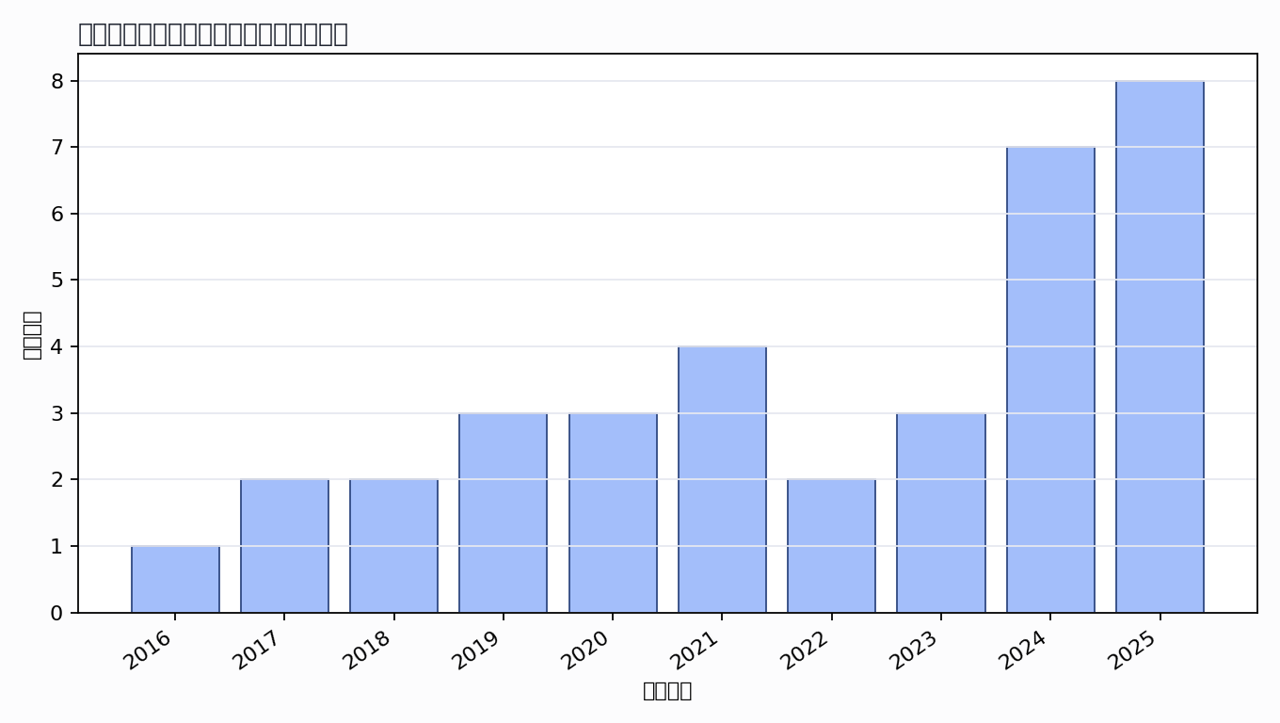

主题覆盖
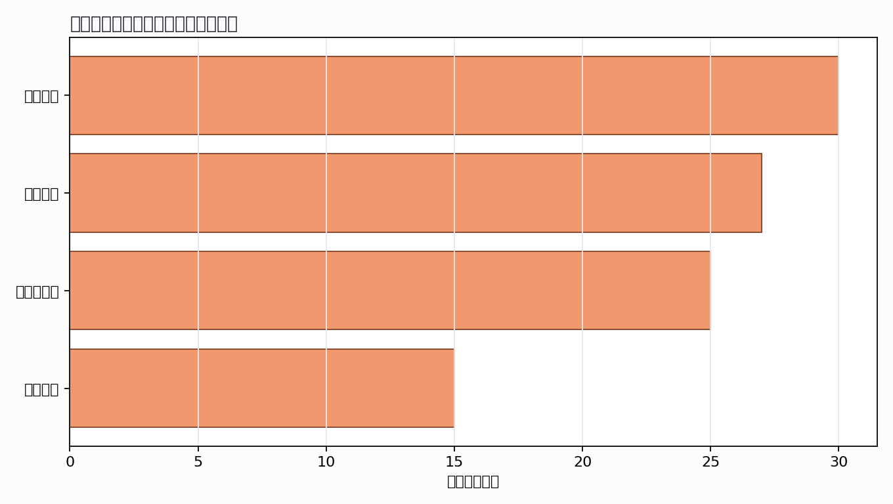

来源结构
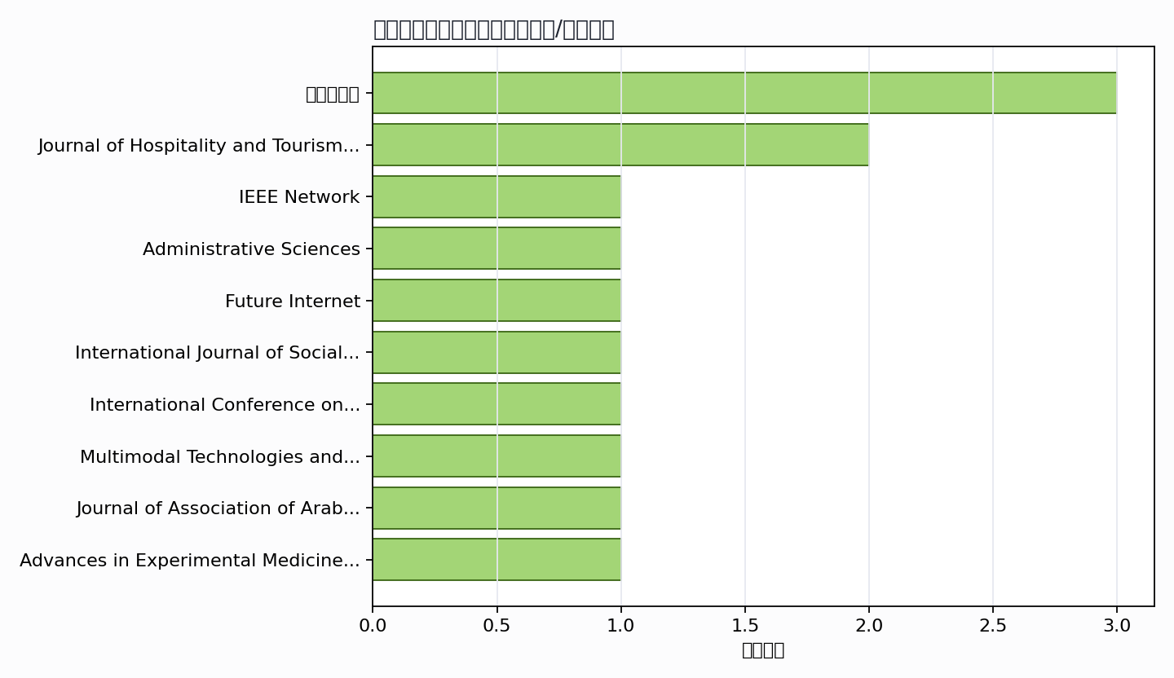

可进入书稿的论证链
- 概念层：使用高被引或综述型文献界定核心概念。
- 机制层：整理为技术能力、场景应用、主体协同、绩效反馈的论证链。
- 方法层：将实证方法转化为课堂练习、章节附录或研究设计示例。
- 边界层：对隐私、真实性、社区参与、算法偏见和数据授权设置专门讨论。

候选参考文献
- Wei Wang; Neeraj Kumar; Junxin Chen; Zhiguo Gong; Xiangjie Kong; Wei Wei; Honghao Gao (2020). Realizing the Potential of Internet of Things for Smart Tourism with 5G and AI. IEEE Network. DOI: 10.1109/MNET.011.2000250.
主题映射：物联网感知; 人工智能; 移动应用；引用数：220。
- Sujood; Naseem Bano; Samiha Siddiqui (2022). Consumers' intention towards the use of smart technologies in tourism and hospitality (T&H) industry: a deeper insight into the integration of TAM, TPB and trust. Journal of Hospitality and Tourism Insights. DOI: 10.1108/jhti-06-2022-0267.
主题映射：物联网感知; 人工智能; 移动应用；引用数：130。
- A. Rosário; Joana Carmo Dias (2024). Exploring the Landscape of Smart Tourism: A Systematic Bibliometric Review of the Literature of the Internet of Things. Administrative Sciences. DOI: 10.3390/admsci14020022.
主题映射：物联网感知; 人工智能; 移动应用; 游客体验；引用数：43。
- A. Alti; Abderrahim Lakehal; Sébastien Laborie; P. Roose (2016). Autonomic Semantic-Based Context-Aware Platform for Mobile Applications in Pervasive Environments. Future Internet. DOI: 10.3390/fi8040048.
主题映射：物联网感知; 人工智能; 移动应用；引用数：25。
- Wai Yie Leong; Yuan Zhi Leong; W. -. Leong (2024). Smart Tourism in ASEAN: Leveraging Technology for Sustainable Development and Enhanced Visitor Experiences. International Journal of Social Sciences and Artistic Innovations. DOI: 10.35745/ijssai2024.v04.03.0003.
主题映射：物联网感知; 人工智能; 移动应用; 游客体验；引用数：20。
- S. Muthuraman; Mohammed Al Haziazi (2019). Smart Tourism Destination - New Exploration towards Sustainable Development in Sultanate of Oman. International Conference on Information Management. DOI: 10.1109/INFOMAN.2019.8714652.
主题映射：物联网感知; 人工智能; 移动应用; 游客体验；引用数：19。
- Mohamed Zaifri; H. Khalloufi; Fatima-Zahra Kaghat; Ahmed Azough; Khalid Alaoui Zidani (2023). From Earlier Exploration to Advanced Applications: Bibliometric and Systematic Review of Augmented Reality in the Tourism Industry (2002-2022). Multimodal Technologies and Interaction. DOI: 10.3390/mti7070064.
主题映射：人工智能; 移动应用; 游客体验；引用数：15。
- Reham Touni; A. Magdy (2020). The application of Robots, Artificial Intelligence, and Service Automation in the Egyptian Tourism and Hospitality Sector (Possibilities, Obstacles, Pros, and Cons). Journal of Association of Arab Universities for Tourism and Hospitality. DOI: 10.21608/JAAUTH.2021.60834.1126.
主题映射：人工智能; 移动应用；引用数：13。
- Maria Psiha; P. Vlamos (2017). IoT Applications with 5G Connectivity in Medical Tourism Sector Management: Third-Party Service Scenarios.. Advances in Experimental Medicine and Biology. DOI: 10.1007/978-3-319-57348-9_12.
主题映射：物联网感知; 移动应用；引用数：13。
- Gabriel Marín Díaz; José Luis Galdón Salvador; José Javier Galán Hernández (2023). Smart Cities and Citizen Adoption: Exploring Tourist Digital Maturity for Personalizing Recommendations. Electronics. DOI: 10.3390/electronics12163395.
主题映射：物联网感知; 人工智能; 移动应用; 游客体验；引用数：12。
- Isaac Machorro-Cano; Mario Andrés Paredes-Valverde; G. Alor-Hernández; María del Pilar Salas-Zárate; M. J. G. Ozuna; J. L. Sánchez-Cervantes (2019). PESSHIoT: Smart Platform for Monitoring and Controlling Smart Home Devices and Sensors. Congreso Internacional de Tecnologías e Innovación. DOI: 10.1007/978-3-030-34989-9_11.
主题映射：物联网感知；引用数：10。
- D. Korzun; Aleksey G. Varfolomeyev; A. Shabaev; Vladimir V. Kuznetsov (2018). On dependability of smart applications within edge-centric and fog computing paradigms. International Conference on Dependable Systems, Services and Technologies. DOI: 10.1109/DESSERT.2018.8409185.
主题映射：移动应用；引用数：9。
- Davood Ghorbanzadeh; B. T. Sayed; H. Alhitmi; R. Hasan; M. Aldulaimi; K. Prasad (2025). Applying UTAUT and experiential consumption theory to understand the adoption of ChatGPT’s digitalized itinerary. Journal of Hospitality and Tourism Insights. DOI: 10.1108/jhti-02-2025-0300.
主题映射：人工智能; 移动应用；引用数：8。
- Abdul Cader; Mohamed Nafrees; F. Shibly (2021). Smart technologies in tourism: a study using systematic review and grounded theory. International Conference on Soft Computing and Software Engineering. DOI: 10.1109/scse53661.2021.9568338.
主题映射：物联网感知; 人工智能; 移动应用；引用数：8。
- Auwaku Saleh Mubarak; Zubaida Sa’id Ameen; P. Tonga; F. Al-turjman (2021). Smart Tourism: A Proof of Concept For Cyprus Museum of Modern Arts In The IoT Era. 2021 International Conference on Artificial Intelligence of Things (ICAIoT). DOI: 10.1109/ICAIoT53762.2021.00016.
主题映射：物联网感知; 人工智能; 移动应用；引用数：7。
- Gaurav Baranwal; D. Kumar (2020). DAFNA: Decentralized Auction based Fog Node Allocation in 5G Era. International Conference on Industrial and Information Systems. DOI: 10.1109/ICIIS51140.2020.9342683.
主题映射：物联网感知; 人工智能; 移动应用；引用数：7。
- T. H. Vu; Nghia Hoang Ba Dai; H. Khanh; Do Vo. Quang (2018). Overall Structural System Solution for Supporting Services and Tourists Management Oriented on Smart City in Viet Nam. Symposium on Information and Communication Technology. DOI: 10.1145/3287921.3287966.
主题映射：待人工判读；引用数：7。
- T. Luo (2025). Service model of smart tourism cities integrated with low-altitude technology. Engineering Management in Production and Services. DOI: 10.2478/emj-2025-0008.
主题映射：物联网感知; 人工智能; 移动应用; 游客体验；引用数：4。
- S. Bila (2021). Strategic priorities of social production digitalization: world experience. Unknown venue. DOI: 10.31470/2306-546X-2021-48-40-55.
主题映射：物联网感知; 人工智能; 移动应用; 游客体验；引用数：4。
- D. Tortora; A. D. Gregorio; C. Chiacchierini; M. Gurioli; R. Gareri (2019). Using Big Data to co-design a sustainable tourist experience. Some highlights by means of a practical example. Unknown venue. URL: https://www.semanticscholar.org/paper/d585e988f3aae243534d88bea02ac392157146df.
主题映射：人工智能; 游客体验；引用数：4。
- Y. Issakov; B. Lečić; Ana Spasojević; Snežana Knežević; Marija Mandarić; Katarina Stojanović; Tamara Gajić; Dragan Vukolić (2025). Security and Sustainability of Tourist Destinations Through Digital Technologies: A Comparative Analysis of Almaty and Belgrade. Sustainability. DOI: 10.3390/su17209126.
主题映射：物联网感知; 人工智能; 移动应用；引用数：3。
- Kittiwat Rattanamanee (2024). Future Perspectives on Communication Management for Promoting Tourism in Chachoengsao Province (2024-2027). International Journal of Professional Business Review. DOI: 10.26668/businessreview/2024.v9i1.4307.
主题映射：物联网感知; 人工智能; 移动应用; 游客体验；引用数：3。
- Ankit Garg; Nitin Saxena; Neha Verma; Ritesh Kumar Singhal; Rahul Singhal; Nagavani Kaggallu (2024). Examining the Smart Tourism Landscape: A Bibliometric Study and Analytical Synopsis of IoT Research. 2024 International Conference on Intelligent & Innovative Practices in Engineering & Management (IIPEM). DOI: 10.1109/IIPEM62726.2024.10925758.
主题映射：物联网感知; 人工智能; 移动应用; 游客体验；引用数：3。
- Y. Safonov; O. Korotun; O. Konarivska (2024). DIGITALISATION AS A MARKETING MANAGEMENT TOOL IN THE TOURISM INDUSTRY. Baltic Journal of Economic Studies. DOI: 10.30525/2256-0742/2024-10-3-295-303.
主题映射：物联网感知; 人工智能; 移动应用; 游客体验；引用数：3。
- Viet Anh Vo; Dat Van Nguyen; T. Tran; Maitrung Pham; Tan-Ri Le; P. Vo (2021). A Tourism Support Framework using Beacons technology. National Foundation for Science and Technology Development Conference on Information and Computer Science. DOI: 10.1109/NICS54270.2021.9701537.
主题映射：物联网感知; 移动应用；引用数：3。
- Pramod Kumar; Kshama Gupta; H. Karnatak; Asfa Siddiqui; A. Kumar (2017). Geo-enabled e-Democracy Tools and Services for Smart Cities. Unknown venue. DOI: 10.1007/978-981-10-4035-1_13.
主题映射：待人工判读；引用数：3。
- BS Krishnamma; K. Babu; Aleena Maria Zacharia (2025). Tourism 2.0: Exploring the evolution of smart destinations. Journal of Management Research and Analysis. DOI: 10.18231/j.jmra.2025.002.
主题映射：物联网感知; 人工智能; 移动应用; 游客体验；引用数：2。
- S. Raza; M. Anwar; Jeetesh Kumar; Emenyeonu, C. Ogadimma; Umer Zaman; Amjad Ali Shah (2025). Can Smart Mobile Applications Attract Travellers? Exploring Catenation Between Digital Tourism Entrepreneurs’ Use of Artificial Intelligence Generative Chatbots for Interactive Marketing Communication and Virtual Reality. Journal of creative communications. DOI: 10.1177/09732586251345220.
主题映射：人工智能; 移动应用；引用数：2。
- S. Tsai; Chia-Huei Wu; Jian Mou (2023). Theme issue on emerging advances in ubiquitous artificial intelligence: trends, challenges, and future research directions. Personal and Ubiquitous Computing. DOI: 10.1007/s00779-023-01715-2.
主题映射：物联网感知; 人工智能; 移动应用；引用数：2。
- Zhihan Lv; Jaime Lloret; H. Song (2022). Editorial: 5G for Augmented Reality. Journal on spesial topics in mobile networks and applications. DOI: 10.1007/s11036-022-01910-0.
主题映射：待人工判读；引用数：2。
- Yibo Chang; Jiahong Wang (2025). Near-field Communication Technology (NFC): Principle Analysis and Intelligent Life Application Research. Industry Science and Engineering. DOI: 10.62381/i255107.
主题映射：物联网感知; 移动应用；引用数：1。
- Elda Nurmalinda; Myrza Rahmanita; Liu Tao (2025). Innovative Strategies for Smart Tourism Growth in Zhuhai, China. International Journal of Scientific Research and Management. DOI: 10.18535/ijsrm/v13i02.t01.
主题映射：物联网感知; 人工智能; 移动应用; 游客体验；引用数：1。
- O. Pobihun; H. Shchuka; A. Makarenko (2025). ANALYSIS OF THE USE OF INNOVATIONS TO INCREASE THE ATTRACTIVENESS OF TOURIST DESTINATIONS. THE SCIENTIFIC ISSUES OF TERNOPIL VOLODYMYR HNATIUK NATIONAL PEDAGOGICAL UNIVERSITY. SERIES: GEOGRAPHY. DOI: 10.25128/2519-4577.25.3.10.
主题映射：人工智能; 移动应用; 游客体验；引用数：1。
- Imran Ahmed; Misbah Ahmad; Abdellah Chehri; Gwanggil Joen (2024). Sustainable Flood Risk Identification and Assessment Using Artificial Intelligence: A Literature Review and Case Scenario. 2024 IEEE World Forum on Public Safety Technology (WFPST). DOI: 10.1109/WFPST58552.2024.00041.
主题映射：物联网感知; 人工智能; 移动应用；引用数：1。
- D. Chauhan; M. Nisha (2024). Marketing Intelligence for Tourism Industry. Educational Administration: Theory and Practice. DOI: 10.53555/kuey.v30i1.9714.
主题映射：物联网感知; 人工智能; 移动应用; 游客体验；引用数：1。
Markdown 源文件：20260705_专著3——智慧旅游技术与应用_文献补充与数据分析报告.md

