专著2——旅游信息化管理 文献补充与数据分析报告

Executive Summary
已形成 35 条候选参考文献，满足每个专著子文件夹不少于 20 条的补充要求。
本证据包为《旅游信息化管理》补充了 35 条候选参考文献，其中 30 条发表于 2021 年及以后，说明该书题与近年数字技术、旅游管理和文化传播研究保持连接。主题上，当前文献主要集中在信息系统、运营决策、服务管理，可以支撑书稿从概念解释转向“技术—场景—主体—绩效”的论证链。方法上，样本文献呈现问卷/结构方程、实验/情景实验、文本挖掘/评论分析、案例/质性研究、预测/机器学习、综述/框架研究等路径，适合在书中分别转化为理论综述、案例框、方法训练和图表化教学材料。需要注意的是，Semantic Scholar 返回的题录不能替代全文精读；涉及地方数据、政策口径和企业案例成效的判断仍应回到原文、官方材料或授权数据核验。
证据边界：本报告基于 Semantic Scholar 题录、摘要和本地数字文旅文献语料生成；正式出版前需逐篇核验 DOI、页码、卷期和全文观点。

关键图表

年份分布
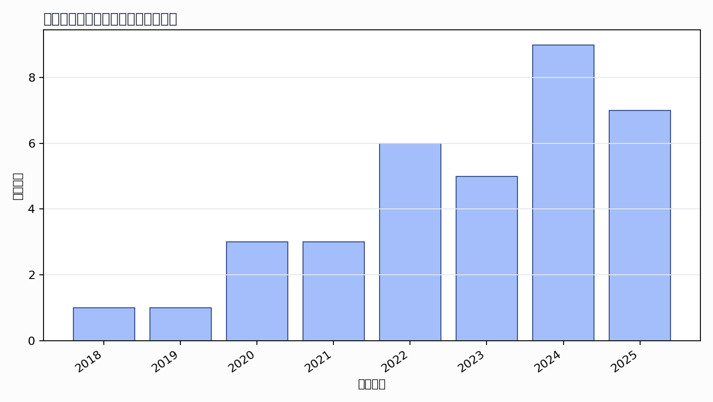

主题覆盖
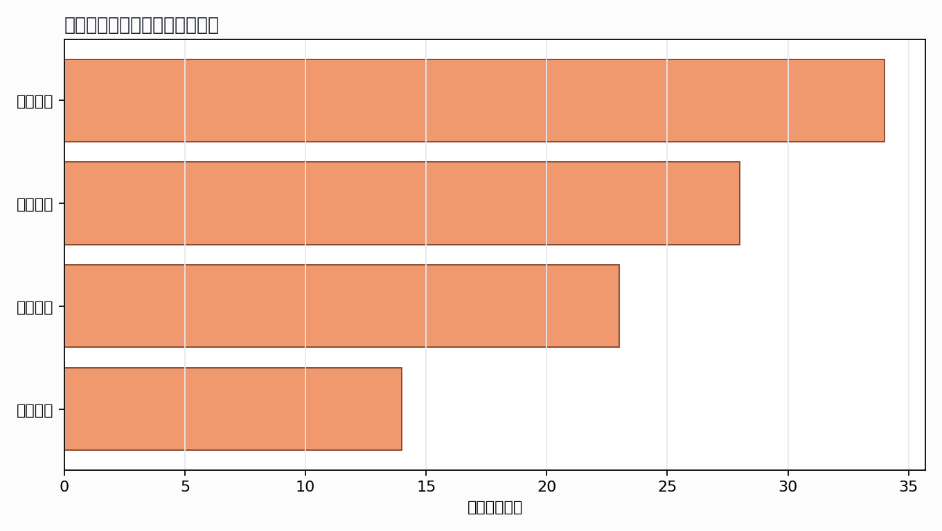

来源结构
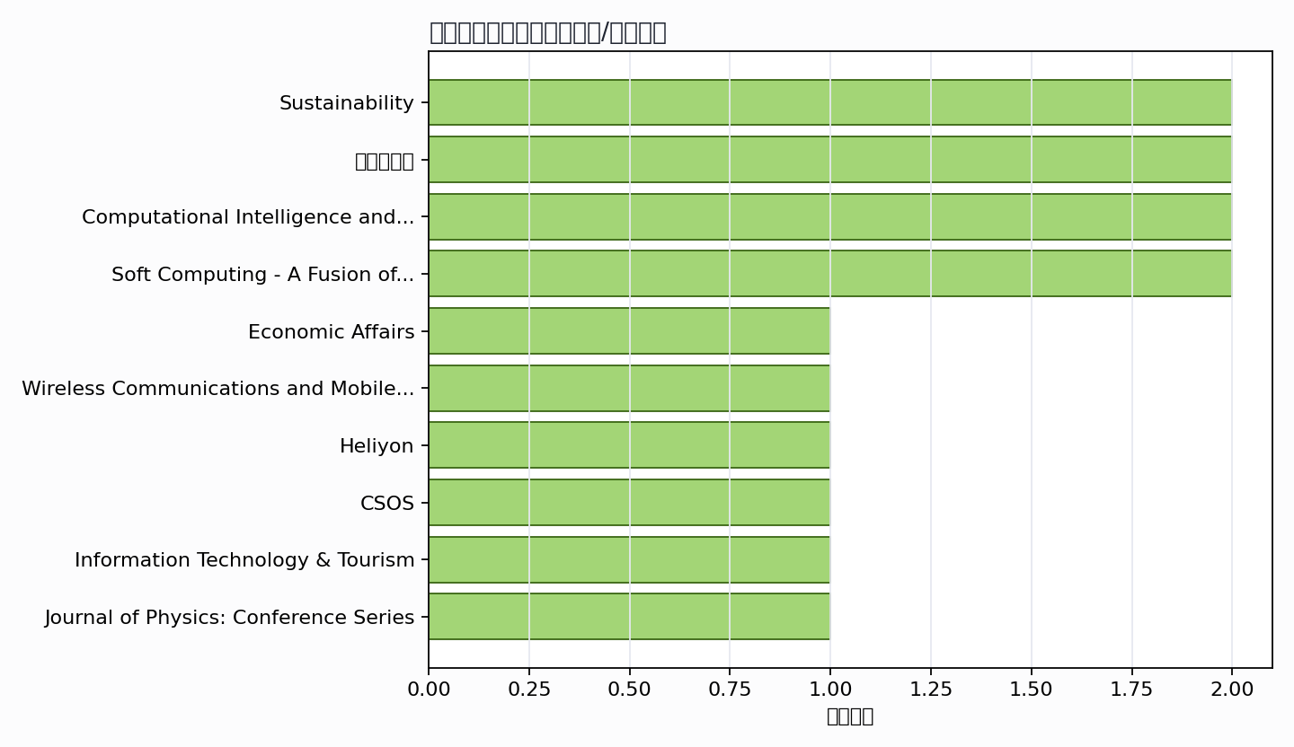

可进入书稿的论证链
- 概念层：使用高被引或综述型文献界定核心概念。
- 机制层：整理为技术能力、场景应用、主体协同、绩效反馈的论证链。
- 方法层：将实证方法转化为课堂练习、章节附录或研究设计示例。
- 边界层：对隐私、真实性、社区参与、算法偏见和数据授权设置专门讨论。

候选参考文献
- Pannee Suanpang; Pattanaphong Pothipassa (2024). Integrating Generative AI and IoT for Sustainable Smart Tourism Destinations. Sustainability. DOI: 10.3390/su16177435.
主题映射：信息系统; 数据治理; 服务管理; 运营决策；引用数：89。
- Lin I-Cheng Hsu Lin Tzu-Yun Le-Ming Tung Ling Ying Hsiao-Hsien (2022). After the Epidemic, Is the Smart Traffic Management System a Key Factor in Creating a Green Leisure and Tourism Environment in the Move towards Sustainable Urban Development?. Unknown venue. DOI: 10.3390/su14073762.
主题映射：信息系统; 服务管理; 运营决策；引用数：61。
- S. Das (2024). Application of AI Technology for the Development of Destination Tourism towards an Intelligent Information System. Economic Affairs. DOI: 10.46852/0424-2513.3.2024.31.
主题映射：信息系统; 数据治理; 服务管理; 运营决策；引用数：30。
- Cao Wei; Qinan Wang; Chengying Liu (2020). Research on Construction of a Cloud Platform for Tourism Information Intelligent Service Based on Blockchain Technology. Wireless Communications and Mobile Computing. DOI: 10.1155/2020/8877625.
主题映射：信息系统; 数据治理; 服务管理; 运营决策；引用数：28。
- Wan-Wan Sun (2021). Research on the Construction of Smart Tourism System Based on Wireless Sensor Network. Unknown venue. DOI: 10.1155/2021/9950752.
主题映射：信息系统; 运营决策；引用数：25。
- Lulu Wang (2024). Enhancing tourism management through big data: Design and implementation of an integrated information system. Heliyon. DOI: 10.1016/j.heliyon.2024.e38256.
主题映射：信息系统; 数据治理; 服务管理; 运营决策；引用数：20。
- T. Gajdošík (2018). Towards a Conceptual Model of Intelligent Information System for Smart Tourism Destinations. CSOS. DOI: 10.1007/978-3-319-91186-1_8.
主题映射：信息系统；引用数：15。
- Pedro Lopes; Luis Almeida; João L. Pinto; Justino de Jesus; Didiana Fernandes; I. Vieira; R. Gama (2019). Open Tourist Information System: a platform for touristic information management and outreach. Information Technology & Tourism. DOI: 10.1007/s40558-019-00159-w.
主题映射：信息系统; 运营决策；引用数：12。
- Ying Liu (2020). Research of Smart Tourism Management Model under the Background of Big Data. Journal of Physics: Conference Series. DOI: 10.1088/1742-6596/1601/3/032003.
主题映射：信息系统; 数据治理; 服务管理; 运营决策；引用数：11。
- X. Teng; Zhenjiang Shen (2020). Design of a Smart Visiting Service Management System for Personal Information Collection in Order to Integrate Tourism Management into an Isolated Island. Applied Sciences. DOI: 10.3390/app10186442.
主题映射：信息系统; 数据治理; 服务管理; 运营决策；引用数：11。
- Ruomei Tang; Chenyue Huang; Xinyu Zhao; Yunbing Tang (2022). Research on Smart Tourism Oriented Sensor Network Construction and Information Service Mode. Italian National Conference on Sensors. DOI: 10.3390/s222410008.
主题映射：信息系统; 服务管理；引用数：10。
- J. Mo; Fei Ren (2021). Analysis on the Countermeasures of Optimizing Urban Tourism Public Service System under the Background of Smart City. Complex. DOI: 10.1155/2021/6642404.
主题映射：信息系统; 数据治理; 服务管理; 运营决策；引用数：10。
- S. Lin (2022). Implementation of Personalized Scenic Spot Recommendation Algorithm Based on Generalized Regression Neural Network for 5G Smart Tourism System. Computational Intelligence and Neuroscience. DOI: 10.1155/2022/3704494.
主题映射：信息系统; 服务管理；引用数：7。
- Jessica Bollenbach; Dominik Rebholz; Robert Keller (2025). The road not taken: Representing expert knowledge for route similarities in sustainable tourism using machine learning. Electronic Markets. DOI: 10.1007/s12525-025-00816-5.
主题映射：信息系统; 运营决策；引用数：6。
- Shaohua Qiang; Ma Lan; Chen Nan (2024). A Smart Tourism Resource Information Management Platform Based on Multi-Source Data Fusion. International Journal of High Speed Electronics and Systems. DOI: 10.1142/s0129156425401342.
主题映射：信息系统; 服务管理; 运营决策；引用数：6。
- Satı Elifcan Özbek; Alberto Lanzavecchia; Francesco Ferrarese (2023). Participatory Geographic-Information-System-Based Citizen Science: Highland Trails Contamination due to Mountaineering Tourism in the Dolomites. Sustainability. DOI: 10.3390/su151813908.
主题映射：信息系统; 运营决策；引用数：5。
- Anfeng Xu; Wenjun Zeng (2022). Dynamic Optimization Modeling of Smart Tourism Information System Using VRGIS in Big Data Environment. Computational Intelligence and Neuroscience. DOI: 10.1155/2022/7914674.
主题映射：信息系统; 数据治理; 服务管理; 运营决策；引用数：5。
- T. Luo (2025). Service model of smart tourism cities integrated with low-altitude technology. Engineering Management in Production and Services. DOI: 10.2478/emj-2025-0008.
主题映射：信息系统; 数据治理; 服务管理; 运营决策；引用数：4。
- Suiqun Li; Yi Feng; Qikai Chu; Guangjian Chen (2024). Design of Smart Tourism Visual Analysis Platform Based on Digital Twin. 2024 IEEE 3rd International Conference on Electrical Engineering, Big Data and Algorithms (EEBDA). DOI: 10.1109/EEBDA60612.2024.10485670.
主题映射：信息系统; 数据治理; 运营决策；引用数：3。
- Xuefei Wu; Jiahui Huang (2023). Construction of a rural tourism information service management system for multi-source heterogeneous data processing. PeerJ Computer Science. DOI: 10.7717/peerj-cs.1334.
主题映射：信息系统; 服务管理; 运营决策；引用数：3。
- Liu Min (2023). Cloud service for rural tourism management based on human–computer interaction system and internet of things. Soft Computing - A Fusion of Foundations, Methodologies and Applications. DOI: 10.1007/s00500-023-08686-9.
主题映射：信息系统; 服务管理; 运营决策；引用数：3。
- Gangmin Weng; Jingyu Zhang (2023). Application Analysis of Smart Tourism Management Model under the Background of Big Data and IOT. Journal of Information Processing Systems. DOI: 10.3745/JIPS.03.0186.
主题映射：数据治理; 运营决策；引用数：3。
- Peilin Chen (2021). Smart Tourism Scenic Spot Platform Based on 5G Internet of Things Virtual Reality Technology. International Conference on Wireless Communications and Mobile Computing. DOI: 10.1109/IWCMC51323.2021.9498826.
主题映射：信息系统; 服务管理；引用数：3。
- Andi Supriadi Chan; Rezha Destiadi; Annalisa Sonaria Hasibuan; Alvendo Wahyu Aranski; Luky Ardiansyah (2024). Implementation of IoT-Based Smart Tourism Destination Tools as Tourism Leisure 5.0. International Journal of Research in Vocational Studies (IJRVOCAS). DOI: 10.53893/ijrvocas.v3i4.105.
主题映射：信息系统；引用数：2。
- Yingchen Hao; Li-Juan Zheng (2023). Application of slam method in big data rural tourism management in dynamic scene. Soft Computing - A Fusion of Foundations, Methodologies and Applications. DOI: 10.1007/s00500-023-08521-1.
主题映射：信息系统; 数据治理; 运营决策；引用数：2。
- L. Du; Xuedong Yang (2022). Research on Urban Smart Tourism System based on Computer Big Data Platform. ICCSIE. DOI: 10.1145/3558819.3565096.
主题映射：信息系统; 数据治理; 运营决策；引用数：2。
- Richard Callaway ; Samuel McGregor (2025). Smart Tourism Chatbot System: An AI-Driven Solution for Personalized Travel Assistance. International Journal on Advanced Computer Engineering and Communication Technology. DOI: 10.65521/ijacect.v14i1.222.
主题映射：信息系统; 服务管理；引用数：1。
- N. L. L. Tarigan; R. Larasati (2025). Management Of Smart Tourism Implementation And Creative Economy Collaboration As A Strategy For Sustainable Tourism Development In Yogyakarta. Jurnal Ilmu Manajemen. DOI: 10.21831/jim.v22i2.90318.
主题映射：信息系统; 服务管理; 运营决策；引用数：1。
- Juwanda Sari (2025). Geographic Information System for Aceh Souvenir Shop Locations Based on Android. Journal Digital Technology Trend. DOI: 10.56347/jdtt.v4i2.272.
主题映射：信息系统; 运营决策；引用数：1。
- Yinting Zhao; L. Ji (2025). Design of a context-aware AR smart guiding platform for enhancing cultural heritage experience in rural tourism. Journal of Computational Methods in Sciences and Engineering. DOI: 10.1177/14727978251385172.
主题映射：信息系统; 服务管理; 运营决策；引用数：1。
- A. Amelia; Taufik Nur Ad; Sinung Suakanto; Safara Cathasa Riverinda Rijadi (2025). Contextual Tourism Access Through Geographic Information System with Recommendation System: The Case of Greater Bandung. 2025 IEEE International Conference on Industry 4.0, Artificial Intelligence, and Communications Technology (IAICT). DOI: 10.1109/IAICT65714.2025.11101505.
主题映射：信息系统; 服务管理; 运营决策；引用数：1。
- Georgios Alexandridis; Georgios Siolas; Tasos Papagiannis; George Ioannou; Konstantinos Michalakis; G. Caridakis; V. Karyotis; S. Papavassiliou (2024). StreetLines: A Smart and Scalable Tourism Platform Based on Efficient Knowledge-Mining. Digit.. DOI: 10.3390/digital4030034.
主题映射：信息系统；引用数：1。
- W. Xu; Junlin Wu; Liang Yang (2024). Designing and Implementing a Digital Management Platform in the Era of Big Data for Enriching Cultural Tourism Experiences. Computer-Aided Design and Applications. DOI: 10.14733/cadaps.2024.s16.33-51.
主题映射：信息系统; 数据治理; 服务管理; 运营决策；引用数：1。
- Longlong Liu; Jiaoyue Li (2024). Design and implementation of tourism management system based on Android platform. 2024 2nd International Conference on Mechatronics, IoT and Industrial Informatics (ICMIII). DOI: 10.1109/ICMIII62623.2024.00110.
主题映射：信息系统; 服务管理; 运营决策；引用数：1。
- Xi Wen; Jing Cheng (2022). Optimization Framework of Smart Tourism Management Information System based on Real-Time GPS Positioning Technology. 2022 3rd International Conference on Smart Electronics and Communication (ICOSEC). DOI: 10.1109/ICOSEC54921.2022.9951978.
主题映射：信息系统; 服务管理; 运营决策；引用数：1。
Markdown 源文件：20260705_专著2——旅游信息化管理_文献补充与数据分析报告.md

