专著1——数字文旅概论 文献补充与数据分析报告

Executive Summary
已形成 35 条候选参考文献，满足每个专著子文件夹不少于 20 条的补充要求。
本证据包为《数字文旅概论》补充了 35 条候选参考文献，其中 33 条发表于 2021 年及以后，说明该书题与近年数字技术、旅游管理和文化传播研究保持连接。主题上，当前文献主要集中在文旅融合、智慧旅游、治理与转型，可以支撑书稿从概念解释转向“技术—场景—主体—绩效”的论证链。方法上，样本文献呈现问卷/结构方程、实验/情景实验、文本挖掘/评论分析、案例/质性研究、预测/机器学习、综述/框架研究等路径，适合在书中分别转化为理论综述、案例框、方法训练和图表化教学材料。需要注意的是，Semantic Scholar 返回的题录不能替代全文精读；涉及地方数据、政策口径和企业案例成效的判断仍应回到原文、官方材料或授权数据核验。
证据边界：本报告基于 Semantic Scholar 题录、摘要和本地数字文旅文献语料生成；正式出版前需逐篇核验 DOI、页码、卷期和全文观点。

关键图表

年份分布
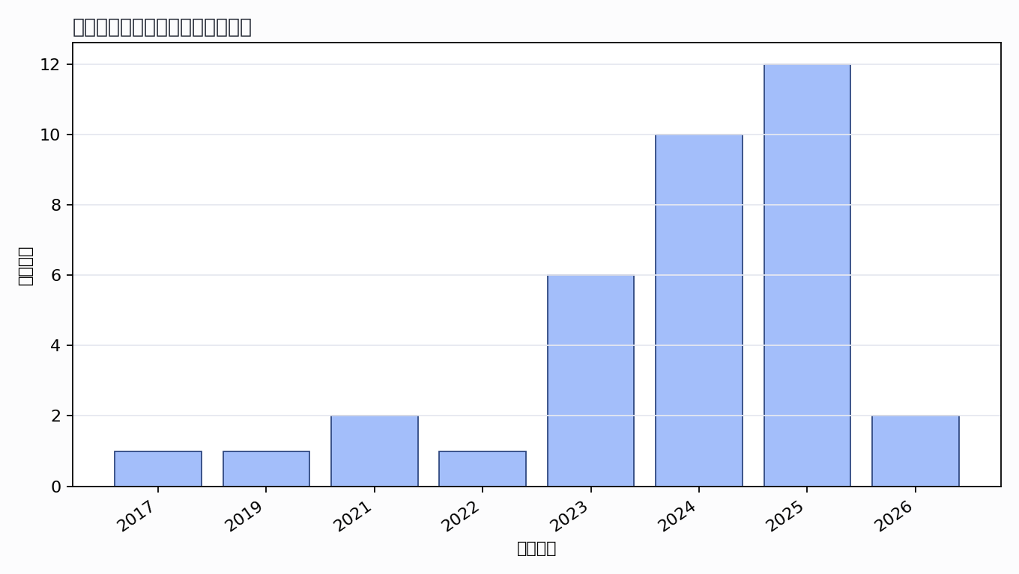

主题覆盖
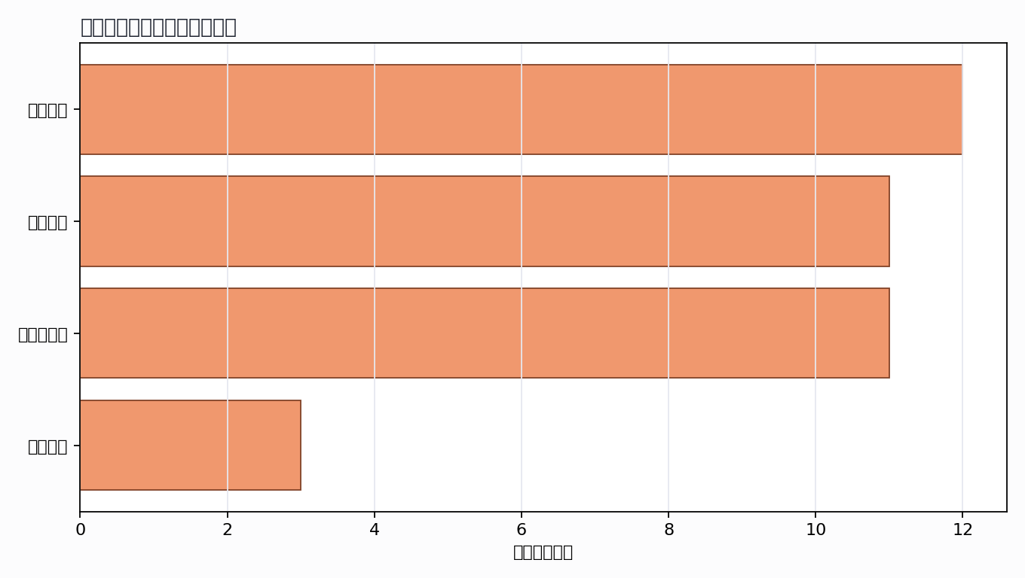

来源结构
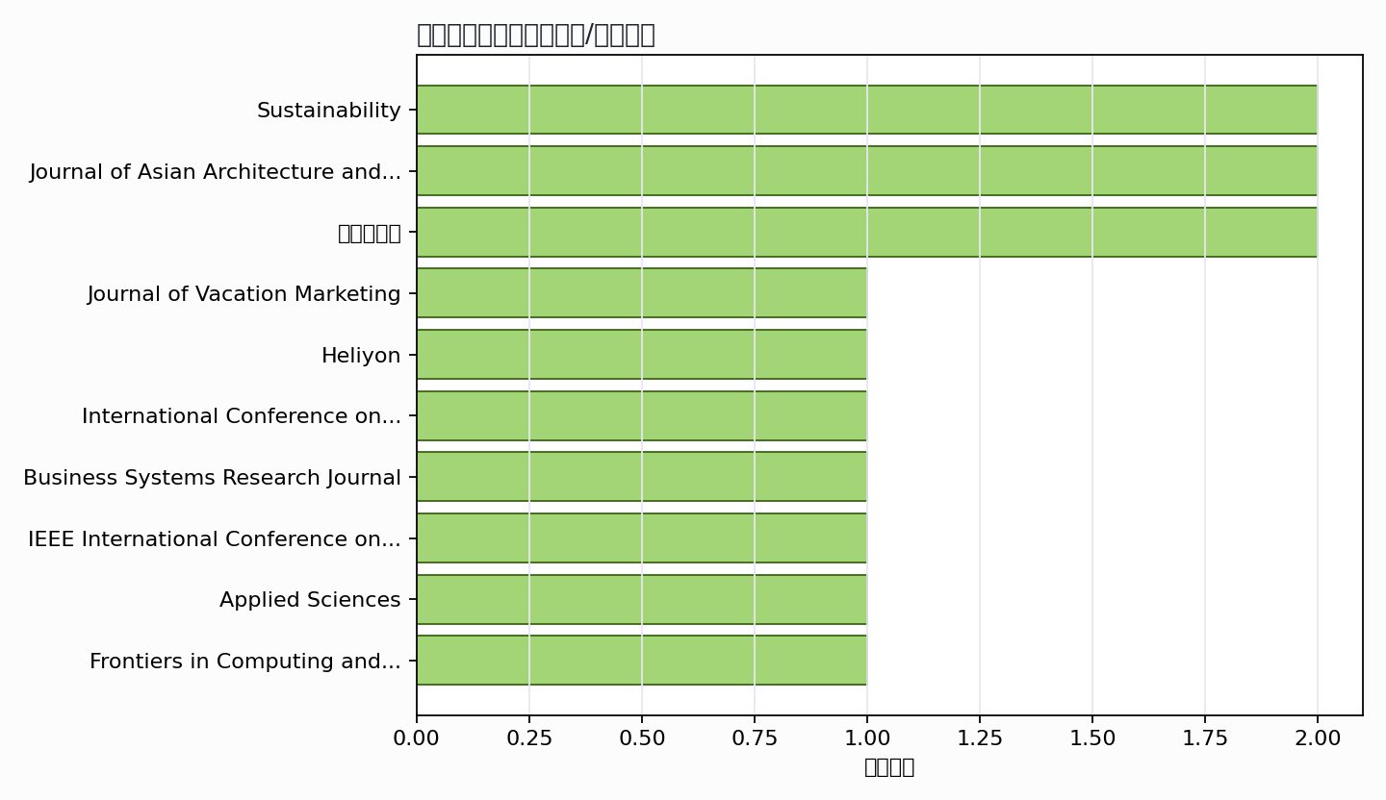

可进入书稿的论证链
- 概念层：使用高被引或综述型文献界定核心概念。
- 机制层：整理为技术能力、场景应用、主体协同、绩效反馈的论证链。
- 方法层：将实证方法转化为课堂练习、章节附录或研究设计示例。
- 边界层：对隐私、真实性、社区参与、算法偏见和数据授权设置专门讨论。

候选参考文献
- I. Vardopoulos; Maria Papoui-Evangelou; Bogdana Nosova; L. Salvati (2023). Smart ‘Tourist Cities’ Revisited: Culture-Led Urban Sustainability and the Global Real Estate Market. Sustainability. DOI: 10.3390/su15054313.
主题映射：智慧旅游；引用数：49。
- Junjie Li; Xiangbin Peng; Xiaodong Liu; Huanchen Tang; Wei Li (2024). A study on shaping tourists’ conservational intentions towards cultural heritage in the digital era: exploring the effects of authenticity, cultural experience, and place attachment. Journal of Asian Architecture and Building Engineering. DOI: 10.1080/13467581.2024.2321999.
主题映射：数字文旅; 治理与转型；引用数：40。
- Jiho Lee; Timothy Jung; M. Claudia; Tom Dieck; Alba García-Milon; Chang-Sik Kim (2024). Affordance, digital media literacy, and emotions in virtual cultural heritage tourism experiences. Journal of Vacation Marketing. DOI: 10.1177/13567667241255383.
主题映射：待人工判读；引用数：34。
- Ying Zhang; Qianqian Zheng; Chengcai Tang; Haixia Liu; Minrui Cui (2024). Spatial characteristics and restructuring model of the agro-cultural heritage site in the context of culture and tourism integration. Heliyon. DOI: 10.1016/j.heliyon.2024.e30227.
主题映射：待人工判读；引用数：32。
- Pancham Singh; Neeti Pahuja; Mrignainy Kansal; Siddhant Gurung; Utkarsh Shukla; Sandeep K. S. Gupta (2024). Enhancing Tourism Experiences and Preserving Cultural Heritage with AR and VR. International Conference on Database Theory. DOI: 10.1109/ICDT61202.2024.10489490.
主题映射：待人工判读；引用数：15。
- Zhidong Zang; Hongpeng Fu; Jiejing Cheng; H. Raza; Dehong Fang (2024). Digital threads of architectural heritage: navigating tourism destination image through social media reviews and machine learning insights. Journal of Asian Architecture and Building Engineering. DOI: 10.1080/13467581.2024.2399681.
主题映射：待人工判读；引用数：15。
- Tamara Floričić; Irena Šker; Hermina Maras Benassi (2023). Enhancing Digital Promotion of Cultural Attractions: Assessing Websites, Online Marketing Tools and Smart Technologies. Business Systems Research Journal. DOI: 10.2478/bsrj-2023-0004.
主题映射：待人工判读；引用数：14。
- Gokce Ozdemir; Sayyeda Zonah (2025). Revolutionising Heritage Interpretation with Smart Technologies: A Blueprint for Sustainable Tourism. Sustainability. DOI: 10.3390/su17104330.
主题映射：待人工判读；引用数：13。
- R. Lopes; O. A. Malik; A. Kumpoh; Chester Keasberry; Ong Wee Hong; S. Lee; Yong Liu (2019). Exploring Digital Architectural Heritage in Brunei Darussalam: Towards Heritage Safeguarding, Smart Tourism, and Interactive Education. IEEE International Conference on Multimedia Big Data. DOI: 10.1109/BigMM.2019.00019.
主题映射：智慧旅游; 治理与转型；引用数：12。
- Vito Del Vecchio; M. Lazoi; Claudio Marche; Christos Mettouris; Mario Montagud; Giorgia Specchia; Mostafa Z. Ali (2025). Designing Innovative Digital Solutions in the Cultural Heritage and Tourism Industry: Best Practices for an Immersive User Experience. Applied Sciences. DOI: 10.3390/app15094935.
主题映射：治理与转型；引用数：9。
- Teqiao Shen; Jialei Rong (2025). Research on Smart Cultural Tourism Based on Virtual Reality Technology. Frontiers in Computing and Intelligent Systems. DOI: 10.54097/71g3qa08.
主题映射：文旅融合; 治理与转型；引用数：4。
- Ruo Dong; Wei Xia (2024). DIGITAL NARRATIVE AND TOURISM VALUE SYMBIOSIS OF ZHEJIANG EAST TANG POETRY ROAD: A CROSS-CULTURAL PERSPECTIVE. Journal of Language, Culture and Education Studies. DOI: 10.61784/jlces3011.
主题映射：待人工判读；引用数：4。
- Han Wang (2023). Models and approaches for the integration of the digital economy and the cultural tourism industry. Journal of Innovation and Development. DOI: 10.54097/jid.v2i1.5117.
主题映射：文旅融合；引用数：4。
- Dzaa Imma Abdul Latiff; Muhamed Shafiq Muhamed Ayub; Suhaila Kamal; Wan Anis Aqilah Megat Zambri (2021). Regenerate Post COVID-19 Tourism with Smart Tourism Application (Moh Poie Rembau - Let’s Go to Rembau) as the Next Cultural Tourism & Travel Destination in Malaysia. International Journal of Academic Research in Business and Social Sciences. DOI: 10.6007/ijarbss/v11-i9/10704.
主题映射：智慧旅游; 文旅融合；引用数：4。
- Adedoyin Festus Fatai; An Hyeyeong (2017). Smart Tourism via Digital Governance: A case for Jeju Volcanic Island and Lava Tubes. Unknown venue. URL: https://www.semanticscholar.org/paper/edccebbcdbd3827c0b108a38c6ca2b61a5b9ac30.
主题映射：智慧旅游; 治理与转型；引用数：4。
- Chunyi Lin; Chen Li (2024). Digitization of intangible cultural heritage as a key factor in the transformation of cultural tourism integration: An analytical perspective of the digitalization framework. Trends in Social Sciences and Humanities Research. DOI: 10.61784/tsshrv2n190.
主题映射：文旅融合; 治理与转型；引用数：3。
- Shuqian Ge; Zhu Jin (2023). Research on the Application of Digital Design of Jinzuo Furniture Cultural Tourism Display Platform Based on Intangible Cultural Heritage. Int. J. Commun. Networks Inf. Secur.. DOI: 10.17762/ijcnis.v15i2.5978.
主题映射：文旅融合; 治理与转型；引用数：3。
- Tamara Florcic; Irena Šker; Hermina Maras Benassi (2022). Affirmation of Cultural Heritage Digital Promotion within Smart Destination Concept. ENTRENOVA - ENTerprise REsearch InNOVAtion. DOI: 10.54820/entrenova-2022-0015.
主题映射：待人工判读；引用数：3。
- Xuemei Jiang; Tingyin Deng; Meiling Wang; Iwei Liu (2024). Study on the Application of Information Technology in International Cultural Tourism and the Evolution of the Trend. International Symposium on Computational Intelligence and Design. DOI: 10.1109/ISCID63852.2024.00044.
主题映射：智慧旅游; 文旅融合；引用数：2。
- A. Shah (2024). Potentials of Employing Digital Technologies for Advancing Sustainable Tourism, and Preservation of Historic Sites: Insights from Manama, Bahrain. International Conference on Smart Health. DOI: 10.1109/ICSH62408.2024.10779699.
主题映射：待人工判读；引用数：2。
- Miwei Zhang; Tang Jun (2023). Transforming Cultural Tourism in Dali, Yunnan: Harnessing Digitalization for Smart Sustainable Heritage Experiences. Journal of Social Sciences and Economics. DOI: 10.61363/jsse.v2i2.80.
主题映射：智慧旅游; 文旅融合；引用数：2。
- Unknown author (2021). Cultural Tourism And Business Opportunities For Museums. Unknown venue. URL: https://www.semanticscholar.org/paper/ad26d6175e9ab95c370b8420eda915a16e37067c.
主题映射：文旅融合；引用数：2。
- Ray Octafian; Aditya Linggar Pramudya; Yema Charista Zelda (2025). Smart Tourism Synergies in Central Java-Yogyakarta: Human Capital, Technology, and Institutional Integration for Sustainable Growth. SHS Web of Conferences. DOI: 10.1051/shsconf/202522601024.
主题映射：智慧旅游; 数字文旅；引用数：1。
- Moh. Ilham Yasin; Moh. Hilman Fikri; Rizky Perdana Bayu Putra; Sri Wahyuni; M. Dwi (2025). Introducing English Literature as a Medium for Promoting Local Cultural Tourism through Digital Content. Jurnal Pengabdian Masyarakat dan Riset Pendidikan. DOI: 10.31004/jerkin.v3i4.571.
主题映射：文旅融合；引用数：1。
- Wei Wang; Wenjing Zhang; Zhaohuan Wu (2025). Influence of New Productive Forces on the Evolution of Cultural Tourism and Heritage Site Management. Herança. DOI: 10.52152/heranca.v8i3.1130.
主题映射：智慧旅游; 文旅融合；引用数：1。
- Nur Wahyuni; Putu Sudira; K. Komariyah; M. Nurtanto; Jasiah (2025). Improving village tourism marketing through the implementation of smart digital platforms: An Applied study in Indonesia. Management. DOI: 10.62486/agma2025295.
主题映射：数字文旅; 治理与转型；引用数：1。
- Yupei Zhang (2025). Exploring the Value Reshaping and Practical Approaches to the Digital Inheritance of Cultural Heritage from the Perspective of Culture-Tourism Integration. Educational Innovation Research. DOI: 10.18063/eir.v3i4.1031.
主题映射：治理与转型；引用数：1。
- Mengting Hu (2025). Exploring Methodological Logic and Innovative Measures for Digital Preservation of Jingdezhen Ceramic Cultural Heritage. Journal of Sociology and Education. DOI: 10.63887/jse.2025.1.8.53.
主题映射：待人工判读；引用数：1。
- Yinting Zhao; L. Ji (2025). Design of a context-aware AR smart guiding platform for enhancing cultural heritage experience in rural tourism. Journal of Computational Methods in Sciences and Engineering. DOI: 10.1177/14727978251385172.
主题映射：智慧旅游; 治理与转型；引用数：1。
- Ziheng Guo; Decai Wang; Zhijian Li (2025). Cultural Tourism Economy and Cultural Heritage of National Music and Dance Bases under the Integration of Digital Intelligence, Industry and Education. Journal of Education, Humanities, and Social Research. DOI: 10.71222/6rhmbe65.
主题映射：文旅融合；引用数：1。
- L. Judijanto; Rella Dwi Respati; Raden Asri Kartini; Yusron Difinubun (2025). Bibliometric Analysis on Ecotourism and Cultural Tourism Development. West Science Interdisciplinary Studies. DOI: 10.58812/wsis.v3i03.1784.
主题映射：智慧旅游; 文旅融合; 治理与转型；引用数：1。
- Ana P. Garcia; Davidson Frade; D. Dias; M. A. Almeida (2024). Gamification and Tourism: the experience of built cultural heritage mediated by digital technology. Symposium on Virtual and Augmented Reality. DOI: 10.1145/3691573.3691602.
主题映射：待人工判读；引用数：1。
- Liling Chen; Yicong Song; Shengfeng Qin; Xiaojing Niu; Liu Yang; Xin Luan (2023). The Framework of Culture Heritage Digital Twin System Based on Semantic Network. 2023 IEEE Smart World Congress (SWC). DOI: 10.1109/SWC57546.2023.10449294.
主题映射：待人工判读；引用数：1。
- S. Samir; Dridi (2026). Smart Tourism and Cultural Heritage: Enhancing Visitor Experience through Digital Innovation. Academic International Journal of Social Sciences and Humanities. DOI: 10.59675/s413.
主题映射：智慧旅游；引用数：0。
- Kewen Li; Jiaxian Jin; Xinyi Zhang; Yi Gao; Fuyu Xue; Yanyu Wu; Bin He Yuanyuan Shen (2026). Research on the Protection and Inheritance of Cultural Heritage under the Integration of Culture, Tourism, Science and Education. Journal of Sociology and Ethnology. DOI: 10.23977/jsoce.2026.080201.
主题映射：待人工判读；引用数：0。
Markdown 源文件：20260705_专著1——数字文旅概论_文献补充与数据分析报告.md

